**STATE OF ARIZONA**

**TRIENNIAL HIGHWAY SAFETY PLAN**

**Federal Fiscal Years**

**2024-2026**

Prepared by:

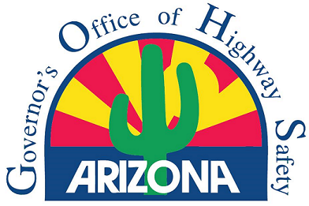

Katie Hobbs, Governor

Julie Cruz, Interim Director and

Interim Governor’s Highway Safety Representative

July 1, 2023

**Table of Contents**

Highway Safety Planning Process and problem identification 6

Pedestrian and Bicycle Safety Public Participation and Engagement 12

Engagement planning: 12

Engagement Outcomes: 15

Ongoing engagement planning: 17

Occupant Protection Public Participation and Engagement 19

Engagement Planning: 19

Engagement Outcomes: 21

Ongoing engagement planning: 23

Performance Plan Chart 26

Performance Measure: C-1) Number of traffic fatalities (FARS) 29

Performance Target Justification 29

Performance Measure: C-2) Number of serious injuries in traffic crashes (State crash data files) 30

Performance Target Justification 30

Performance Measure: C-3) Fatalities/VMT (FARS, FHWA) 31

Performance Target Justification 31

Performance Measure: C-4) Number of unrestrained passenger vehicle occupant fatalities, all seat positions (STATE CRASH DATA FILES) 31

Performance Target Justification 32

Performance Measure: C-5) Number of fatalities in crashes involving a driver or motorcycle operator with a BAC of .08 and above (FARS DATA) 33

Performance Target Justification 33

Performance Measure: C-6) Number of speeding-related fatalities (STATE CRASH DATA FILES) 33

Performance Target Justification 34

Performance Measure: C-7) Number of motorcyclist fatalities (STATE CRASH DATA FILES) 35

Performance Target Justification 35

Performance Measure: C-8) Number of unhelmeted motorcyclist fatalities (STATE CRASH DATA FILES) 36

Performance Target Justification 36

Performance Measure: C-9) Number of drivers age 20 or younger involved in fatal crashes (STATE CRASH DATA FILES) 37

Performance Target Justification 37

Performance Measure: C-10) Number of pedestrian fatalities (STATE CRASH DATA FILES) 38

Performance Target Justification 38

Performance Measure: C-11) Number of bicyclists fatalities (STATE CRASH DATA FILES) 39

Performance Target Justification 39

Performance Measure: B-1) Observed seat belt use for passenger vehicles, front seat outboard occupants (survey) 40

Performance Target Justification 40

Countermeasure Strategies for Programming funds: 42

***Program Area: Impaired Driving (Drug and Alcohol)*** 42

Description of Highway Safety Problems 42

Countermeasure Strategy: Court Monitoring 43

Countermeasure and justification 43

Funding sources 44

Countermeasure Strategy: DWI Courts 45

Countermeasure and justification 45

Funding sources 46

Countermeasure Strategy: Enforcement of Drug-Impaired Driving 46

Countermeasure and justification 46

Funding sources 48

Countermeasure Strategy: High Visibility Enforcement/Saturation Patrols/Checkpoints 48

Countermeasure and justification 48

Funding sources 50

Countermeasure Strategy: Youth and Awareness Programs 50

Countermeasure and justification 50

Funding Sources 51

***Program Area: Police Traffic Services*** 52

Description of Highway Safety Problems 52

Countermeasure Strategy: Crash Investigation 53

Countermeasure and justification 53

Funding sources 55

Countermeasure Strategy: High Visibility Enforcement 55

Countermeasure and Justification 55

Funding sources 57

Countermeasure Strategy: Other Enforcement methods 57

Countermeasure and justification 57

Funding sources 58

Countermeasure Strategy: Communication and Outreach supporting enforcement 58

Countermeasure and justification 58

Funding sources 60

*Program Area: Occupant Protection (Adult and Child Passenger Safety)* 61

Description of Highway Safety Problems 61

Countermeasure Strategy: Inspection Stations and Education 62

Countermeasure and justification 62

Funding sources 64

Countermeasure Strategy: Observational Survey 65

Countermeasure and justification 65

Funding sources 67

Countermeasure Strategy: Short-term, High Visibility Seat Belt/Child Restraint Law Enforcement 67

Countermeasure and justification 67

Funding sources 68

Countermeasure Strategy: Sustained Enforcement 69

Countermeasure and justification 69

Funding sources 70

*Program Area: Non-motorized (Pedestrians and Bicyclist)* 71

Description of Highway Safety Problems 71

Countermeasure Strategy: Enforcement Strategies 72

Countermeasure and justification 72

Funding sources 74

Countermeasure Strategy: Pedestrian/Bicycle safety education and awareness 74

Countermeasure and justification 74

Funding sources 76

*Program Area: Motorcycle Safety* 77

Description of Highway Safety Problems 77

Countermeasure Strategy: Motorcycle Training and Education 77

Countermeasure and justification 77

Funding sources 79

*Program Area: Traffic Records* 80

Description of Highway Safety Problems 80

Countermeasure Strategy: Improves timeliness of a core highway safety database 81

Countermeasure and justification 81

Funding sources 85

*Program Area: Emergency Medical Services* 86

Description of Highway Safety Problems 86

Countermeasure Strategy: Emergency Medical Assistance 87

Countermeasure and justification 87

Funding sources 88

*Program Area: Communications (Media)* 89

Description of Highway Safety Problems 89

Countermeasure Strategy: Mass Media Campaign 90

Countermeasure and justification 90

Funding sources 91

*Program Area: Planning & Administration* 92

Description of Highway Safety Problems 92

Countermeasure Strategy: Highway Safety Office Program Management 92

Countermeasure and justification 92

Funding sources 93

Performance Report Chart 94

Performance Measure: C-1) Number of traffic fatalities* (FARS) 95

Program-Area-Level Report 95

Performance Measure: C-2) Number of serious injuries in traffic crashes* (State crash data files) 95

Program-Area-Level Report 95

Performance Measure: C-3) Fatalities/VMT* (FARS, FHWA) 96

Program-Area-Level Report 96

Performance Measure: C-4) Number of unrestrained passenger vehicle occupant fatalities, all seat positions (STATE) 96

Program-Area-Level Report 96

Performance Measure: C-5) Number of fatalities in crashes involving a driver or motorcycle operator with a BAC of .08 and above (FARS) 97

Program-Area-Level Report 97

Performance Measure: C-6) Number of speeding-related fatalities (STATE) 97

Program-Area-Level Report 97

Performance Measure: C-7) Number of motorcyclist fatalities (STATE) 98

Program-Area-Level Report 98

Performance Measure: C-8) Number of unhelmeted motorcyclist fatalities (STATE) 98

Program-Area-Level Report 98

Performance Measure: C-9) Number of drivers age 20 or younger involved in fatal crashes (STATE) 99

Program-Area-Level Report 99

Performance Measure: C-10) Number of pedestrian fatalities (STATE) 99

Program-Area-Level Report 99

Performance Measure: C-11) Number of bicyclists fatalities (STATE) 100

Program-Area-Level Report 100

Performance Measure: B-1) Observed seat belt use for passenger vehicles, front seat outboard occupants (STATE SURVEY) 100

Program-Area-Level Report 100

# **Highway Safety Planning Process and problem identification**

#### Data Sources and Processes

Through its established processes and available data sources, the Arizona Governor's Office of Highway Safety (GOHS) has identified its highway safety problems, determined its highway traffic safety performance measures, established its performance targets, developed and selected evidence-based countermeasure strategies, and conducted public participation and engagement to address its problems and achieve its performance targets by the following:

GOHS uses the following data sources:

1. Fatality Analysis Reporting System (FARS) – FARS is a national data collection system that contains information on all known motor vehicle traffic crashes in which there was at least one fatality;
2. NHTSA Fatality and Injury Reporting System Tool (FIRST) – This query tool allows a user to construct customized queries from FARS and from the Crash Report Sampling System (CRSS);
3. NHTSA State Traffic Safety Information (STSI)- STSI is an information portal for state or county specific data;
4. United State Census bureau data (www.Census.gov);
5. Arizona Motor Vehicle Crash Facts - This publication is an annual statistical review of the motor vehicle crashes in the State of Arizona;
6. Arizona Department of Transportation Accident Location Identification Surveillance System (ALISS) - ALISS is the central repository for crash data within Arizona;
7. Arizona Seat Belt and Driver Survey - A study to determine the statewide seat belt use rate;
8. GOHS Enforcement Reporting System - A statistical reporting system of DUI and all other traffic enforcement activities for law enforcement agencies;
9. GOHS public engagement surveys conducted.

The data validates that the four leading causes of fatalities and serious injuries from vehicular collisions in Arizona are unrestrained passenger vehicle occupants, speeding and reckless driving, impaired driving and pedestrians respectively. Consequently, the majority of funding in the Highway Safety Plan is allocated to include Police Traffic Services, Impaired Driving, and Occupant Protection. While law enforcement agencies around Arizona receive HSP funding to conduct impaired, speeding, and occupant protection enforcement, the majority enforcement funds are focused in the counties of Maricopa and Pima. These two counties account for approximately over 80% of the State’s total population based on 2022 population estimates from the Arizona Office of Economic Opportunity.

The tables below go in to further detail on the amount of total traffic, impaired related, speeding related, and unrestrained occupant crashes, injuries, and fatalities by county in 2022.



GOHS develops performance measures and targets to determine its HSP's effectiveness against provided funds for countermeasure strategies and projects that will ultimately make Arizona roadways safer. GOHS, in conjunction with ADOT, AZ State Traffic Safety Plan and FHWA, sets targets for three core performance measures (Fatalities, Serious Injuries, and VMT). The remaining core performance measures, as designated by NHTSA, serve as guidelines for GOHS in implementing evidence-based countermeasures. GOHS uses all core performance measures to guide program and project activities and assist in justifying resources/funding allocations.

The primary highway safety goal for Arizona is to reduce fatalities and injuries across all program areas. GOHS tracks performance measures based on FARS data in combination with several other data sources to understand trends and set safety performance targets. GOHS uses Countermeasures That Work: A Highway Safety Countermeasure Guide for State Highway Safety Offices, Tenth Edition, 2020 (CTW) as a primary reference aid in the selection of effective evidence-based countermeasure strategies for the HSP program areas. The following table summarizes the performance measures established by GOHS:

Effective strategies to improve road safety require a multifaceted approach. They involve enforcement, public participation, and educational campaigns to foster positive behavioral changes in all road users. A targeted approach to enforcement, such as focusing on specific violations like speeding or reckless driving, and public education campaigns are key components in reducing the number of accidents and injuries on our roads. Ultimately, all stakeholders must work together to prioritize road safety and create a culture of responsible driving. The Data Driven Approach to Crime and Traffic Safety (DDACTS) model and similar strategies, using data to identify high crash locations requiring specific solutions are also employed.

| Type | Program Area | Performance Measure | Data Source |
| --- | --- | --- | --- |
| Outcome | Overall | Number of traffic-related fatalities. | FARS |
| Outcome | Overall | Number of traffic-related serious injuries. | ADOT |
| Outcome | Overall | Fatalities per 100 million VMT. | FARS |
| Outcome | Alcohol and Other Drugs (AL) | Number of fatalities involving a driver or motorcycle operator with a BAC of 0.08 percent or greater. | FARS |
| Outcome | Occupant Protection (OP) | Number of unrestrained passenger vehicle occupant fatalities in all seating positions. | ADOT |
| Outcome | Police Traffic Services (PTS) | Number of speeding-related fatalities. | ADOT |
| Outcome | Police Traffic Services (PTS), Alcohol and Other Drugs (AL), Motorcycle, Bicycle, and Pedestrian Safety (MC/PS), and Occupant Protection (OP) | Number of drivers age 20 or younger involved in fatal crashes. | ADOT |
| Outcome | Motorcycle Safety (MC) | Number of motorcycle fatalities. | ADOT |
| Outcome | Motorcycle Safety (MC) | Number of unhelmeted motorcycle fatalities. | ADOT |
| Outcome | Pedestrian Safety (PS) | Number of pedestrian fatalities. | ADOT |
| Outcome | Bicycle Safety (PS) | Number of bicycle fatalities. | ADOT |
| Behavior | Occupant Protection (OP) | Percent of front seat vehicle occupants who are observed using safety belts. | Survey |
| Activity | Occupant Protection (OP) | Number of Seat Belt Citations issued. | Grant Activity Reports and GOHS Web Site Reporting System |
| Activity | Alcohol and Other Drugs (AL) | Number of Impaired Driving arrests made during grant-funded enforcement. | Grant Activity Reports and GOHS Web Site Reporting System |
| Activity | Police Traffic Services (PTS) | Number of Speeding Citations issued during grant-funded enforcement. | Grant Activity Reports and GOHS Web Site Reporting System |

#### Description and analysis of Highway Safety Problems

Arizona is comprised of over 113,998 square miles with a population of over 7.4 million people, according to the 2021 Census Estimate, and is the 4th fastest growing state. During the problem identification process, emphasis was given to assessing changes in severity over a period or a reduction over the previous year’s data; whichever showed the most realistic incremental change for improved highway safety. While the HSP is a three-year plan under the new Bipartisan Infrastructure Law (BIL), behavioral change takes time. A countermeasure instituted to address a particular traffic safety problem may not show a measurable impact for several years or more.

GOHS supports activities aimed at reducing the number of crashes and resulting injuries and fatalities on Arizona's roadways. The agency establishes performance targets that indicate progress towards incremental safety gains, resulting in safer travel over the years. These targets serve as a benchmark for various initiatives and programs aimed at improving road safety, including impaired driving prevention, distracted driving awareness, improved infrastructure, and better driver training. GOHS focuses on implementing evidence-based strategies to ensure measurable outcomes that positively impact road safety, ensuring safer and more secure travel for all Arizonans. GOHS uses a comprehensive approach to identify and address safety concerns in the state.

Analyzing various data sets related to highway safety can provide insights into the overall problems faced by a state in terms of road safety. These data sets may include information on fatalities, injuries, enforcement activities, judicial outcomes, geospatial factors, and sociodemographic characteristics. The data-driven approach used by the GOHS is crucial in pinpointing the most critical safety issues and improving roadway safety effectively. By utilizing data and tapping into the expertise of its staff and highway safety research, GOHS can make informed decisions and develop strategies that target the areas that need the most attention.

# **Pedestrian and Bicycle Safety Public Participation and Engagement**

Engagement planning:

The Governor’s Office of Highway Safety (GOHS) will engage the City of Goodyear, Arizona, and the surrounding community on Pedestrian and Bicycle Safety.  Goodyear is located approximately 17 miles west of downtown Phoenix, in Maricopa County, in the central part of Arizona. Most recently, the City experienced a tragic incident where a truck ran into a group of cyclists, resulting in injuries and two fatalities. While this was a cycling tragedy, our efforts will prioritize pedestrian safety because these areas affect families in Goodyear and throughout Arizona.

Engaging with this group will help GOHS identify the appropriate countermeasures that best serve Goodyear through partnerships and authentic community outreach approach strategies. Outreach strategies include cycling clubs, community organizations, and event sponsorship opportunities. Arizona is known for its rich natural environment landscape that attracts hikers and bicyclists. The State is home to one of the largest cycling communities in the United States, with an estimated 39,000 in-state and 14,000 out-of-state participants.

*Identification of the affected and potentially affected communities:* The City of Goodyear alone is involved annually in as many as 250 state-level competitive events, and with over 43,000 cyclists annually on the Goodyear roadways, pedestrian motor vehicle crashes have increased dramatically. Pedestrian data shows increased pedestrian and cycling-related deaths in several state regions and high-event-affected areas, including Goodyear. According to the NHTSA, 932 bicyclists were killed in motor-vehicle traffic crashes in 2020, an 8.9% increase from 856 in 2019.

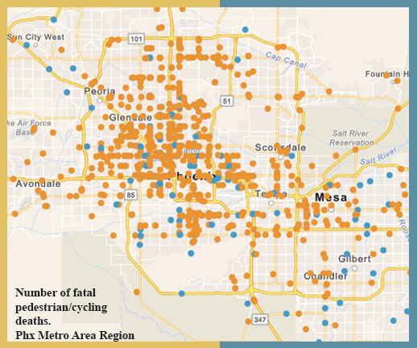

*Affected community* - ADOT analysis shows pedestrian fatalities have gone from 155 in 2014 to 220 in 2019 — a 42% increase, though 2018 had the most pedestrian deaths during that time frame, with 245 fatalities. More than half of fatal pedestrian crashes occur in the roadway but not in a crosswalk or an intersection, while just 10% happen at intersections with marked crosswalks.

GOHS mapped out nearly every recorded crash in the state involving a pedestrian or cyclist fatality between 2014 and 2019 using longitudinal and latitudinal coordinates provided by ADOT.

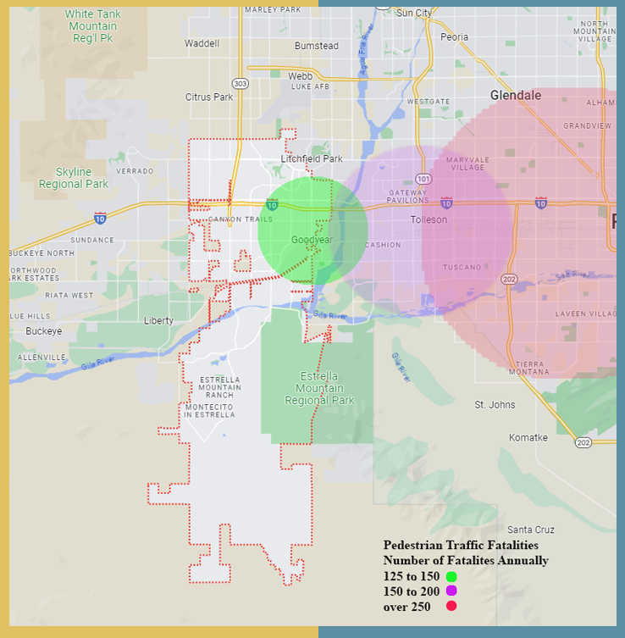

Most pedestrian crashes occur when a pedestrian is crossing the road, meaning that intersections and busy roadways are where most of these crashes happen.  There were 219 fatal crashes in urban areas, compared to 39 fatal crashes in rural areas. There were 1376 injury-inducing crashes in urban areas, whereas, in rural areas, there were only 80 injury crashes.

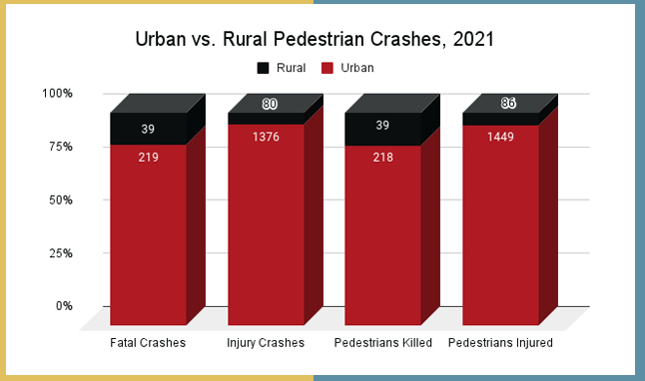

*Data:*

According to the US Census 2019, Americans living in low-income communities have experienced disproportionately higher pedestrian fatalities than more affluent nearby neighborhoods. Children at poverty levels are particularly at risk of being struck by motor vehicles while walking in low-income neighborhoods thus, why there’s a need for GOHS to engage with communities like Goodyear and others to inform families about safe practices and awareness when it comes to pedestrian and bicycle safety.

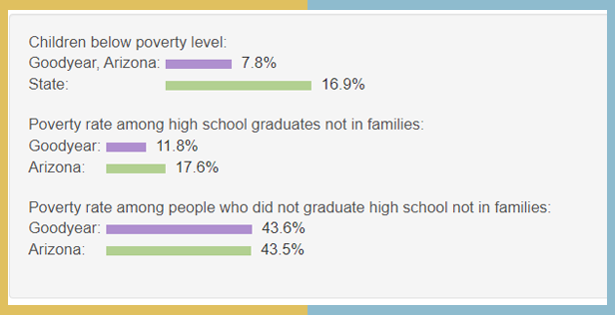

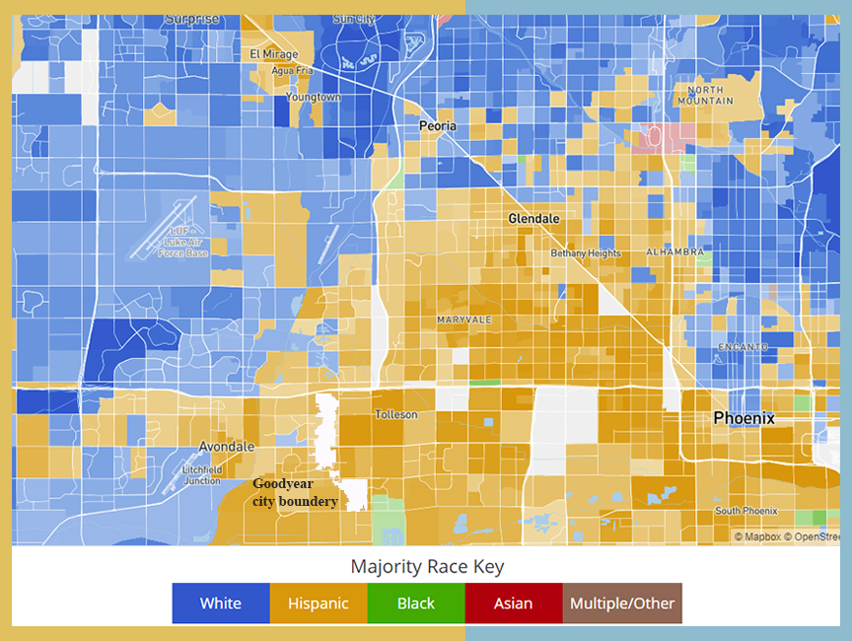

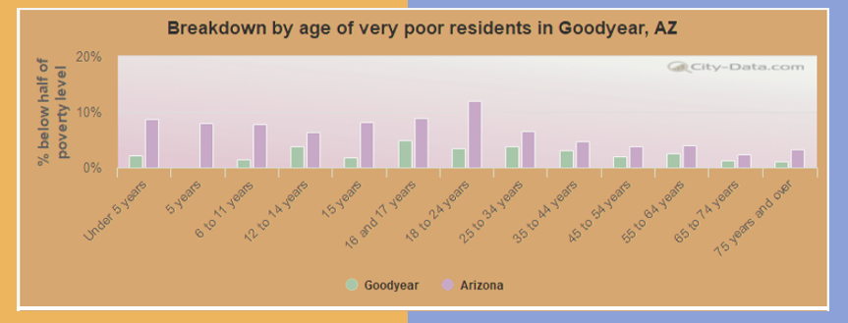

## Engagement Outcomes:

#### Steps taken for meaningful engagement:Due to the number of community members who confirmed to attend the Governor’s Office of Highway Safety (GOHS) meeting, it was determined that a virtual meeting would provide flexibility and accessibility for community members to provide feedback to State and City Officials regarding pedestrian and bicycle safety.

*ADOT Pedestrian data for the City of Goodyear (2018-2022)*

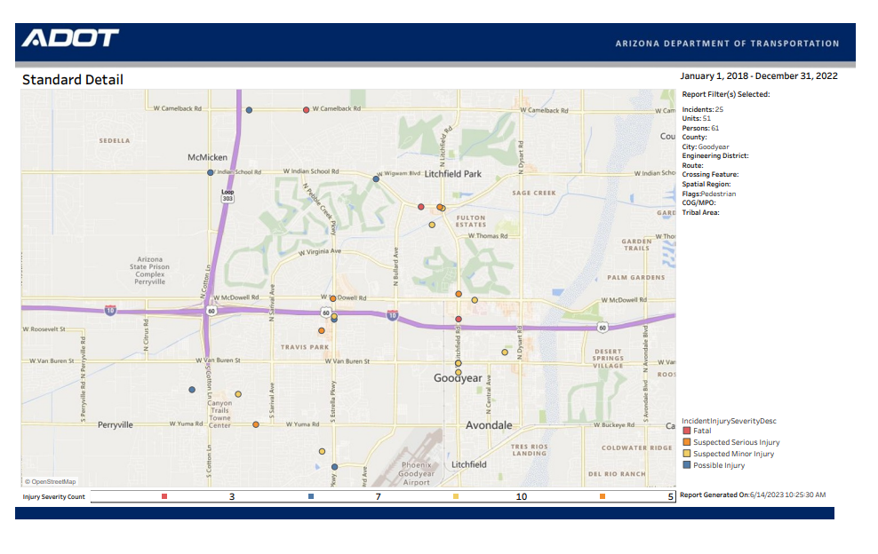

GOHS partnered with the City of Goodyear Police Department to address community concerns over the need for change in pedestrian/cyclist safety after an unfortunate event that occurred in the morning of February 25, 2023, when a truck crashed into a group of bicyclists, resulting in the death of two bicyclists and seventeen injured in the [**City of Goodyear**](https://www.abc15.com/traffic/multiple-people-hurt-after-vehicle-crashes-into-group-of-bicyclists-in-goodyear), Arizona. On February 27, 2023, a press conference was held by the Goodyear Police Department about the ongoing investigation into the tragic incident. During the press conference, the Chief summarized that safe roads and a safe community are top priorities for Goodyear PD.  In the past two years, the City of Goodyear has successfully had two major cycling events with zero incidents.

Locally, there was one fatality from 2018-2022 in the City of Goodyear. As of 2023 data, four more fatalities involving cyclists have occurred, an alarming increase. The traffic data has shown a significant increase in crashes involving pedestrians and cyclists within the Goodyear city limits and surrounding areas. As a result, the increase in crashes over the past three years has negatively affected those who live and work in Goodyear, causing significant concerns for City leadership and the community.

Unfortunately, this is not a local issue but a statewide and national issue impacting communities across the county. According to the Arizona Department of Transportation’s data from 2021, there were 1,027 crashes involving non-motorized bicycles, in which forty-five cyclists died.  Nationally, 938 cyclists were killed in collisions with motorized vehicles in 2020, according to [National Highway Traffic Safety Administration](https://www.nhtsa.gov/road-safety/bicycle-safety) (NHTSA) data.

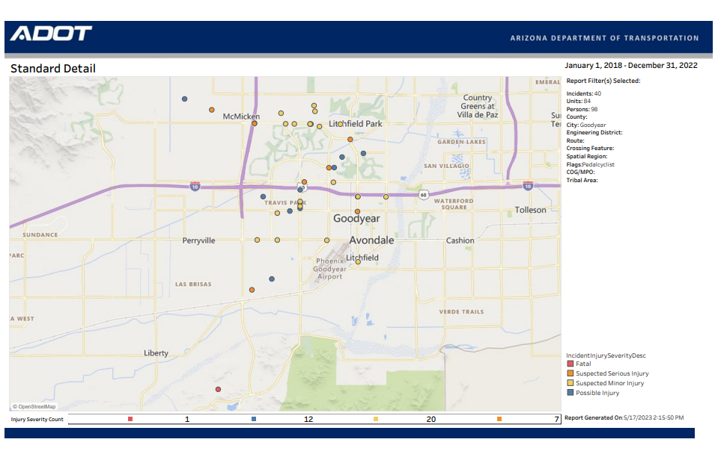

*ADOT Pedalcyclist data for the City of Goodyear (2018-2022)*

ADA Accessibility: Accessibility measures implemented included close caption on slides used during meeting and a local sign interpreter to ensure clear communication by GOHS. GOHS aims to be ADA-compliant; however, no interpreter was necessary during this meeting.

Attendees: On April 6, 2023, a virtual meeting was hosted by the West Valley Cycle Club (WVCC) and the Goodyear PD. WVCC was established in 2002 and is one of the city’s largest cycle clubs, with local and tour memberships of over 250 count as of FY2022.  Memberships vary in age groups, riding ability, and life experience. All meeting attendees identified as members of the bike club and lived within the city limits of Goodyear.

Attendees Feedback: During the meeting, a poll was conducted by the Chief of Police that asked attendees questions by a “raise of hands” button on the virtual forum. Of the meeting attendees, seventy percent have had close calls with vehicle/cycling crashes, and thirty percent of attendees have witnessed traffic incidents that involved cyclists within city limits. Ten percent of attendees did not participate in the survey.

Community members in attendance identified restricted visibility, excessive speeds from drivers, and driver impairment as key factors in the increase in incidents.  Several strategies were proposed, including education and public awareness through media-supported efforts; roadway safety enhancements such as improved street markings and street widening to accommodate larger groups cycling in hotspot areas; and designated officers or volunteers to be located along certain high-risk roads and bridges. Additionally, members expressed their willingness to assist in various capacities to expedite increased safety measures.

The above ideas will help guide the City’s traffic safety plans, thus, enhancing public education and awareness for safe driving amongst bicyclists.

Development of the 3HSP: Engaging the WVC will help us determine countermeasures relative to the City of Goodyear and the surrounding area. These countermeasures can be aligned with existing grantees that can support traffic safety in the specific region. GOHS aims to leverage partnerships with Goodyear and local community organizations like WVC to implement projects and initiatives to reduce and avoid safety risks for bicyclists.  With feedback GOHS received at the virtual community meeting, GOHS is increasing the media countermeasure within the pedestrian and bicycle strategy and will also use the feedback to inform the State’s project selection. Additionally, GOHS will work with ADOT in their Pedestrian and Bicycle program to organize and educate the community across the State of Arizona about safety issues and implement safety outreach strategies and materials for pedestrians, bicyclists, and motorists in the community.

## Ongoing engagement planning:

#### Engagement efforts:

#### Through focus groups, non-traditional events, and community meetings and surveys, the Governor’s Office of Highway Safety (GOHS) will engage state municipalities and surrounding populations across counties GOHS has identified as overrepresented/underserved in Pedestrian and Bicycle vehicle motor vehicle crashes.

#### Steps to reach and engage:

Based on community input from the Goodyear event regarding bicycle safety, GOHS aims to strengthen its outreach efforts focusing on pedestrian and bicycle safety. Using data from ADOT and NHTSA, GOHS plans on engaging with local municipalities, community organizations, and State partners where there’s a trend in pedestrian or bicycle incidents. GOHS will continue to partner with the City of Goodyear and work on expanding its reach to other communities, such as the City of Guadalupe. GOHS aims to continue leveraging existing relationships with the law enforcement community while expanding relationships with community organizations like the Coalition of Arizona Bicyclists, schools, and nonprofits that serve families. GOHS will continue working with State partners like the Arizona Department of Transportation and collaborate with new ones like the Youth and Family Services.

Through authentic community engagement, the plan is to reduce the number of serious injuries or deaths among pedestrians and bicyclists by 6% in the next three years. Further engagement strategies from GOHS include sponsorship and participation in community events, conducting surveys seeking public input, and funding public awareness initiatives and media campaigns. GOHS strives to be ADA-compliant and will take accessibility measures during engagement efforts. Additionally, GOHS will review any public phasing materials (website, brochures, grant applications) and revise them accordingly to ensure the information is accessible to all, and if providing funding support, ensure the process is streamlined and easy to navigate.

#### Affected community:

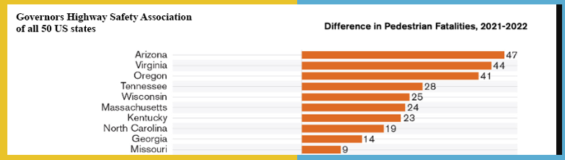According to the Federal Highway Administration report, the context for pedestrian crashes was as follows: Crossing Road, Walking with Traffic, Walking Against Traffic, Standing, Lying, Getting on/off Vehicle, Other, and Unknown. Crossing the road had the highest percentage of pedestrian accidents, accounting for 63.8% of all pedestrian crashes in Arizona in 2022. Although crossing the road is the highest contextual situation in which pedestrian accidents occur, driver error is the number one cause of Arizona pedestrian crashes. The last few years have seen an alarming rise in pedestrian fatalities. In 2010, 4,302 pedestrians were killed by US traffic, accounting for 13 percent of all traffic deaths. But by 2021, pedestrian deaths had increased by 77 percent to 7,624. Arizona tops the list of highest pedestrian fatalities from 2021 to 2022.

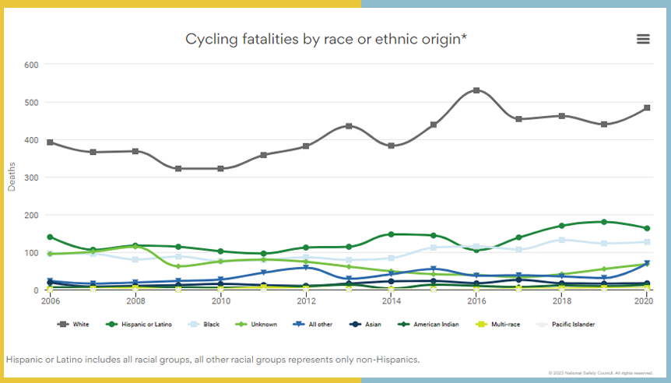

National trends indicates increases within cycling fatalities by race or ethnicityU.S. Department of Transportation Federal Highway Administration 2006 to 2020

#### Decision making:

GOHS will consult and involve the public in decision-making through various methods, including in-person meetings, surveys, or online feedback. With the input provided, GOHS will continuously assess and revise its engagement strategies to address pedestrian and bicycle safety within communities impacted. To ensure success, GOHS will build new partnerships with community groups, schools, and local governments to connect with communities within areas with a high risk for pedestrian and bicycle incidents.

# **Occupant Protection Public Participation and Engagement**

## Engagement Planning:

The Governor’s Office of Highway Safety (GOHS) will focus its efforts on Occupant Protection Safety through meaningful community engagement with the Salt River Pima-Maricopa Indian Community (SRPMIC) and its member districts of the tribe in Occupant Protection Safety. This partnership will help GOHS identify the appropriate countermeasures that best serve SRPMIC and the region. According to the National Highway Traffic Safety Administration (NHTSA) and the Bureau of Indian Affairs Indian Highway Safety Program, the overall seat belt use rate in Indian Country was 76% in 2020. Although belt use varies significantly across reservations, seat belt use among American Indians and Alaska Native persons at 76% is lower than that of the United States at 90%.

Additionally, child passenger restraint laws that require car seats and booster seats are not readily adhered or enforced on the SRPMIC reservation, placing children at a higher risk.  According to SRPMIC tribal police department, booster seat use for all children is required until at least age 9 years of age on the reservation.

Understanding these risk factors will guide GOHS to develop the appropriate safety countermeasure strategies to implement with the tribal community and local organizations.

*Identification of the affected and potentially affected communities:*

SRPMIC reservation and the eastern part of the City of Scottsdale have experienced increased traffic in the region, creating a high-risk environment for motor vehicle traffic and pedestrian accidents. The growing congestion on the regional freeway system, such as the Red Mountain Freeway (Loop 202) and Pima Freeway, causes drivers to look for shortcuts across SRPMIC. Another contributing element to the increased volume of vehicles in the area is the Talking Stick Resort Casino and commercial development on Pima Road. Suppose Pima Freeway is restricted due to a traffic incident. In that case, Pima Road is the primary traffic detour, which generates additional cut-through traffic across tribal reservation districts and school zones in the tribe, according to local law enforcement.

These conditions contribute to the disproportionate rate of car accident injuries among American Indians/Alaska Natives young adults compared with other Americans. Furthermore, tribal communities in rural areas will likely experience alcohol-related car accidents due to unsafe road conditions.

Arizona Preliminary Motor Vehicle Crash Data Analysis 2007-2016 states that the percentage of crashes off‐tribal land with known fatalities and/or incapacitating injuries is about 3.86 percent. On the other hand, the percentage of tribal land is about 6.95 percent or 80 percent higher. The percent of persons with known fatalities and/or incapacitating injuries in crashes on‐tribal land is 119 percent (3.88/1.77) higher than off tribal land.

Most notably, Native American children experience the highest injury death rates among all racial and ethnic groups in the United States. According to the CDC report on traffic crash death, rates among American Indian and Alaska Native children and youth aged 0–19 years were about 2 to 5 times higher than those of other racial and ethnic groups. Furthermore, the CDC reports 2 out of 3 passengers who died in crashes on reservations were not wearing seat belts at the time of the crash. These statistics are alarming factors that are impacting families on tribal reservations.

*Affected community:*

Additional information below highlights the risk factors separated by demographic groups.

The Fatality Analysis Reporting System (FARS) indicates a disproportional number of American Indians and Alaskan Native people are killed in traffic motor vehicle traffic accidents at a rate twice as much as any other ethnicity.

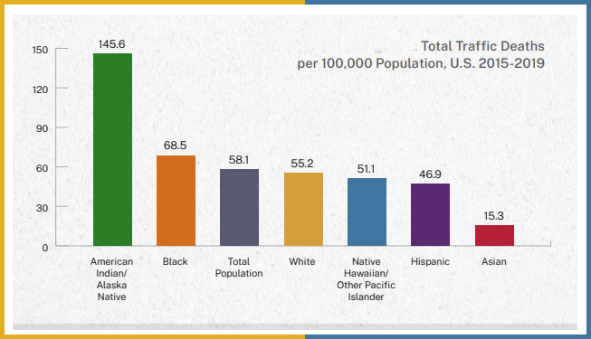

*Data:*

The map below shows majority race by area in the Phoenix area, as self-identified on the US census. Darker shades indicate a larger racial majority in that neighborhood. It should be noted in the Phoenix metro other population races are dominate while American Indian is marginal and underrepresented.

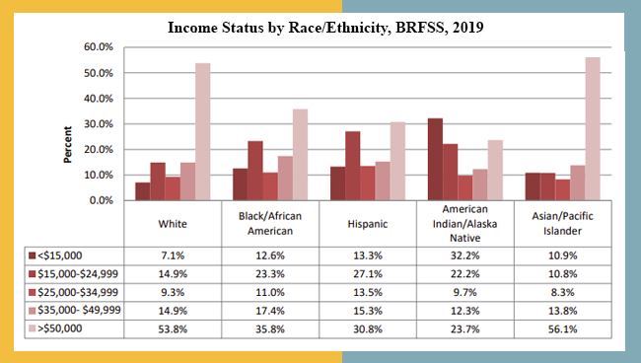Despite the vast wealth of natural resources on tribal lands, Native Americans remain the most impoverished demographic in the United States, partly because stringent rules on land development limit their ability to develop those resources. For the overall population, the estimated percentage living in poverty was highest among the AIAN population (12.4%)—compared to Black (11.3%), Hispanic (11.2%), and White non-Hispanic (5.7%)—regardless of the poverty measure used.

## Engagement Outcomes:

##### Steps taken for meaningful engagement: The relationship between the Salt River Pima Maricopa Indian Community (SRPMIC) and ADOT dates back nearly 60 years when the first State Freeway was built by ADOT within the SRPMIC in 1959. Since that time ADOT built the SR Loop 202 (and also interchange of the SR Loop 101 Pima Freeway and SR Loop 202 Red Mountain Freeway) and SR Loop 101, both with segments within the SRPMIC. These segments buildouts on the reservation have contributed to significant increases in traffic volume and a higher trend in vehicle and pedestrian crashes.

##### The Salt River Pima-Maricopa Indian Community is dominated by those under 18 years of age. The under-18 population accounts for 29.8 percent of all tribal members, representing a similar proportion for that age group compared to the State (25.5%) and Maricopa County (26.4%). The fact that almost one-third of the tribe is younger than 18 years of age carries with it important policy implications. The large portion of younger tribal members influences the provision of health and educational services as well as poverty and workforce issues as well. In 2010, there were 2,198 households on the Salt River Pima-Maricopa Indian Community, with an average household size of 2.9 persons and an average family size of 3.7 persons. The average household size of 2.9 persons is slightly larger than the State average (2.6 persons) and the County average (2.7 persons). The average family size for tribal members (3.7 persons), which is also larger than the State and the County, where the average is 3.2 and 3.3 persons respectively.

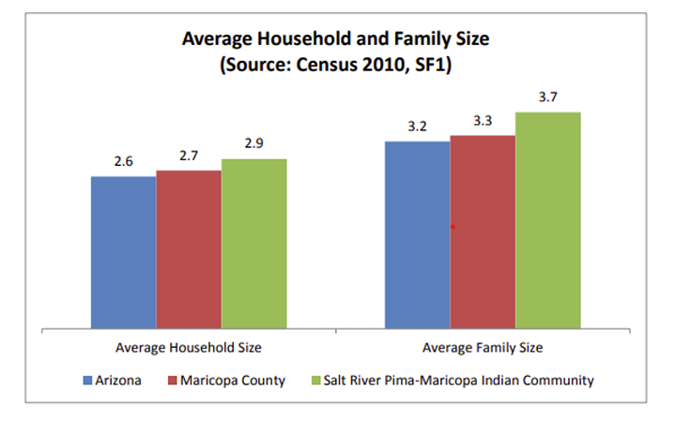

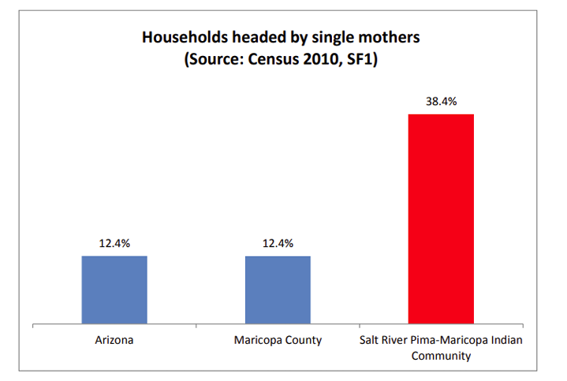Households on the Salt River Pima-Maricopa Indian Community are three times more likely to be headed by a female householder (38.4%) with no husband present. Households headed by single mothers are far less prevalent at the State or County (12.4% each). Households on the Salt River Pima-Maricopa Indian Community are as likely (34%) to have children under the age of 18 living in the household, as are households in the State (34%) and the County (34%).

GOHS has identified a direct correlation between the number of tribal member single mothers and children involved in vehicle crashes resulting in injury or death. The Salt River Police Department (SRPD), reported traffic data indicates a growing trend in Motor Vehicle Crashes (MVC) involving American Indian women ages 18 to 24 and children ages 2 to 14 years old. The Arizona Child Fatality Review Program Twenty-Ninth Annual Report dated November 15, 2022 seems to support this data. Motor Vehicle Crashes of American Indian children and Black children were disproportionately affected. American Indian made up 23% of MVC deaths but only 5% of the total population. Black children made up 20% of MVC deaths but only 6% of the total population. Hispanic children 46% with 45% of the total population and White children at 38% and 40% of the total population.

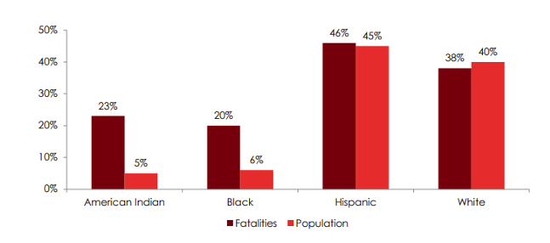

ADA Accessibility: Accessibility measures implemented included Native language interpreters from car seat technicians and inspectors during the child safety check event to ensure clear communication by GOHS. Although GOHS aims to be ADA-compliant, there was no need for an interpreter during this particular event. These measures reflect GOHS's commitment to making events accessible and inclusive for all attendees.

Attendees: The Early Childhood Education Center in the Salt River Pima/Maricopa Indian Community works with the O’Odham and Piipaash cultures. Parents and caregivers attended this event in the community. The Early Childhood Education center serves children from birth to 5 years of age in the affected community identified. Based on the surveys, GOHS showed 50% were parents and 50% were caregivers.

Attendees Feedback:During a child safety seat check event in June 2023, community feedback revealed a strong desire to improve safety measures for child passengers. 70% of the community already use child safety seats, but participants noted that the state needs to expand awareness campaigns for seatbelt use and child safety to reach more families. The event highlights the importance of listening to community needs to create effective strategies for improving child safety on the road.

Summary of issues: Issues addressed from the community in attendance at the event, identified lack of education and awareness, and addressed excessive speeds of drivers coming into the community. All attendees agreed that increased education, media supported efforts were needed. The need for improved enforcement, education and awareness in the areas of the community. Attendees mentioned possible designated officers or volunteers to be located along certain high-risk roads. Many of the community partners and members expressed their desire to assist GOHS in future safety level projects, in order assist in increased safety measures.

Development of the 3HSP: From the meaningful feedback GOHS received at the community child safety seat check event, GOHS is increasing the media countermeasure within the Occupant Protection safety countermeasure strategy and will also use the community feedback to inform the State’s project selection. GOHS is going to increase the funded amount on the ongoing media contract to provide specific education campaigns around seat belt and child safety seat awareness in the Salt River Pima/Maricopa Indian Community area. GOHS is also going to work with Native Health Services, Ak-Chin Indian Community, and Salt River Fire Department in their Occupant Protection programs to organize, educate the community about safety issues and produce safety outreach materials for Occupant Protection in the community. The countermeasures can be aligned with existing grantees that can support traffic safety in the specific region. GOHS’s goal is to achieve a clear understanding of the level of potential safety risk to Occupant Protection and increase partnerships with Salt River Indian Community leadership and local community organizations to implement projects that would help the communities increase this trend.

## Ongoing engagement planning:

#### Engagement efforts:

In Arizona, approximately 1,235 miles or twenty percent of the State’s highway system crosses tribal lands where many children from these communities are statistically involved in crashes. Additionally, families in tribal land are among underserved communities that face barriers to information access. For the next three years, GOHS will focus on improving transportation safety to reduce child death and serious injuries resulting from crashes.

The event GOHS participated in with the Salt River Indian Community is part of the Office’s commitment to meeting the community where they are at. GOHS aims to continue leveraging relationships with the law enforcement community while expanding and strengthening relationships with community organizations, schools, nonprofits, community block watches, and more. GOHS will continue working with State partners like the Arizona Department of Transportation and collaborate with new ones like the Youth and Family Services.

Through authentic community engagement, the plan is to reduce child restraint deaths and serious injuries by 6% in the next three years, thus improving transportation safety in tribal communities and nations.

#### Steps to reach and engage:

Strategies for meaningful engagement with Tribal communities require cultural sensitivity. A few essential things for GOHS staff to demonstrate cultural respect and sensitivity include:

* Invite tribal leaders and introduce them at the beginning of the meeting, starting with the highest elected official.
* Allow tribal representatives to review materials in advance before finalizing.
* Provide tribal members the opportunity to offer a prayer at the beginning of the meeting.
* Ensure team members know how to correctly pronounce the name of the tribe and any tribal facilities, towns, or geographic features.
* Seek approval from tribal representatives before the meeting before taking photos.

Further engagement strategies from GOHS include sponsorship and participation in community events, conducting surveys to track public engagement, and funding public awareness initiatives and media campaigns. GOHS strives to be ADA-compliant and will take accessibility measures during engagement efforts. Additionally, GOHS will review any public phasing materials (website, brochures, grant applications) and revise them accordingly to ensure the information is accessible to all, and if seeking applicants for funding support, ensure the process is streamlined and easy to navigate.

#### Affected community:

The overall seat belt use rate in Indian Country was 76% in 2020, according to the National Highway Traffic Safety Administration (NHTSA) and the Bureau of Indian Affairs Indian Highway Safety Program.4 Although belt use varies significantly across reservations, seat belt use among American Indians and Alaska Native persons (76%) 4 is lower than that of the United States (90%).

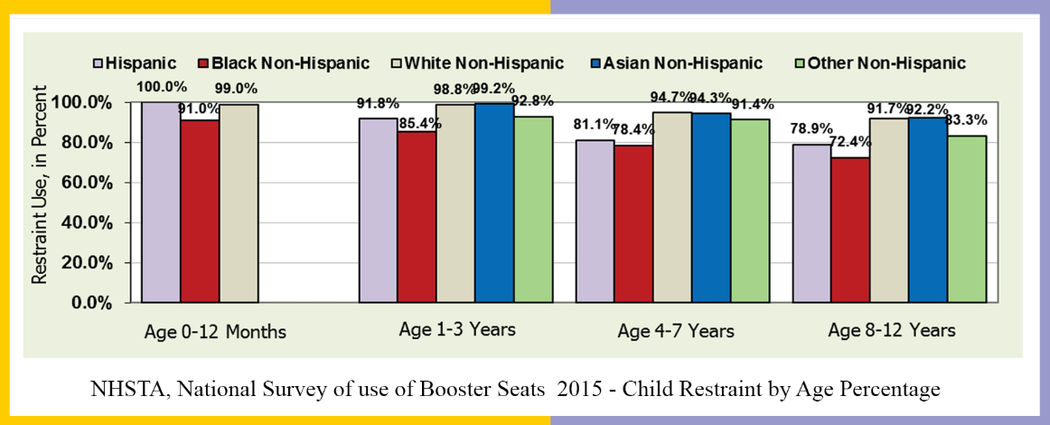American Indian and Alaska Native child safety and booster seat use rates are much lower than other racial and ethnic groups, although these rates vary significantly across reservations. Proper restraint use among American Indian and Alaska Native children age 7 years and younger ranged from 23% to 79% in a study by NHSTA.

GOHS identified overrepresented and underserved communities using the US Census Data survey conducted from 2010 to 2021.

#### Decision making:

GOHS will consult and involve the public in decision-making through various methods, including in-person meetings, surveys, or online feedback. GOHS will use this feedback from these communities to help determine countermeasures and project activities within our current and future programs. GOHS will continuously assess and revise its engagement strategies based on feedback and outcomes to address the child restraint issue within each county and develop educational tools to reach the affected community in each area. GOHS’ goal is to clearly understand the level of potential safety risk to occupant protection and leverage partnerships with the Salt River Indian Community leadership as well as Native Health Services and local community organizations to implement projects that will reduce this trend. GOHS will provide public engagement efforts in upcoming events starting in October 2023 with Native Health open house in the community to get feedback on all traffic safety issues, including occupant protection, and we strive to continue to build upon it.

# **Performance Plan Chart**

| **PERFORMANCE PLAN CHART –**  **FY24-26 Triennial Highway Safety Plan** | | | **BASE YEARS** | | | | | |
| --- | --- | --- | --- | --- | --- | --- | --- | --- |
|  | | | **2017** | **2018** | **2019** | **2020** | **2021** | **2022\*** |
| **C-1** | Traffic Fatalities (FARS) | FARS Annual | 998 | 1,011 | 979 | 1,053 | 1,180 | N/A |
|  | Reduce total fatalities by 6% from 1,293 in 2022 to a current safety level of 1,217.2 (2024-2026 rolling average) by 2026. | 5-Year Rolling Avg. | 894 | 926 | 967 | 999 | 1,044 | 1,103.2 |
| **C-2** | Serious Injuries in Traffic Crashes (ADOT) | State Annual | 4,207 | 3,790 | 3,627 | 3,108 | 3,851 | 3,752 |
|  | Reduce serious traffic injuries by 6% from 3,752 in 2022 to a current safety level of 3,476.3 (2024-2026 rolling average) by 2026. | 5-Year Rolling Avg. | 4,268 | 4,160 | 4,092 | 3,869 | 3,717 | 3,626 |
| **C-3** | Fatalities/100M VMT (FARS/FHWA) | FARS Annual | 1.53 | 1.53 | 1.39 | 1.60 | 1.60 | 1.75 |
|  | Reduce fatality rate by 6% from 1.75 in 2022 to a current safety level of 1.65 (2024-2026 rolling average) by 2026. | 5-Year Rolling Avg. | 1.40 | 1.42 | 1.46 | 1.50 | 1.53 | 1.57 |
| **C-4** | Unrestrained Passenger Vehicle Occupant Fatalities, All Seat Positions | State Annual | 229 | 213 | 214 | 218 | 290 | 272 |
|  | Reduce unrestrained passenger vehicle occupant fatalities, all seat positions by 6% from 272 in 2022 to a current safety level of 257 (2024-2026 rolling average) by 2026. | 5-Year Linear State trend | 287 | 270 | 260 | 241 | 233 | 241 |
| **C-5** | Alcohol-Impaired Driving Fatalities | FARS Annual* | 270 | 298 | 259 | 295 | 421 | N/A |
|  | Reduce alcohol-impaired driving fatalities by 6% from 421 in 2021 to a current safety level of 397 (2024-2026 rolling average) by 2026. | 5-Year Rolling Avg. | 240 | 256 | 268 | 273 | 309 | 318 |
| **C-6** | Speeding-Related Fatalities | State Annual | 306 | 303 | 310 | 353 | 371 | 425 |
|  | Reduce speeding-related fatalities by 6% from 425 in 2022 to a current safety level of 401 (2024-2026 rolling average) by 2026. | 5-Year Linear State trend | 285 | 292 | 307 | 317 | 329 | 352 |
| **C-7** | Motorcyclist Fatalities | State Annual | 161 | 154 | 170 | 161 | 167 | 227 |
|  | Reduce motorcyclist fatalities by 6% from 227 in 2022 to a current safety level of 214 (2024-2026 rolling average) by 2026. | 5-Year Linear State trend | 143 | 144 | 153 | 158 | 163 | 176 |
| **C-8** | Unhelmeted Motorcyclist Fatalities | State Annual | 71 | 67 | 76 | 75 | 76 | 80 |
|  | Reduce unhelmeted, motorcyclist fatalities by 6% from 80 in 2022 to a current safety level of 74 (2024-2026 rolling average) by 2026. | 5-Year Linear State trend | 69 | 67 | 71 | 73 | 73 | 75 |
| **C-9** | Drivers Age 20 or Younger involved in Fatal Crashes | State Annual | 116 | 107 | 101 | 118 | 150 | 151 |
|  | Reduce drivers age 20 and younger involved in fatal crashes by 6% from 151 in 2022 to a current safety level of 142 (2024-2026 rolling average) by 2026. | 5-Year Linear State trend | 104 | 101 | 104 | 109 | 118 | 125 |
| **C-10** | Pedestrian Fatalities | State Annual | 226 | 245 | 218 | 235 | 260 | 302 |
|  | Reduce pedestrian fatalities by 6% from 302 in 2022 to a current safety level of 284 (2024-2026 rolling average) by 2026. | 5-Year Linear State trend | 179 | 196 | 209 | 223 | 237 | 252 |

| **PERFORMANCE PLAN CHART –**  **FY24-26 Triennial Highway Safety Plan** | | | **BASE YEARS** | | | | | |
| --- | --- | --- | --- | --- | --- | --- | --- | --- |
| **2017** | **2018** | **2019** | **2020** | **2021** | **2022\*** |
| **C-11** | Bicyclist Fatalities | State Annual | 32 | 24 | 30 | 32 | 45 | 48 |
|  | Reduce bicyclist fatalities by 6% from 48 in 2022 from a current safety level to 45 (2024-2026 rolling average) by 2026. | 5-Year Linear State trend | 32 | 29 | 29 | 30 | 33 | 36 |
| **B-1** | Observed Seat Belt Use for Passenger Vehicles, Front Seat Outboard Occupants (State Survey) | State Annual | 86.1% | 85.9% | 90.6% | *90.6% | 88.8% | 87.0% |
|  | Increase observed seat belt use for passenger vehicles, front seat outboard occupants by 6% from 87.0% in 2022 from a current safety level to 91.0% by 2026. |  |  |  |  |  |  |  |

*\*Due to COVID-19 in FY 2020, Arizona did not do a Statewide Seat Belt Survey. AZ used the FY 2019 percentage.*

*\* FARS data not available for FFY 2022. ADOT State Crash facts is being used for 2022.*

*\* The difference between the requirements from pulling data from ADOT State Crash files, GOHS chose to default to use 2021 FARS for C-5.*

## Performance Measure: C-1) Number of traffic fatalities (FARS)

**Performance Target details**

|  |  |  |  |  |
| --- | --- | --- | --- | --- |
| **Performance Target** | **Target Metric Type** | **Target Value** | **Target Period** | **Target Start Year** |
| C-1) Number of traffic fatalities (FARS)  Reduce total fatalities by 6% from 1,293 in 2022 to a current safety level of 1,217.2 (2024-2026 rolling average) by 2026. | Numeric | 1,217.2 | 5 year | 2020 |

### Performance Target Justification

The chart below shows the 5-year rolling average target for 2024-2026 total traffic fatalities. The C-1 Core Performance Outcome Measure was established with ADOT and FHWA. FARS data from 2017 - 2021 and 2022 state crash data were analyzed to project annual traffic fatalities for calendar years 2024-2026. This projection was then calculated into a 5-year rolling average for 2020-2023. The 2024-2026 targets for Core Performance Measure, C-1, are 1,267.4 for 2024, 1,242.1 for 2025 and 1,217.2 for 2026 total traffic fatalities based on a 5-year rolling average for the years of 2019-2023. Several factors can influence highway safety targets, including the number of vehicles on the road, road design and conditions, weather, driver behavior, and enforcement of traffic laws. Effective collaboration between transportation agencies, law enforcement, and community organizations can also contribute to achieving highway safety targets. GOHS will fund priority programs to combat the rise of traffic fatalities on Arizona roadways.

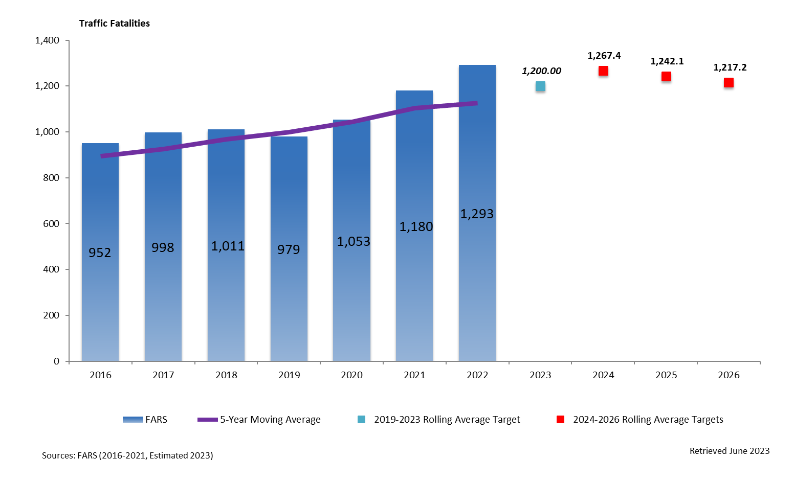

## Performance Measure: C-2) Number of serious injuries in traffic crashes (State crash data files)

**Performance Target details**

|  |  |  |  |  |
| --- | --- | --- | --- | --- |
| **Performance Target** | **Target Metric Type** | **Target Value** | **Target Period** | **Target Start Year** |
| C-2) Number of serious injuries in traffic crashes (State crash data files)  Reduce serious traffic injuries by 6% from 3,752 in 2022 to a current safety level of 3,476.3 (2024-2026 rolling average) by 2026. | Numeric | 3,476.3 | 5 Year | 2020 |

### Performance Target Justification

The chart below shows the 5-year rolling average target for 2024-2026 Serious Traffic Injuries. The C-2 Core Performance Outcome Measure was established with ADOT and FHWA. State crash data from 2018-2022 was analyzed to project annual serious traffic injuries for calendar years 2024-2026. This projection was then calculated in to a 5-year rolling average for the years of 2020-2024. The 2024-2026 targets for Core Performance Measure, C-2, are 3,619.6 for 2024, 3,547.2 for 2025 and 3,476.3 for 2026 serious traffic injuries based on the 5-year rolling average. Current trend projections show a decrease in serious traffic injuries through 2022. Several factors can influence highway safety targets, including the number of vehicles on the road, road design and conditions, weather, driver behavior, and enforcement of traffic laws. Effective collaboration between transportation agencies, law enforcement, and community organizations can also contribute to achieving highway safety targets. GOHS will prioritize programs that will help to lower serious injuries crashes.

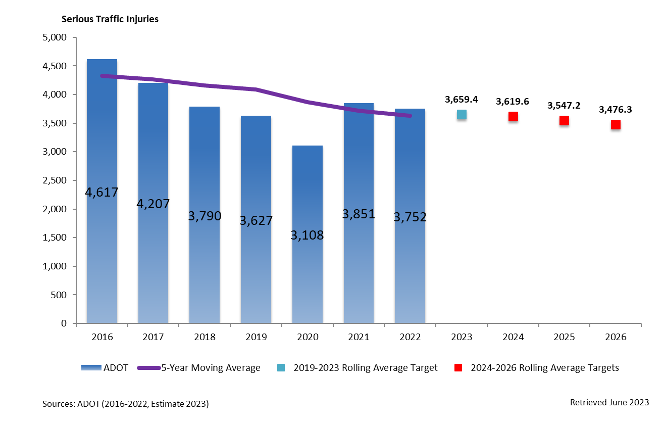

## Performance Measure: C-3) Fatalities/VMT (FARS, FHWA)

**Performance Target details**

|  |  |  |  |  |
| --- | --- | --- | --- | --- |
| **Performance Target** | **Target Metric Type** | **Target Value** | **Target Period** | **Target Start Year** |
| C-3) Fatalities/VMT (FARS, FHWA)  Reduce fatality rate by 6% from 1.75 in 2022 to a current safety level of 1.65 (2024-2026 rolling average) by 2026. | Numeric | 1.65 | 5 Year | 2020 |

### Performance Target Justification

The chart below shows the 5-year rolling average target for 2024-2026 fatalities per 100 million vehicle miles travelled (fatalities/VMT). The C-3 Core Performance Outcome Measure was established with ADOT and FHWA. FARS data from 2018-2022 and 2022 state crash data were analyzed to project annual fatalities/VMT rate for calendar years 2024-2026. This projection was then calculated in to a 5-year rolling average for the years of 2020-2024. The 2024-2026 targets for Core Performance Measure, C-3, are 1.72 for 2024, 1.69 for 2025 and 1.65 for 2026 fatalities/VMT based on the 5-year rolling average. Several factors can influence highway safety targets, including the number of vehicles on the road, road design and conditions, weather, driver behavior, and enforcement of traffic laws. Effective collaboration between transportation agencies, law enforcement, and community organizations can also contribute to achieving highway safety targets. GOHS will prioritize programs to combat the rise of traffic fatalities on Arizona roadways.

## Performance Measure: C-4) Number of unrestrained passenger vehicle occupant fatalities, all seat positions (STATE CRASH DATA FILES)

**Performance Target details**

|  |  |  |  |  |
| --- | --- | --- | --- | --- |
| **Performance Target** | **Target Metric Type** | **Target Value** | **Target Period** | **Target Start Year** |
| C-4) Number of unrestrained passenger vehicle occupant fatalities, all seat positions (STATE CRASH DATA FILES)  Reduce unrestrained passenger vehicle occupant fatalities, all seat positions by 6% from 272 in 2022 to a current safety level of 257 (2024-2026 rolling average) by 2026. | Numeric | 257 | 3 year | 2024 |

### Performance Target Justification

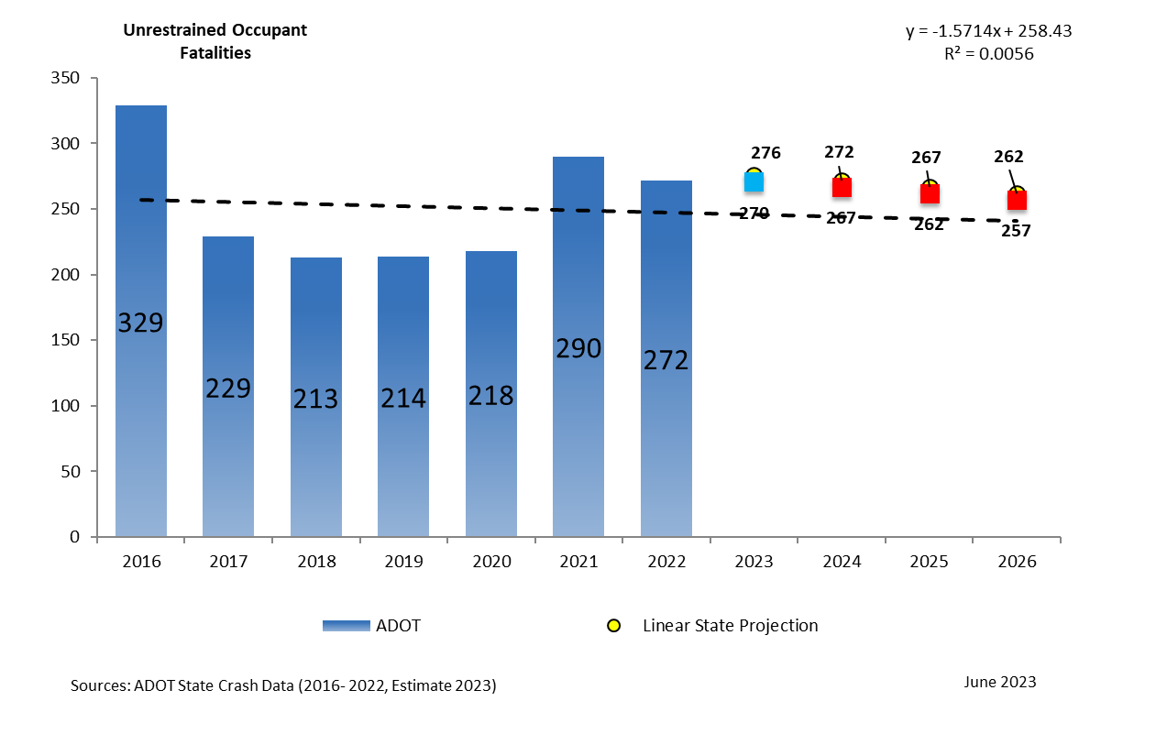GOHS developed a 3-year annual performance measure target by conducting a statistical forecasting analysis of 2016-2022 state fatality data. GOHS then conducts an annual linear state analysis of the data for each core performance measure to establish projected 2024-2026 numbers. GOHS has established an annual target reduction of 2% from current 2022 State Crash Data for 2024-2026. GOHS has set annual 2024-2026 targets of 267 for 2024, 262 for 2025 and 257 for 2026 for core performance measure C-4) unrestrained occupant vehicle fatalities. Several factors can influence highway safety targets, including the number of vehicles on the road, road design and conditions, weather, driver behavior, and enforcement of traffic laws. Effective collaboration between transportation agencies, law enforcement, and community organizations can also contribute to achieving highway safety targets. GOHS will fund HSP program areas through enforcement, public awareness, public participation, and engagement, along with education providing more grants for Occupant Protection to lower number of unrestrained occupant vehicle fatalities on Arizona roadways.

## Performance Measure: C-5) Number of fatalities in crashes involving a driver or motorcycle operator with a BAC of .08 and above (FARS DATA)

**Performance Target details**

|  |  |  |  |  |
| --- | --- | --- | --- | --- |
| **Performance Target** | **Target Metric Type** | **Target Value** | **Target Period** | **Target Start Year** |
| C-5) Number of fatalities in crashes involving a driver or motorcycle operator with a BAC of .08 and above (FARS DATA)  Reduce alcohol-impaired driving fatalities by 6% from 421 in 2021 to a current safety level of 397 (2024-2026 rolling average) by 2026. | Numeric | 397 | 3 year | 2024 |

### Performance Target Justification

GOHS developed a 3-year annual performance measure target by conducting a statistical forecasting analysis of 2016-2021 FARS fatality data. GOHS then conducts an annual linear state analysis of the data for each core performance measure to establish projected 2024-2026 numbers. The difference between the requirements from pulling data from ADOT State Crash files, GOHS chose to default to FARS to compute the performance target until there is sufficient data from ADOT to establish future trends. GOHS has established an annual target reduction of 2% from current 2021 FARS Data for 2024-2026. GOHS has set annual 2024-2026 targets of 413 for 2024, 405 for 2025 and 397 for 2026 for core performance measure C-5) number of fatalities in crashes involving a driver or motorcycle operator with a BAC of .08 and above. Several factors can influence highway safety targets, including the number of vehicles on the road, road design and conditions, weather, driver behavior, and enforcement of traffic laws. Effective collaboration between transportation agencies, law enforcement, and community organizations can also contribute to achieving highway safety targets. GOHS will fund HSP program areas through enforcement, public awareness initiatives, community participation, engagement and education to lower the number of alcohol-impaired fatalities on Arizona roadways.

## Performance Measure: C-6) Number of speeding-related fatalities (STATE CRASH DATA FILES)

**Performance Target details**

|  |  |  |  |  |
| --- | --- | --- | --- | --- |
| **Performance Target** | **Target Metric Type** | **Target Value** | **Target Period** | **Target Start Year** |
| C-6) Number of speeding-related fatalities (STATE CRASH DATA FILES)  Reduce speeding-related fatalities by 6% from 425 in 2022 to a current safety level of 401 (2024-2026 rolling average) by 2026. | Numeric | 401 | 3 year | 2024 |

### Performance Target Justification

GOHS developed a 3-year annual performance measure target by conducting a statistical forecasting analysis of 2016-2022 state fatality data. GOHS then conducts an annual linear state analysis of the data for each core performance measure to establish projected 2024-2026 numbers. GOHS has established an annual target reduction of 2% from current 2022 State Crash Data for 2024-2026. GOHS has set annual 2024-2026 targets of 417 for 2024, 409 for 2025 and 401 for 2026 for core performance measure C-6) number of speeding-related fatalities. Several factors can influence highway safety targets, including the number of vehicles on the road, road design and conditions, weather, driver behavior, and enforcement of traffic laws. Effective collaboration between transportation agencies, law enforcement, and community organizations can also contribute to achieving highway safety targets. GOHS will fund HSP program areas through enforcement, awareness, public participation, engagement and education to lower the number of speeding-related fatalities on Arizona roadways.

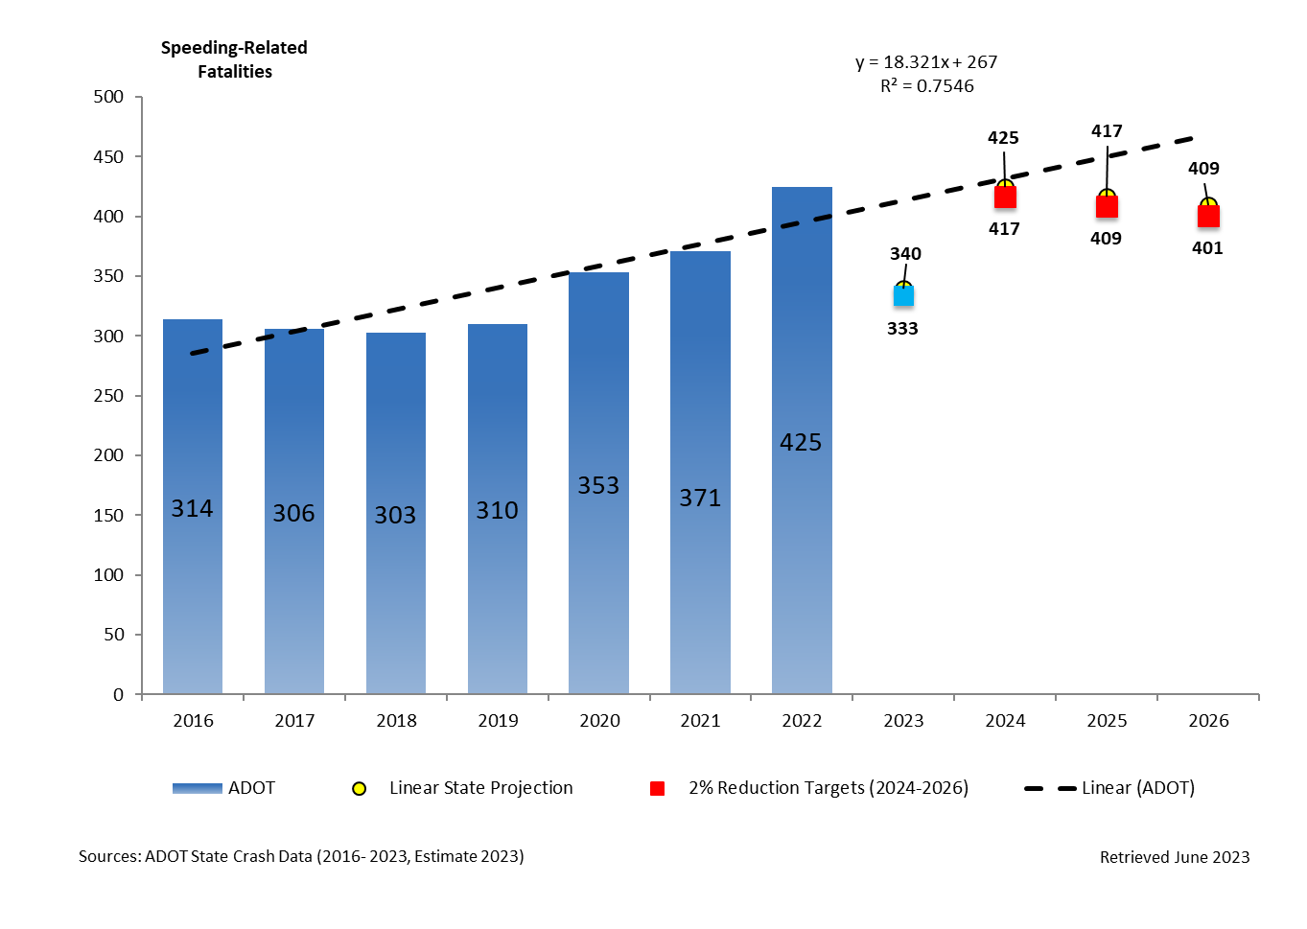

## Performance Measure: C-7) Number of motorcyclist fatalities (STATE CRASH DATA FILES)

**Performance Target details**

|  |  |  |  |  |
| --- | --- | --- | --- | --- |
| **Performance Target** | **Target Metric Type** | **Target Value** | **Target Period** | **Target Start Year** |
| C-7) Number of motorcyclist fatalities (STATE CRASH DATA FILES)  Reduce motorcyclist fatalities by 6% from 227 in 2022 to a current safety level of 214 (2024-2026 rolling average) by 2026. | Numeric | 214 | 3 year | 2024 |

### Performance Target Justification

GOHS developed a 3-year annual performance measure target by conducting a statistical forecasting analysis of 2016-2022 state fatality data. GOHS then conducts a linear state analysis of the data for each core performance measure to establish projected 2024-2026 numbers. GOHS has established an annual target reduction of 2% from current 2022 State Crash Data for 2024-2026. GOHS has set annual 2024-2026 targets of 222 for 2024, 218 for 2025 and 214 for 2026 for core performance measure C-7) Number of motorcyclist fatalities. Several factors can influence highway safety targets, including the number of vehicles on the road, road design and conditions, weather, driver behavior, and enforcement of traffic laws. Effective collaboration between transportation agencies, law enforcement, and community organizations can also contribute to achieving highway safety targets. GOHS will fund HSP program areas through enforcement, awareness, public engagement, and education to lower the number of motorcycle fatalities on Arizona roadways.

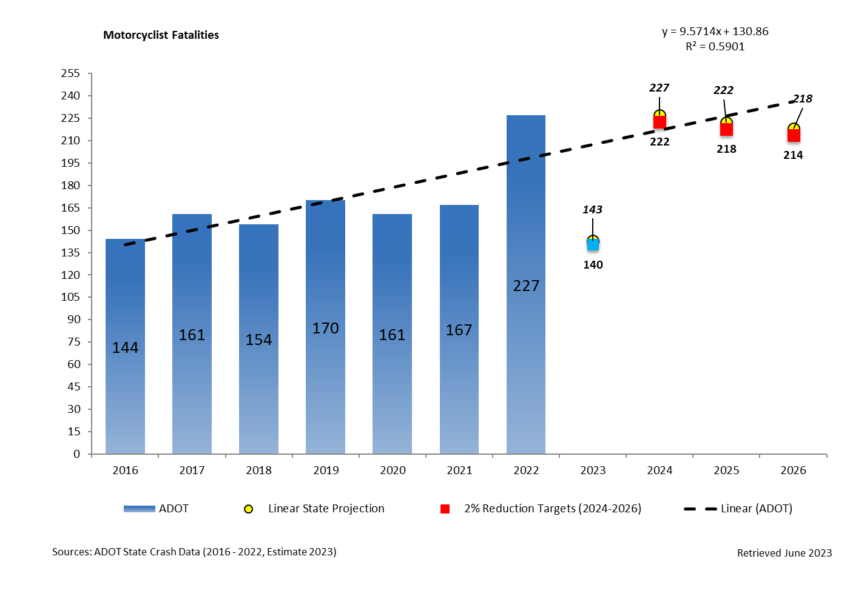

## Performance Measure: C-8) Number of unhelmeted motorcyclist fatalities (STATE CRASH DATA FILES)

**Performance Target details**

|  |  |  |  |  |
| --- | --- | --- | --- | --- |
| **Performance Target** | **Target Metric Type** | **Target Value** | **Target Period** | **Target Start Year** |
| C-8) Number of unhelmeted motorcyclist fatalities (STATE CRASH DATA FILES)  Reduce unhelmeted, motorcyclist fatalities by 6% from 80 in 2022 to a current safety level of 74 (2024-2026 rolling average) by 2026. | Numeric | 74 | 3 year | 2024 |

### Performance Target Justification

GOHS developed a 3-year annual performance measure target by conducting a statistical forecasting analysis of 2016-2022 state fatality data. GOHS then conducts a linear state analysis of the data for each core performance measure to establish projected 2024-2026 numbers. GOHS has established an annual target reduction of 2% from current 2022 State Crash Data for 2024-2026. GOHS has set annual 2024-2026 targets of 78 for 2024, 76 for 2025 and 74 for 2026 for core performance measure C-8) Number of unhelmeted motorcyclist fatalities. Several factors can influence highway safety targets, including the number of vehicles on the road, road design and conditions, weather, driver behavior, and enforcement of traffic laws. Effective collaboration between transportation agencies, law enforcement, and community organizations can also contribute to achieving highway safety targets. GOHS will continue to assist agencies through public awareness initiatives, community engagement, and education on the safety of helmet use with the goal of lowering the total number of unhelmeted motorcyclist fatalities.

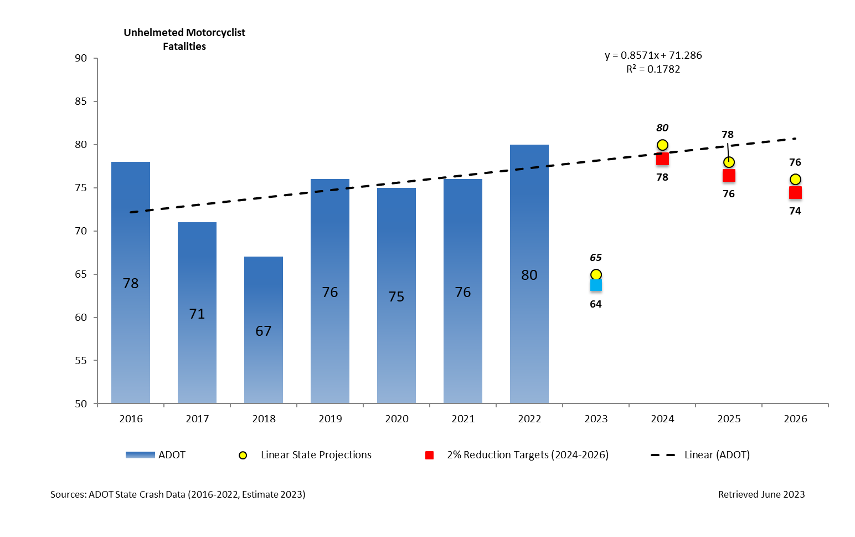

## Performance Measure: C-9) Number of drivers age 20 or younger involved in fatal crashes (STATE CRASH DATA FILES)

**Performance Target details**

|  |  |  |  |  |
| --- | --- | --- | --- | --- |
| **Performance Target** | **Target Metric Type** | **Target Value** | **Target Period** | **Target Start Year** |
| C-9) Number of drivers age 20 or younger involved in fatal crashes (STATE CRASH DATA FILES)  Reduce drivers age 20 and younger involved in fatal crashes by 6% from 151 in 2022 to a current safety level of 142 (2024-2026 rolling average) by 2026. | Numeric | 142 | 3 year | 2024 |

### Performance Target Justification

GOHS developed a 3-year annual performance measure target by conducting a statistical forecasting analysis of 2016-2022 state fatality data. GOHS then conducts a linear state analysis of the data for each core performance measure to establish projected 2024-2026 numbers. GOHS has established an annual target reduction of 2% from current 2022 State Crash Data for 2024-2026. GOHS has set annual 2024-2026 targets of 148 for 2024, 145 for 2025 and 142 for 2026 for core performance measure C-9) Number of drivers age 20 or younger involved in a fatal crash. Several factors can influence highway safety targets, including the number of vehicles on the road, road design and conditions, weather, driver behavior, and enforcement of traffic laws. Effective collaboration between transportation agencies, law enforcement, and community organizations can also contribute to achieving highway safety targets. GOHS will fund HSP program areas through public awareness initiatives, public engagement, and education to lower the number of drivers age 20 or younger involved in fatal crashes on Arizona roadways.

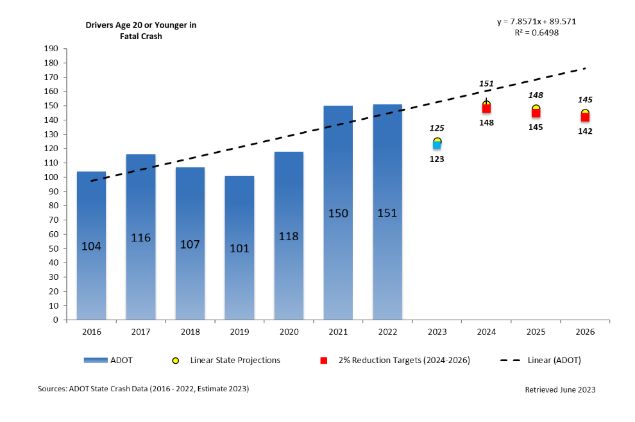

## Performance Measure: C-10) Number of pedestrian fatalities (STATE CRASH DATA FILES)

**Performance Target details**

|  |  |  |  |  |
| --- | --- | --- | --- | --- |
| **Performance Target** | **Target Metric Type** | **Target Value** | **Target Period** | **Target Start Year** |
| C-10) Number of pedestrian fatalities (STATE CRASH DATA FILES)  Reduce pedestrian fatalities by 6% from 302 in 2022 to a current safety level of 284 (2024-2026 rolling average) by 2026. | Numeric | 284 | 3 year | 2024 |

### Performance Target Justification

GOHS developed a 3-year annual performance measure target by conducting a statistical forecasting analysis of 2016-2022 state fatality data. GOHS then conducts a linear state analysis of the data for each core performance measure to establish projected 2024-2026 numbers. GOHS has established an annual target reduction of 2% from current 2022 State Crash Data for 2024-2026. GOHS has set annual 2024-2026 targets of 296 for 2024, 290 for 2025 and 284 for 2026 for core performance measure C-10) Number of pedestrian fatalities. Several factors can influence highway safety targets, including the number of vehicles on the road, road design and conditions, weather, driver behavior, and enforcement of traffic laws. Effective collaboration between transportation agencies, law enforcement, and community organizations can also contribute to achieving highway safety targets. GOHS will fund HSP program areas through enforcement, public awareness initiatives, public engagement, and education to lower pedestrian fatalities in Arizona.

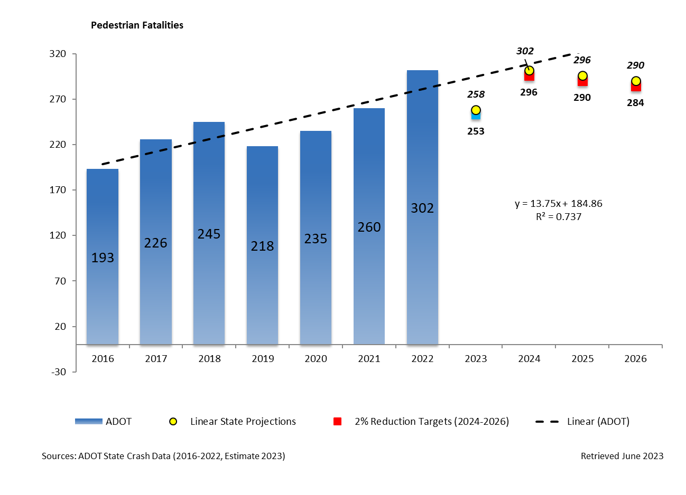

## Performance Measure: C-11) Number of bicyclists fatalities (STATE CRASH DATA FILES)

**Performance Target details**

|  |  |  |  |  |
| --- | --- | --- | --- | --- |
| **Performance Target** | **Target Metric Type** | **Target Value** | **Target Period** | **Target Start Year** |
| C-11) Number of bicyclists fatalities (STATE CRASH DATA FILES)  Reduce bicyclist fatalities by 6% from 48 in 2022 from a current safety level to 45 (2024-2026 rolling average) by 2026. | Numeric | 45 | 3 year | 2024 |

### Performance Target Justification

GOHS developed a 3-year annual performance measure target by conducting a statistical forecasting analysis of 2016-2022 state fatality data. GOHS then conducts a linear state analysis of the data for each core performance measure to establish projected 2024-2026 numbers. GOHS has established an annual target reduction of 2% from current 2022 State Crash Data for 2024-2026. GOHS has set annual 2024-2026 targets of 47 for 2024, 46 for 2025 and 45 for 2026 for core performance measure C-11) Number of bicyclist fatalities. Several factors can influence highway safety targets, including the number of vehicles on the road, road design and conditions, weather, driver behavior, and enforcement of traffic laws. Effective collaboration between transportation agencies, law enforcement, and community organizations can also contribute to achieving highway safety targets. GOHS will provide funds to help raise awareness, public engagement efforts, and education to reduce bicyclist fatalities.

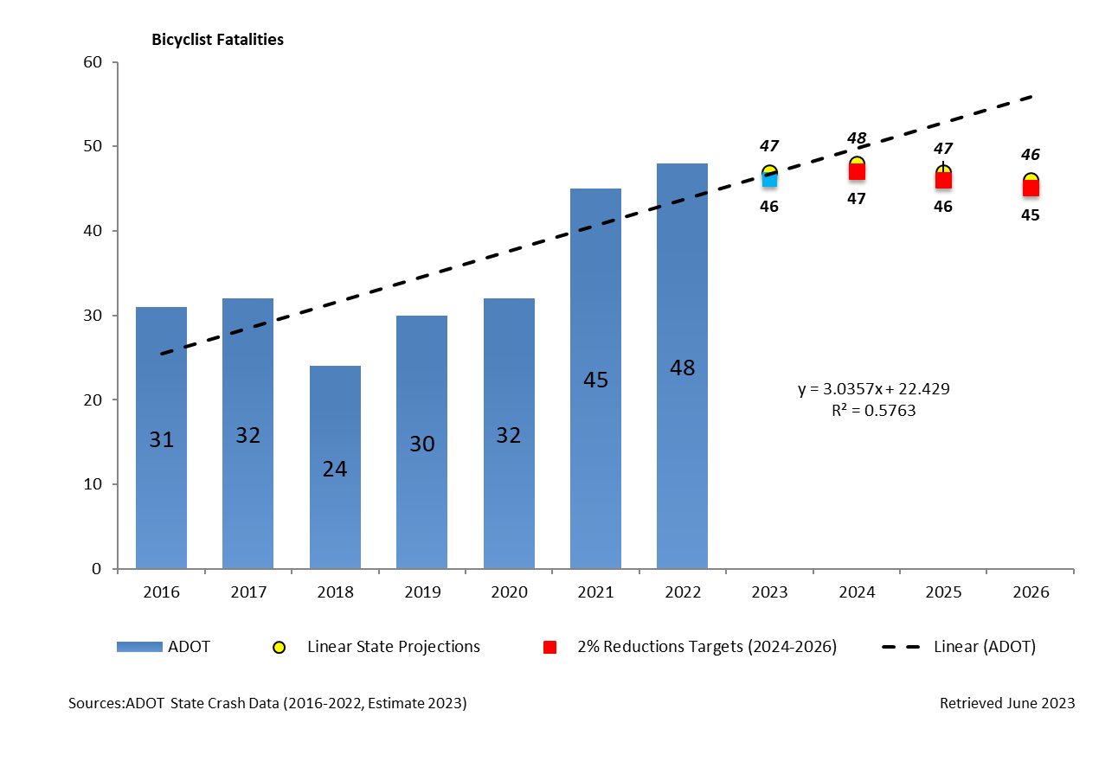

## Performance Measure: B-1) Observed seat belt use for passenger vehicles, front seat outboard occupants (survey)

**Performance Target details**

|  |  |  |  |  |
| --- | --- | --- | --- | --- |
| **Performance Target** | **Target Metric Type** | **Target Value** | **Target Period** | **Target Start Year** |
| B-1) Observed seat belt use for passenger vehicles, front seat outboard occupants (survey)  Increase observed seat belt use for passenger vehicles, front seat outboard occupants by 6% from 87.0% in 2022 from a current safety level to 91.0% by 2026. | Numeric | 91.0 | 3 year | 2024 |

## Performance Target Justification

GOHS developed a 3-year annual performance measure target by conducting a statistical forecasting analysis of 2016-2022 state fatality data. GOHS then conducts a linear state analysis of the data for each core performance measure to establish projected 2024-2026 numbers. GOHS has set annual 2024-2026 targets of 87% for 2024, 89% for 2025 and 91% for 2026 for core performance measure B-1) Observed seat belt use for passenger vehicles, front seat outboard occupants. Several factors can influence highway safety targets, including the number of vehicles on the road, road design and conditions, weather, driver behavior, and enforcement of traffic laws. Effective collaboration between transportation agencies, law enforcement, and community organizations can also contribute to achieving highway safety targets. GOHS will provide funds to the Occupant Protection program area to help raise awareness, support engagement, and education to increase seat belt usage in the state of Arizona.

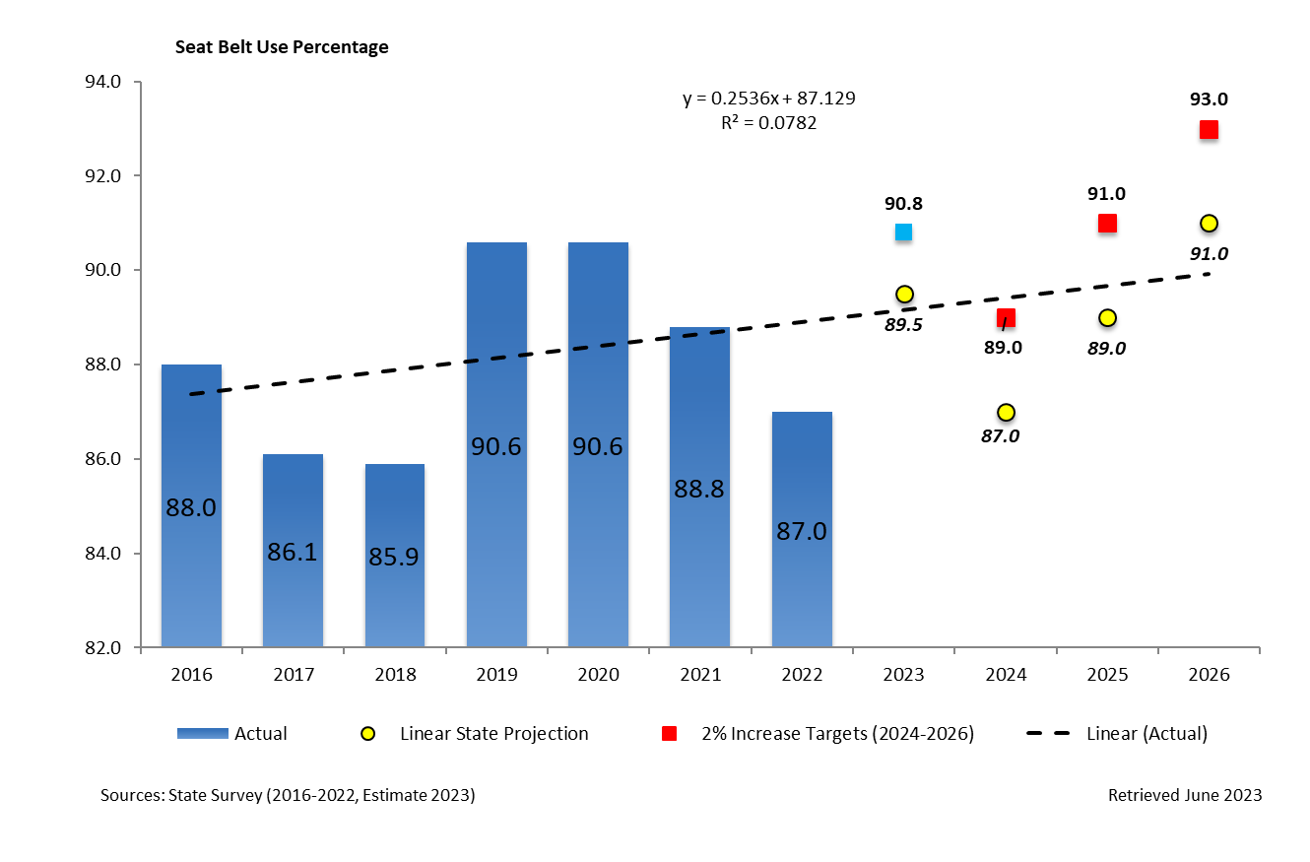

**Certification: State HSP performance targets are identical to the State DOT targets for common performance measures (fatality, fatality rate, and serious injuries) reported in the HSIP annual report, as coordinated through the State SHSP.**

I certify: **Yes**

**A-1) Number of seat belt citations issued during grant-funded enforcement activities\***

Seat belt citations: **24,126**

Fiscal Year A-1: **2022**

**A-2) Number of impaired driving arrests made during grant-funded enforcement activities\***

Impaired driving arrests: **30,303**

Fiscal Year A-2: **2022**

**A-3) Number of speeding citations issued during grant-funded enforcement activities\***

Speeding citations: **258,158**

Fiscal Year A-3: **2022**

# **Countermeasure Strategies for Programming funds:**

## ***Program Area: Impaired Driving (Drug and Alcohol)***

## Description of Highway Safety Problems

Addressing impaired driving, whether due to alcohol or drugs, is a critical focus area for enhancing highway safety in Arizona. The statistics from the 2021 Fatality Analysis Reporting System (FARS) data, which indicate that alcohol impairment was involved in 421 fatalities, underscore the urgent need for efforts to combat drug and alcohol abuse and prevent such crashes. The Arizona Governor's Office of Highway Safety (GOHS) plays a crucial role in providing ongoing support for impaired driving enforcement initiatives. Collaborating closely with law enforcement agencies, GOHS staff work to communicate the specific impaired driving issues affecting different areas of responsibility. This collaborative approach allows for a coordinated response to impaired driving across the state. Grantees, including law enforcement agencies, also play a vital role in combating impaired driving. They collaborate with local schools, civic groups, and media organizations to raise public awareness about the dangers of impaired driving and provide education opportunities. These initiatives aim to change behaviors, promote responsible decision-making, and discourage driving under the influence of alcohol or drugs.

To ensure effective allocation of resources, GOHS utilizes data collected on the GOHS Enforcement reporting website. This data helps inform the distribution of funding, allowing for targeted support of impaired driving enforcement needs throughout the state. By utilizing data-driven approaches, GOHS can maximize the impact of their efforts and allocate resources where they are most needed. The comprehensive approach, which involves law enforcement agencies, community organizations, schools, and media, creates a strong network to address impaired driving. Through ongoing education, public awareness campaigns, and targeted enforcement, Arizona can work towards reducing the number of alcohol-impaired fatalities and injuries on its highways, making roads safer for all motorists.

Road safety awareness campaigns and strict law enforcement measures are crucial in promoting responsible driving behaviors and preventing tragic incidents on the roads. GOHS recognizes the importance of allocating funding to support these efforts. GOHS allocates funding to both law enforcement and non-law enforcement agencies, including the state highway patrol and other state agencies. This funding allows them to participate in overtime enforcement details, dedicating additional resources to impaired driving enforcement. The provision of extra enforcement personnel during specific periods or events, such as holidays or weekends, can help deter impaired driving and increase the chances of detecting and apprehending offenders.

Additionally, GOHS funding enables agencies to purchase equipment specifically designed to enhance impaired driving enforcement. This may include tools and technologies such as breathalyzers, drug testing kits, and other equipment that aids in detecting and evaluating impairment accurately. By providing agencies with the necessary resources, GOHS supports their efforts to enforce impaired driving laws effectively. Combining road safety awareness campaigns with strict law enforcement measures creates a comprehensive approach to address impaired driving. Public education and awareness initiatives help in changing attitudes and behaviors regarding impaired driving, while law enforcement measures provide a deterrent effect and ensure the enforcement of impaired driving laws.

By allocating funding to support overtime enforcement details and the acquisition of specialized equipment, GOHS enhances the capacity of law enforcement agencies to combat impaired driving. This multi-faceted approach, coupled with effective enforcement and public education, contributes to promoting responsible driving behaviors and making Arizona's roads safer for everyone.

**Associated Performance Measures**

|  |  |  |  |  |
| --- | --- | --- | --- | --- |
| **Fiscal Year(s)** | **Performance measure/Target** | **Target End Year** | **Target Period** | **Target Value** |
| 2024-2026 | C-5) Number of fatalities in crashes involving a driver or motorcycle operator with a BAC of .08 and above (FARS) | 2026 | 3 Year | 397 |

**Countermeasure Strategies in Program Area**

|  |
| --- |
| **Countermeasure Strategy** |
| CTW - Chapter 1 Section 3.3 - Court Monitoring (3 stars) |
| CTW - Chapter 1. Section 3.1 - DWI courts (3 stars) |
| CTW - Chapter 1. Section 7.1 - Enforcement of Drug-Impaired Driving (3 stars) |
| CTW - Chapter 1. Section 2.1 - Publicized sobriety checkpoints (5 stars) |
| CTW - Chapter 1. Section 2.2 - High visibility saturation patrols (4 stars) |
| CTW - Chapter 1. Section 2.3 – Preliminary Breath Test Devices (4 stars) |
| Youth and Awareness Programs (1 star) - NHTSA Uniform Guidelines #8 – School-based prevention programs, beginning in elementary school and continuing through college and trade school, should play a critical role in preventing underage drinking and impaired driving. These programs should be developmentally appropriate, culturally relevant and coordinated with drug prevention and health promotion programs. |

## Countermeasure Strategy: Court Monitoring

Program Area: **Impaired Driving (Drug and Alcohol)**

### Countermeasure and justification

In court monitoring programs, citizens observe, track, and report on DWI court or administrative hearing activities. Court monitoring provides data on how many cases are dismissed or pled down to lesser offenses, how many result in convictions, what sanctions are imposed, and how these results compare across different judges and different courts. Court monitoring programs usually are operated and funded by citizen organizations such as Mothers Against Drunk Driving (MADD). Court monitoring programs inform GOHS, nonprofits, the TSRP, and others about prosecution and adjudication practices. The main requirement for a court monitoring program is a reliable supply of monitors. Monitors typically are unpaid volunteers from MADD, Remove Intoxicated Drivers (RID), or a similar organization.

Court monitoring is a 3-star countermeasure in CTW and was informed by the uniform guidelines #8 issued in accordance with 23 U.S.C. 402(a)(2). These guidelines served as a framework for identifying effective countermeasures based on evidence-based research and best practices. By aligning the countermeasure strategy with the uniform guidelines and drawing on the insights from NHTSA-facilitated programmatic assessments, GOHS ensures that its approach is well-informed, evidence-based, and in compliance with federal regulations. This collaboration with federal guidelines and assessments strengthens the overall effectiveness and impact of the state's traffic safety initiatives.

* CTW Chapter 1 Section 3.3 - Court Monitoring - Shinar (1992) found that court-monitored cases in Maine produced higher conviction rates and stiffer sentences than unmonitored cases. Probst et al. (1987) found that judges, prosecutors, and other officials in 51 communities believed that court monitoring programs helped increase DWI arrests, decrease plea agreements, and increase guilty pleas.

When determining which projects to fund for implementing the countermeasure strategy, GOHS will consider several key factors. These considerations will include 1) Public Engagement to gather community input and understand their concerns regarding traffic safety. This will help GOHS identify specific needs and priorities of the community being served and ensure funded projects align with their expectations; 2) - Traffic Safety data to analyze crash data, traffic volume, and historical trends, identify high-risk areas, prevalent traffic violations, and patterns of unsafe behaviors. This data-driven approach will help prioritize projects based on the severity and frequency of incidents; 3) Directly affected communities impacted by traffic safety issues. Understanding the unique challenges different communities face will guide the countermeasure strategy; 4) Areas such as intersections, highways, or neighborhoods that experience a higher volume of accidents or unsafe behaviors. By focusing on these locations, GOHS can strategically allocate resources to address the most critical areas; and 5) Solicitation of Proposals from relevant stakeholders, including government agencies, nonprofit organizations, and community groups will encourage diverse project ideas, innovation, and collaboration in addressing traffic safety concerns.

These factors will guide GOHS to make informed decisions about funding projects that effectively address the identified traffic safety issues and positively impact the affected communities. This data-driven approach shows a dedication to making Arizona's roads safer.

### Funding sources

|  |  |
| --- | --- |
| **Funding Source** | **Estimated 3-year Funding allocation** |
| BIL 405d Impaired Driving Mid | $262,500.00 |

## Countermeasure Strategy: DWI Courts

Program Area: **Impaired Driving (Drug and Alcohol)**

### Countermeasure and justification

The Arizona GOHS TSRP program provides comprehensive support for DUI and impaired driving enforcement through training programs for law enforcement personnel, prosecutors, judges, interns, and community members. The program also coordinates speakers for events and conferences, helping to promote knowledge and awareness of impaired driving issues. With its innovative approach and broad-based support, the TSRP is a valuable resource for addressing impaired driving in Arizona and beyond. Arizona’s TSRP program has focused on four primary objectives:

* + Provide training to prosecutors, law enforcement and other traffic safety professionals;
  + Be a resource for prosecutors and the traffic safety community statewide;
  + Improve communication; and
  + Be a liaison.

The TSRP assists prosecutors statewide in the adjudication of impaired driving cases. The TSRP focuses on two goals: 1) increase the visibility of traffic safety cases with prosecutors and prosecutors’ visibility within the traffic safety community and 2) increase the confidence of prosecutors in the courtroom. GOHS will continue to fund the TSRP program as the education provided is essential for law enforcement and prosecutors who must provide testimony in DUI court cases.

DWI Courts is a 3-star countermeasure in CTW and was informed by the uniform guidelines #8 issued in accordance with 23 U.S.C. 402(a)(2). These guidelines served as a framework for identifying effective countermeasures based on evidence-based research and best practices. By aligning the countermeasure strategy with the uniform guidelines and drawing on the insights from NHTSA-facilitated programmatic assessments, GOHS ensures that its approach is well-informed, evidence-based, and in compliance with federal regulations. This collaboration with federal guidelines and assessments strengthens the overall effectiveness and impact of the state's traffic safety initiatives.

* CTW Chapter 1. Section 3.1 – DWI courts - Traffic Safety Resource Prosecutors (TSRPs) are professionals with prosecutorial experience who specialize in the prosecution of traffic crimes, and DWI cases in particular. They provide training, education, and technical support to other prosecutors and law enforcement agencies within their State.

When determining which projects to fund for implementing the countermeasure strategy, GOHS will consider several key factors. These considerations will include 1) Public Engagement to gather community input and understand their concerns regarding traffic safety. This will help GOHS identify specific needs and priorities of the community being served and ensure funded projects align with their expectations; 2) - Traffic Safety data to analyze crash data, traffic volume, and historical trends, identify high-risk areas, prevalent traffic violations, and patterns of unsafe behaviors. This data-driven approach will help prioritize projects based on the severity and frequency of incidents; 3) Directly affected communities impacted by traffic safety issues. Understanding the unique challenges different communities face will guide the countermeasure strategy; 4) Areas such as intersections, highways, or neighborhoods that experience a higher volume of accidents or unsafe behaviors. By focusing on these locations, GOHS can strategically allocate resources to address the most critical areas; and 5) Solicitation of Proposals from relevant stakeholders, including government agencies, nonprofit organizations, and community groups will encourage diverse project ideas, innovation, and collaboration in addressing traffic safety concerns.

These factors will guide GOHS to make informed decisions about funding projects that effectively address the identified traffic safety issues and positively impact the affected communities. This data-driven approach shows a dedication to making Arizona's roads safer.

### Funding sources

|  |  |
| --- | --- |
| **Funding Source** | **Estimated 3-year Funding Allocation** |
| BIL 405d Impaired Driving Mid | $354,000.00 |

## Countermeasure Strategy: Enforcement of Drug-Impaired Driving

Program Area: **Impaired Driving (Drug and Alcohol)**

### Countermeasure and justification

In 2021, Arizona law enforcement agencies made approximately over 1.13 million traffic stops and over 32,000 DUI arrests. Though Arizona has some of the toughest impaired driving laws in the country, there is an alarming increase in arrests stemming from drug impaired driving. Prescription drug abuse is an epidemic and “medical marijuana” is legal. As drugged driving has become more prevalent, arrests have increased dramatically, from about 1,153 in 2009 to over 8,700 in 2021, a 654% increase in over 11 years. This increase is more likely due to the focus on drugged driving recognition training (DRE) for law enforcement. The State has a cadre of superbly trained officers in alcohol- and drug-impaired driver detection, but the challenges continue. Most law enforcement training in drugged driving recognition is through the Advanced Roadside Impaired Driving Enforcement (ARIDE) course. This course is targeted at NHTSA Standardized Field Sobriety Test (SFST) certified officers.

It is HIGHLY recommended that every law enforcement agency send as many officers as possible to the 16-hour courses. GOHS purchased Arizona's own customized AZ DRE Data Entry Management System (AZDDEMS), which is a web-based application. This application is accessed on a computer or using a 10-inch tablet. The tablets will be purchased and remain the property of GOHS. This application was purchased from the Institute for Traffic Safety Management & Research (ITSMR) and the 3-year license agreement is with ITSMR and The Research Foundation for The State University of New York (SUNY). Every DRE in the state has access to this application. One of the main benefits of AZDDEMS is that data entered into our AZDDEMS will automatically upload into the NHTSA system.

Eventually, every DRE will be issued and use a tablet for their DRE evaluation. GOHS plans an implementation process for purchasing, training and equipping every DRE with a tablet. GOHS devotes significant resources toward the training of officers in areas such as Standardized Field Sobriety Test (SFST), Drug Recognition Expert (DRE), Horizontal Gaze Nystagmus (HGN), DUI report writing and testimony, law enforcement phlebotomy, Advanced Roadside Impaired Driving Enforcement (ARIDE), and Drug Impairment Training for Educational Professionals (DITEP). As a result, Arizona continues to be a national leader in the DRE program. Consequently, Arizona provides training to law enforcement officials from other states and countries. GOHS has funded DRE Certification Nights hosted by the Maricopa County Sheriff’s Office (MCSO) for law enforcement officials for over a dozen other states, and are now hosting the return of DRE students from Canada. Arizona’s robust DRE Certification Night program has proven to be successful.

GOHS has provided funding in support of law enforcement training programs, conference speakers with special training knowledge, and conference registrations to provide necessary updates for Arizona’s DREs, as well as funding training for law enforcement phlebotomists. Arizona takes drugged driving impairment seriously and to date all Department of Public Safety officers are mandated to attend ARIDE training. GOHS also conducts training for prosecutors and judges on DUI law issues through the Arizona Prosecuting Attorneys Advisory Council and the Arizona Supreme Court.

Enforcement of Drug-Impaired driving is a 3-star countermeasure in CTW and was informed by the uniform guidelines #8 issued in accordance with 23 U.S.C. 402(a)(2). These guidelines served as a framework for identifying effective countermeasures based on evidence-based research and best practices. By aligning the countermeasure strategy with the uniform guidelines and drawing on the insights from NHTSA-facilitated programmatic assessments, GOHS ensures that its approach is well-informed, evidence-based, and in compliance with federal regulations. This collaboration with federal guidelines and assessments strengthens the overall effectiveness and impact of the state's traffic safety initiatives.

* CTW Chapter 1. Section 7.1 - Enforcement of Drug-Impaired Driving - Several studies have shown DRE judgments of drug impairment are corroborated by toxicological analysis in 85% or more of cases (NHTSA, 1996). However, one experimental laboratory study found DREs' ability to distinguish between impaired and non-impaired people was moderate to poor for several types of drugs including marijuana, codeine, and amphetamines (Shinar et al., 2000). This study showed DREs tended to rely on just one or two “pivotal” cues to identify specific drug impairment. A study of the drug evaluation and classification program determined that a combination of cues could provide higher levels of true positives in DRE identification of cannabis consumption (Hartman et al., 2016). These cues included metrics from physiological tests (finger-to-nose test, one-leg stand, and the walk-and-turn) and visual indicators (eyelid tremors). The findings suggest that there are certain differentiating cues for use by DREs in discerning cannabis consumption, though the relation to driving impairment is still unclear. To date there have been no studies examining the effectiveness of enforcement in reducing drug-impaired driving or crashes. Research has been focused on the impact of decriminalization and legalization of marijuana on several aspects of the DWI system, including prevalence and enforcement. See the joint report by NHTSA, GHSA, and the Volpe National Transportation Systems Center (2017) and Otto et al. (2016) for comparative discussions across States.

When determining which projects to fund for implementing the countermeasure strategy, GOHS will consider several key factors. These considerations will include 1) Public Engagement to gather community input and understand their concerns regarding traffic safety. This will help GOHS identify specific needs and priorities of the community being served and ensure funded projects align with their expectations; 2) - Traffic Safety data to analyze crash data, traffic volume, and historical trends, identify high-risk areas, prevalent traffic violations, and patterns of unsafe behaviors. This data-driven approach will help prioritize projects based on the severity and frequency of incidents; 3) Directly affected communities impacted by traffic safety issues. Understanding the unique challenges different communities face will guide the countermeasure strategy; 4) Areas such as intersections, highways, or neighborhoods that experience a higher volume of accidents or unsafe behaviors. By focusing on these locations, GOHS can strategically allocate resources to address the most critical areas; and 5) Solicitation of Proposals from relevant stakeholders, including government agencies, nonprofit organizations, and community groups will encourage diverse project ideas, innovation, and collaboration in addressing traffic safety concerns.

These factors will guide GOHS to make informed decisions about funding projects that effectively address the identified traffic safety issues and positively impact the affected communities. This data-driven approach shows a dedication to making Arizona's roads safer.

### Funding sources

|  |  |
| --- | --- |
| **Funding Source** | **Estimated 3-year Funding Allocations** |
| BIL 405d Impaired Driving Mid | $1,460,000.00 |
| BIL NHTSA 402 | $345,000.00 |

## Countermeasure Strategy: High Visibility Enforcement/Saturation Patrols/Checkpoints

Program Area: **Impaired Driving (Drug and Alcohol)**

### Countermeasure and justification

GOHS developed a strategic, statewide impaired driving task force which includes members from state, county, local, and tribal law enforcement personnel in addition to non-law enforcement agencies. The strategic task force works to increase impaired driver recognition training for law enforcement personnel and enhance enforcement efforts in addition to identifying best practices to increase public awareness and education about the dangers and consequences of impaired driving. The strategic task force coordinates with law enforcement agencies statewide to encourage the implementation of additional high-visibility enforcement impaired driving efforts such as saturation patrols, and Task Force details. Each agency schedules enforcement details specific to the impaired driving issues in their respective areas. Overtime details include sobriety checkpoints as well as saturation patrols and DUI Task Force details set up to address holiday and special event enforcement. Staffing for the overtime details includes full time officers, deputies, and detention officers who detect, evaluate, arrest, and process impaired drivers.

It's commendable that GOHS is prioritizing resources and efforts to address impaired driving and reduce the number of alcohol and drug-related fatalities on Arizona's roads. The strategies mentioned, such as overtime enforcement, equipment provision, and training for law enforcement officers, are effective approaches to tackling this issue. By increasing the number of DUI arrests, law enforcement can apprehend impaired drivers and prevent potential accidents. Furthermore, education, training, and public awareness initiatives play a crucial role in changing behavior and promoting responsible driving. By informing the public about the dangers of impaired driving and the potential legal and economic consequences, GOHS can contribute to creating a safer environment on the roads.

High-Visibility Saturation Patrols is a 4-star countermeasure, Publicized sobriety checkpoints is a 5-star countermeasure and Preliminary Breath Test Devices is a 4-star countermeasure in CTW and were informed by the uniform guidelines #8 issued in accordance with 23 U.S.C. 402(a)(2). These guidelines served as a framework for identifying effective countermeasures based on evidence-based research and best practices. By aligning the countermeasure strategy with the uniform guidelines and drawing on the insights from NHTSA-facilitated programmatic assessments, GOHS ensures that its approach is well-informed, evidence-based, and in compliance with federal regulations. This collaboration with federal guidelines and assessments strengthens the overall effectiveness and impact of the state's traffic safety initiatives.

* CTW Chapter 1. Section 2.1 - Publicized sobriety checkpoints - Checkpoints must be highly visible and publicized extensively to be effective. Communication and enforcement plans should be coordinated. Messages should clearly and unambiguously support enforcement. Paid media may be necessary to complement news stories and other earned media, especially in a continuing checkpoint program. See Fell et al. (2013) for additional recommendations concerning checkpoint visibility.
* CTW Chapter 1, Section 2.2 - High visibility saturation patrols - As with sobriety checkpoints, saturation patrols should be highly visible and publicized extensively to be effective in deterring impaired driving. Communication and enforcement plans should be coordinated. Messages should clearly and unambiguously support enforcement. Paid media may be necessary to complement social media, news stories, and other earned media, especially in a continuing saturation patrol program (Goodwin et al., 2005, Strategy B1).
* CTW Chapter 1, Section 2.3 - Breath test Devices – Law enforcement officers generally agree that breath test devices are useful. Sixty-nine percent of the 2,731 LEOs surveyed by Simpson and Robertson (2001) supported greater breath test devices availability and use. Breath test devices are especially valuable for two classes of drivers who may appear to perform normally on many tasks: drivers with high tolerance to alcohol (Simpson & Robertson, 2001) and drivers under 21 who may be in violation of zero-tolerance laws (Ferguson et al., 2000). A breath test device also can be useful at crash scenes where a driver is injured and unable to perform an SFST. There is some evidence that breath test devices use increases DWI arrests and reduces alcohol-involved fatal crashes (Century Council, 2008).

When determining which projects to fund for implementing the countermeasure strategy, GOHS will consider several key factors. These considerations will include 1) Public Engagement to gather community input and understand their concerns regarding traffic safety. This will help GOHS identify specific needs and priorities of the community being served and ensure funded projects align with their expectations; 2) - Traffic Safety data to analyze crash data, traffic volume, and historical trends, identify high-risk areas, prevalent traffic violations, and patterns of unsafe behaviors. This data-driven approach will help prioritize projects based on the severity and frequency of incidents; 3) Directly affected communities impacted by traffic safety issues. Understanding the unique challenges different communities face will guide the countermeasure strategy; 4) Areas such as intersections, highways, or neighborhoods that experience a higher volume of accidents or unsafe behaviors. By focusing on these locations, GOHS can strategically allocate resources to address the most critical areas; and 5) Solicitation of Proposals from relevant stakeholders, including government agencies, nonprofit organizations, and community groups will encourage diverse project ideas, innovation, and collaboration in addressing traffic safety concerns.

These factors will guide GOHS to make informed decisions about funding projects that effectively address the identified traffic safety issues and positively impact the affected communities. This data-driven approach shows a dedication to making Arizona's roads safer.

### Funding sources

|  |  |
| --- | --- |
| **Funding Source** | **Estimated 3-year Funding allocation** |
| BIL 405d Impaired Driving Mid | $5,565,000.00 |
| BIL NHTSA 402 | $3,750,000.00 |
| BIL 405d Impaired Driving Int | $445,000.00 |

## Countermeasure Strategy: Youth and Awareness Programs

Program Area: **Impaired Driving (Drug and Alcohol)**

Countermeasure and justification

Law enforcement agencies and fire departments are using "mock crashes" to educate high school students about the risks of underage drinking. Non-profit organizations are also implementing programs to educate students on the dangers of impaired driving. The success of pilot programs has led to the implementation of wider educational initiatives, aimed at reducing the rate of alcohol-related accidents among young people. As a result, high school students are becoming increasingly aware of the risks associated with underage drinking and are learning to make smarter choices when it comes to driving under the influence. Educating citizens on DUI laws and promoting alternative transportation or a designated sober driver can help reduce the risk of crashes related to drunk driving. General awareness programs can also remind students of the dangers of driving after drinking. These messages require regular reinforcement to ensure that individuals don't forget the importance of making safe choices when it comes to drinking and driving. Overall, promoting responsible and preventative behavior can save lives and prevent unnecessary harm to others on the road.

The Know Your Limit program, started in 2009 as a pilot program, which educates individuals on responsible drinking habits, has become a weekly campaign for law enforcement agencies working with GOHS. The program has been implemented during high-profile events such as the Super Bowl and NCAA competitions. The initiative helps prevent drunk driving and promotes safe drinking practices. States and communities have conducted extensive youth drinking-and-driving-prevention programs over the past 25 years. These programs seek to motivate youth not to drink, not to drink and drive, and not to ride with a driver who has been drinking. GOHS currently partners with over 30 agencies in providing the Know Your Limit program. Each year, new agencies are provided funding to conduct campaigns in their city or county.

Youth Programs is a 1-star countermeasure in CTW and was informed by the uniform guidelines #8 issued in accordance with 23 U.S.C. 402(a)(2). These guidelines served as a framework for identifying effective countermeasures based on evidence-based research and best practices. By aligning the countermeasure strategy with the uniform guidelines and drawing on the insights from NHTSA-facilitated programmatic assessments, GOHS ensures that its approach is well-informed, evidence-based, and in compliance with federal regulations. This collaboration with federal guidelines and assessments strengthens the overall effectiveness and impact of the state's traffic safety initiatives.

* CTW Chapter 1, Section 6.5 – Youth Programs - This countermeasure involves youth drinking-and-driving prevention programs that seek to motivate youth not to drink, not to drink and drive, and not to ride with drivers who have been drinking. Although some programs use scare tactics, many employ positive messages and methods by providing positive role models that discourage alcohol use, promoting positive norms that do not involve alcohol, and encouraging youth activities that do not involve or lead to alcohol use.
* Highway Safety Program Guideline #8 - East state should conduct community-based programs that implement prevention strategies at the local level through a variety of settings, including schools, employers, medical and health care professionals, community coalitions and traffic safety programs. - School-based prevention programs, beginning in elementary school and continuing through college and trade school, should play a critical role in preventing underage drinking and impaired driving. These programs should be developmentally appropriate, culturally relevant and coordinated with drug prevention and health promotion programs.

When determining which projects to fund for implementing the countermeasure strategy, GOHS will consider several key factors. These considerations will include 1) Public Engagement to gather community input and understand their concerns regarding traffic safety. This will help GOHS identify specific needs and priorities of the community being served and ensure funded projects align with their expectations; 2) - Traffic Safety data to analyze crash data, traffic volume, and historical trends, identify high-risk areas, prevalent traffic violations, and patterns of unsafe behaviors. This data-driven approach will help prioritize projects based on the severity and frequency of incidents; 3) Directly affected communities impacted by traffic safety issues. Understanding the unique challenges different communities face will guide the countermeasure strategy; 4) Areas such as intersections, highways, or neighborhoods that experience a higher volume of accidents or unsafe behaviors. By focusing on these locations, GOHS can strategically allocate resources to address the most critical areas; and 5) Solicitation of Proposals from relevant stakeholders, including government agencies, nonprofit organizations, and community groups will encourage diverse project ideas, innovation, and collaboration in addressing traffic safety concerns.

These factors will guide GOHS to make informed decisions about funding projects that effectively address the identified traffic safety issues and positively impact the affected communities. This data-driven approach shows a dedication to making Arizona's roads safer.

### Funding Sources

|  |  |
| --- | --- |
| **Funding Source** | **Estimated 3-year Funding Allocation** |
| BIL 405d Impaired Driving Mid | $840,000.00 |
| BIL NHTSA 402 | $705,000.00 |

## ***Program Area: Police Traffic Services***

## Description of Highway Safety Problems

According to 2022 State crash data, 425 speeding-related fatalities occurred. Speeding-related fatalities accounted for approximately 33 percent of all traffic fatalities in 2022. Throughout the year, the public becomes aware of the frequency of individuals being apprehended for driving under the influence and ponders the hazards presented by these impaired drivers on our roads and highways. However, there appears to be a lack of public awareness regarding the risks associated with speeding motorists. Excessive speed collisions result in numerous tragic incidents. Arizona's expansive roads provide an environment where drivers frequently exceed the designated speed limits, engage in lane changes without caution, tailgate, and dangerously overtake others during daily commutes. Regrettably, some drivers disregard the fundamental principles of safe driving, which revolve around using common sense and demonstrating courtesy.

In Arizona, there has been an alarming increase in criminal incidents occurring on state roadways and highways, involving car clubs unlawfully obstructing traffic and disrupting travel lanes to engage in various illegal activities. These activities include street racing, reckless and aggressive driving, endangering others, impaired driving, and attempting to evade law enforcement, along with numerous other traffic-related violations. In a proactive measure, the Governor's Office of Highway Safety (GOHS) has forged partnerships with local municipal and county law enforcement agencies to take decisive action against illegal street racing and ensure strict enforcement of state laws. The high volume of vehicles engaging in these activities at intersections and on freeways poses a grave threat to the safety of valley residents who commute on our city streets and freeways.

Law enforcement officers are supported by robust statutes that regulate speeding and reckless driving, bolstering their efforts to maintain road safety. Arizona has implemented a "Double Fine" program specifically designed to combat persistent speeding and reckless driving infractions in construction zones. Under this program, drivers who accumulate eight or more points within a 12-month period face the suspension of their driver's license as a consequence. This serves as a strong deterrent to discourage such dangerous driving behaviors. The "Double Fine" program is extended to address cases of exceeding the posted speed limit in construction zones while workers are present. While enforcement plays a crucial role in deterring speeders, the involvement of prosecutors and the courts is equally vital for effective adjudication. It is important to emphasize that posted speed limits are not mere suggestions; they hold the force of law.

Driving at reasonable and prudent speeds necessitates recognizing the inherent dangers posed to oneself and others by speeding. Arizona takes a proactive approach to prosecute and adjudicate red light violators. To support law enforcement agencies, GOHS not only funds overtime for the Selective Traffic Enforcement Program (STEP) but also provides resources such as laser and radar guns, speed trailers, and enforcement vehicles. These initiatives aim to enhance the overall enforcement efforts and promote road safety.

**Associated Performance Measures**

|  |  |  |  |  |
| --- | --- | --- | --- | --- |
| **Fiscal Year** | **Performance measure name** | **Target End Year** | **Target Period** | **Target Value** |
| 2024-2026 | C-6) Number of speeding-related fatalities (State crash data files) | 2026 | 3 Year | 401 |

**Countermeasure Strategies in Program Area**

|  |
| --- |
| **Countermeasure Strategy** |
| Uniform guidelines for state highway safety programs #18 - Crash Investigation - Each State should establish procedures that require the reporting of motor vehicle crashes and incidents to the responsible State agency within a reasonable time after the occurrence. |
| CTW – Chapter 3, Section 2.2 - High Visibility Enforcement (2 stars) |
| CTW – Chapter 3, Section 2.3 - Other Enforcement methods (2 stars) |
| CTW – Chapter 3, Section 4.1 – Communications and Outreach supporting enforcement (3 stars) |

## Countermeasure Strategy: Crash Investigation

Program Area: **Police Traffic Services**

### Countermeasure and justification

With the evolving technologies in both vehicles and crash investigation equipment, it is imperative to ensure that investigators receive updated training to effectively investigate fatal accidents. Alongside the utilization of advanced equipment, providing overtime to partnering agencies becomes crucial in assisting smaller police departments in efficiently conducting thorough crash scene investigations. This additional support contributes to accessing high-level expertise and plays a vital role in securing successful prosecutions, if required, related to the incident. By prioritizing ongoing training and collaborative efforts, law enforcement agencies can enhance their capabilities in handling complex accident cases and ensuring justice.

As the population in Arizona steadily grows, leading to a corresponding rise in the number of vehicles on the roads, the potential for fatal crashes also escalates. To address this challenge, offering advanced crash investigation training becomes crucial for law enforcement agencies and court prosecutors. Equipping them with enhanced skills and knowledge allows for the construction of stronger cases in the prosecution of vehicular crimes. The Vehicular Crime Units (VCU) detectives within the Maricopa County Sheriff's Office play a pivotal role in this regard by extending assistance to smaller law enforcement agencies in handling fatal crash investigations. This collaborative support enables the smaller agencies to expedite the investigation process and clear crash scenes in a more timely manner, thereby ensuring effective and efficient handling of these incidents.

Crash Investigation area grants play a pivotal role in enhancing the capabilities of Vehicular Crime Units (VCU) detectives in investigating fatal and serious injury collisions. These grants provide essential funding for the acquisition of advanced equipment, materials, and supplies necessary for the agencies to employ cutting-edge crash measuring and documentation systems. This enables them to effectively reconstruct collisions and determine causation, thereby facilitating subsequent criminal prosecutions. Moreover, the funding supports both in-state and out-of-state training opportunities for VCU personnel, ensuring they receive the most up-to-date training and stay abreast of the latest trends in the field of collision reconstruction. Additionally, the grants allocate overtime funding to agencies, allowing them to provide assistance to other political subdivisions in conducting thorough crash investigations. This comprehensive approach empowers VCU detectives and collaborating agencies to deliver thorough and accurate investigations in their pursuit of justice.

Crash Investigations was informed by the uniform guidelines #18 issued in accordance with 23 U.S.C. 402(a)(2). This guideline served as a framework for identifying effective countermeasures based on evidence-based research and best practices. By aligning the countermeasure strategy with the uniform guidelines and drawing on the insights from NHTSA-facilitated programmatic assessments, GOHS ensures that its approach is well-informed, evidence-based, and in compliance with federal regulations. This collaboration with federal guidelines and assessments strengthens the overall effectiveness and impact of the state's traffic safety initiatives.

* Highway Safety Uniform guideline #18 - Crash Investigation - Each State should establish procedures that require the reporting of motor vehicle crashes and incidents to the responsible State agency within a reasonable time after the occurrence.

When determining which projects to fund for implementing the countermeasure strategy, GOHS will consider several key factors. These considerations will include 1) Public Engagement to gather community input and understand their concerns regarding traffic safety. This will help GOHS identify specific needs and priorities of the community being served and ensure funded projects align with their expectations; 2) - Traffic Safety data to analyze crash data, traffic volume, and historical trends, identify high-risk areas, prevalent traffic violations, and patterns of unsafe behaviors. This data-driven approach will help prioritize projects based on the severity and frequency of incidents; 3) Directly affected communities impacted by traffic safety issues. Understanding the unique challenges different communities face will guide the countermeasure strategy; 4) Areas such as intersections, highways, or neighborhoods that experience a higher volume of accidents or unsafe behaviors. By focusing on these locations, GOHS can strategically allocate resources to address the most critical areas; and 5) Solicitation of Proposals from relevant stakeholders, including government agencies, nonprofit organizations, and community groups will encourage diverse project ideas, innovation, and collaboration in addressing traffic safety concerns.

These factors will guide GOHS to make informed decisions about funding projects that effectively address the identified traffic safety issues and positively impact the affected communities. This data-driven approach shows a dedication to making Arizona's roads safer.

### Funding sources

|  |  |
| --- | --- |
| **Funding Source** | **Estimated 3-year Funding Allocation** |
| BIL NHTSA 402 | $2,000,000.00 |

## Countermeasure Strategy: High Visibility Enforcement

Program Area: **Police Traffic Services**

### Countermeasure and Justification

Traffic law enforcement plays a crucial role in deterring impaired driving, promoting seat belt usage, ensuring compliance with speed limits, and reducing unsafe driving behaviors. To optimize their efforts, law enforcement agencies have adopted a selective approach, concentrating maximum enforcement in specific areas and during specific times. It has been observed that many crashes are either caused or exacerbated by drivers who fail to comply with traffic laws related to speed and distracted driving. The effectiveness of enforcement can be enhanced when drivers perceive a substantial likelihood of being cited for violations. Visible enforcement programs have proven effective in increasing drivers' awareness of the risks associated with speeding and distracted driving, thereby deterring such behaviors on the road. By employing visible enforcement strategies, law enforcement agencies can significantly contribute to promoting safer driving practices and reducing road accidents. GOHS offers support for Selective Traffic Enforcement Programs (STEP), which are ongoing traffic enforcement campaigns implemented by law enforcement agencies throughout the year. These programs focus on enforcing speed limits, addressing reckless driving, curbing red light running, and combating DUI offenses. Law enforcement funding is allocated based on several criteria, including: a) Agencies with a demonstrated history of actively and vigorously enforcing traffic laws in Arizona; b) Agencies that have experienced a high number of fatalities attributed to speeding or reckless driving incidents and; c) Agencies implementing innovative speed management and reckless driving enforcement initiatives.

By providing financial support to these selected agencies, GOHS aims to bolster their capacity to enforce traffic laws effectively and reduce the occurrence of traffic-related fatalities and injuries. This collaborative approach encourages law enforcement agencies to implement strategic measures and programs that target specific traffic safety concerns in their respective jurisdictions.

High Visibility Enforcement is a 2-star countermeasure in CTW and was informed by the uniform guidelines #19 issued in accordance with 23 U.S.C. 402(a)(2). These guidelines served as a framework for identifying effective countermeasures based on evidence-based research and best practices. By aligning the countermeasure strategy with the uniform guidelines and drawing on the insights from NHTSA-facilitated programmatic assessments, GOHS ensures that its approach is well-informed, evidence-based, and in compliance with federal regulations. This collaboration with federal guidelines and assessments strengthens the overall effectiveness and impact of the state's traffic safety initiatives.

* CTW Chapter 1, Section 6.5 – High-visibility enforcement campaigns have been used to deter speeding and aggressive driving through specific and general deterrence. In the HVE model, law enforcement targets certain high-crash or high-violation geographical areas using either expanded regular patrols or designated aggressive driving patrols. The objective is to convince the public that speeding and aggressive driving actions are likely to be detected and that offenders will be arrested and punished.
* Highway Safety Program Guideline #19 – Enforcement is critical to achieve compliance with speed limits. More than half of all traffic stops result from speeding violations, and public support for speed enforcement activities depends on the confidence of the public that speed enforcement is fair, rational, and motivated by safety concerns. The State should provide the leadership, training, and technical assistance necessary to:
* Support speed enforcement operations that:
  + Compliment a comprehensive speed management program including traffic engineering, enforcement, judiciary, and public support;
  + Strategically address speeders, locations, and conditions most common or most hazardous in speeding-related crashes; and
  + Support the national commercial motor vehicle safety enforcement program;
* Integrate speed enforcement into related highway safety and priority enforcement activities such as impaired driving prevention, safety belt use, motorcycle rider training, and other injury control activities;
* Provide speed enforcement guidelines that promote driver compliance with appropriately set speed limits;
* Coordinate speed enforcement programs with educational and media communication activities;
* Ensure the accuracy and reliability of speed-measuring devices used during speed enforcement operations through compliance with the appropriate performance specifications and established testing protocols;
* Ensure the knowledge, skills, and abilities of law enforcement officers involved in speed enforcement activities through comprehensive speed management training and appropriate speed-measuring device operator training programs; and
* Promote the proper use of automated speed enforcement programs, application of automated speed enforcement technologies, and compliance with automated speed enforcement implementation guidelines designed to deter speeding effectively and to prohibit revenue generation beyond reasonable operational cost.

When determining which projects to fund for implementing the countermeasure strategy, GOHS will consider several key factors. These considerations will include 1) Public Engagement to gather community input and understand their concerns regarding traffic safety. This will help GOHS identify specific needs and priorities of the community being served and ensure funded projects align with their expectations; 2) - Traffic Safety data to analyze crash data, traffic volume, and historical trends, identify high-risk areas, prevalent traffic violations, and patterns of unsafe behaviors. This data-driven approach will help prioritize projects based on the severity and frequency of incidents; 3) Directly affected communities impacted by traffic safety issues. Understanding the unique challenges different communities face will guide the countermeasure strategy; 4) Areas such as intersections, highways, or neighborhoods that experience a higher volume of accidents or unsafe behaviors. By focusing on these locations, GOHS can strategically allocate resources to address the most critical areas; and 5) Solicitation of Proposals from relevant stakeholders, including government agencies, nonprofit organizations, and community groups will encourage diverse project ideas, innovation, and collaboration in addressing traffic safety concerns.

These factors will guide GOHS to make informed decisions about funding projects that effectively address the identified traffic safety issues and positively impact the affected communities. This data-driven approach shows a dedication to making Arizona's roads safer.

### Funding sources

|  |  |
| --- | --- |
| **Funding Source** | **Estimated 3-year Funding Allocation** |
| BIL NHTSA 402 | $7,810,000.00 |

Countermeasure Strategy: Other Enforcement methods

Program Area: **Police Traffic Services**

### Countermeasure and justification

Speeding violations are indeed one of the most prevalent reasons for traffic stops nationwide. In this context, speeding can be considered a "gateway" violation that allows law enforcement officers to identify a range of potential traffic safety and criminal issues. By stopping drivers for speeding, officers have an opportunity to detect impaired driving, violations related to occupant protection (such as seat belt usage), and various other traffic-related offenses. This initial traffic stop for speeding provides law enforcement with a valuable entry point to address broader safety concerns and potential criminal activities on the roadways. Many traffic enforcement operations help to deter speeding and aggressive driving as well as other traffic offenses. In addition to high visibility enforcement campaigns and automated enforcement, a number of technologies have been recommended to address speeding and aggressive driving (NHTSA, 2001).

The Police Traffic Safety/Speed Control program is specifically designed to prioritize the enforcement of traffic laws and promote compliance with seat belt usage, speed limits, aggressive/reckless driving, and other related regulations. The program utilizes grants aimed at supporting selective enforcement and educational initiatives, which have proven highly effective in reducing traffic collisions. These grants can provide funding to law enforcement agencies, enabling them to acquire necessary equipment and supplies that facilitate the resolution of traffic-related issues. By investing in these resources and focusing on targeted enforcement and education, the program aims to enhance overall traffic safety and minimize the occurrence of crashes on the roadways.

Other Enforcement methods is a 2-star countermeasure in CTW and was informed by the uniform guidelines #19 issued in accordance with 23 U.S.C. 402(a)(2). These guidelines served as a framework for identifying effective countermeasures based on evidence-based research and best practices. By aligning the countermeasure strategy with the uniform guidelines and drawing on the insights from NHTSA-facilitated programmatic assessments, GOHS ensures that its approach is well-informed, evidence-based, and in compliance with federal regulations. This collaboration with federal guidelines and assessments strengthens the overall effectiveness and impact of the state's traffic safety initiatives.

* CTW Chapter 3. Section 2.3 - Other enforcement methods - Several technologies have been recommended to address speeding and aggressive driving, and LEAs around the country have conducted innovative and effective aggressive driving enforcement programs. These include several different types of infrastructure-based and in-vehicle technologies, such as speed trailers, drone radar, and intelligent speed adaptation.

When determining which projects to fund for implementing the countermeasure strategy, GOHS will consider several key factors. These considerations will include 1) Public Engagement to gather community input and understand their concerns regarding traffic safety. This will help GOHS identify specific needs and priorities of the community being served and ensure funded projects align with their expectations; 2) - Traffic Safety data to analyze crash data, traffic volume, and historical trends, identify high-risk areas, prevalent traffic violations, and patterns of unsafe behaviors. This data-driven approach will help prioritize projects based on the severity and frequency of incidents; 3) Directly affected communities impacted by traffic safety issues. Understanding the unique challenges different communities face will guide the countermeasure strategy; 4) Areas such as intersections, highways, or neighborhoods that experience a higher volume of accidents or unsafe behaviors. By focusing on these locations, GOHS can strategically allocate resources to address the most critical areas; and 5) Solicitation of Proposals from relevant stakeholders, including government agencies, nonprofit organizations, and community groups will encourage diverse project ideas, innovation, and collaboration in addressing traffic safety concerns.

These factors will guide GOHS to make informed decisions about funding projects that effectively address the identified traffic safety issues and positively impact the affected communities. This data-driven approach shows a dedication to making Arizona's roads safer.

### Funding sources

|  |  |
| --- | --- |
| **Funding Source** | **Estimated 3-year Funding Allocation** |
| BIL NHTSA 402 | $300,000.00 |

## Countermeasure Strategy: Communication and Outreach supporting enforcement

Program Area: **Police Traffic Services**

### Countermeasure and justification

Past project experiences have demonstrated that combining enforcement efforts with well-designed public information and education campaigns yields more significant results compared to enforcement alone. It is crucial to provide targeted public information and education specifically tailored for traffic law enforcement programs. By allocating funds to support effective communication and education campaigns, Arizona aims to enhance drivers' awareness of safe practices while operating their vehicles within a diverse environment comprising pedestrians, bicycles, motorcycles, transit, and commercial vehicles. The objective is to foster a culture of safe and responsible driving, ultimately reducing the risk of accidents and promoting a harmonious coexistence among all road users. Indeed, the focus on public information and education becomes even more crucial for teenage drivers who are new to Arizona's busy highways and roads. Public information and education projects are specifically designed and implemented to provide support to targeted enforcement activities. Both enforcement efforts and public information and education initiatives are planned and coordinated simultaneously to ensure mutual reinforcement. This coordinated approach aims to create awareness among the motoring public about ongoing enforcement activities while also educating them about the dangers associated with risky driving behaviors. By effectively synchronizing enforcement and public information and education efforts, Arizona endeavors to promote safer driving practices and increase the understanding of the potential consequences of irresponsible driving among all road users, especially young and inexperienced drivers.

Communications and Outreach Supporting Enforcement is a 3-star countermeasure in CTW and was informed by the uniform guidelines #19 issued in accordance with 23 U.S.C. 402(a)(2). These guidelines served as a framework for identifying effective countermeasures based on evidence-based research and best practices. By aligning the countermeasure strategy with the uniform guidelines and drawing on the insights from NHTSA-facilitated programmatic assessments, GOHS ensures that its approach is well-informed, evidence-based, and in compliance with federal regulations. This collaboration with federal guidelines and assessments strengthens the overall effectiveness and impact of the state's traffic safety initiatives.

* CTW Chapter 3. Section 4.1 - Communications and Outreach supporting enforcement - Effective, high-visibility communications and outreach are essential parts of successful speed and aggressive-driving enforcement programs (Neuman et al., 2003; NHTSA, 2000). All examples discussed in Chapter 3, Sections 2.2, High-Visibility Enforcement, and 2.3, Other Enforcement Methods, used extensive communications campaigns to support their enforcement efforts. Most campaigns to date have not used paid advertising. The success of paid advertising in seat belt use campaigns (Chapter 2, Section 3.1) suggests that it is worth considering for speed and aggressive driving enforcement campaigns.

When determining which projects to fund for implementing the countermeasure strategy, GOHS will consider several key factors. These considerations will include 1) Public Engagement to gather community input and understand their concerns regarding traffic safety. This will help GOHS identify specific needs and priorities of the community being served and ensure funded projects align with their expectations; 2) - Traffic Safety data to analyze crash data, traffic volume, and historical trends, identify high-risk areas, prevalent traffic violations, and patterns of unsafe behaviors. This data-driven approach will help prioritize projects based on the severity and frequency of incidents; 3) Directly affected communities impacted by traffic safety issues. Understanding the unique challenges different communities face will guide the countermeasure strategy; 4) Areas such as intersections, highways, or neighborhoods that experience a higher volume of accidents or unsafe behaviors. By focusing on these locations, GOHS can strategically allocate resources to address the most critical areas; and 5) Solicitation of Proposals from relevant stakeholders, including government agencies, nonprofit organizations, and community groups will encourage diverse project ideas, innovation, and collaboration in addressing traffic safety concerns.

These factors will guide GOHS to make informed decisions about funding projects that effectively address the identified traffic safety issues and positively impact the affected communities. This data-driven approach shows a dedication to making Arizona's roads safer.

### Funding sources

|  |  |
| --- | --- |
| **Funding Source** | **Estimated 3-year Funding Allocation** |
| BIL NHTSA 402 | $490,000.00 |

# ***Program Area: Occupant Protection (Adult and Child Passenger Safety)***

## Description of Highway Safety Problems

According to 2022 State Crash Data, unrestrained passenger vehicle occupant fatalities decreased from 290 in 2021 to 272 in 2022. It's encouraging to see that efforts to promote safety belt and child safety seat use through enforcement and education campaigns have had a positive impact. The statewide enforcement and education campaigns under the slogan "Buckle Up, Arizona…It's the Law!" are designed to raise awareness about the importance of seat belt usage and ensure compliance with seat belt laws. These campaigns aim to encourage all vehicle occupants to buckle up for their safety. While there was a slight decrease in Arizona's seat belt usage rate from 88.8 percent in 2021 to 87.0 percent in 2022, it's essential to continue working towards increasing compliance. Consistent education and enforcement efforts can help reinforce the message that seat belt use is a critical component of road safety. By maintaining strong and cohesive statewide campaigns, GOHS can continue to promote the importance of seat belt and child safety seat usage. These efforts can contribute to further reducing fatalities and injuries resulting from unrestrained occupants in Arizona's passenger vehicles.

It's interesting to note the distinction between Arizona's primary law for child safety seat violations and secondary law for safety belt violations. The implementation of a zero-tolerance policy by law enforcement agencies when encountering non-use of safety belts during a traffic stop for another violation is a proactive approach to encourage compliance and prioritize occupant protection. The inclusion of occupant protection enforcement as a consistent component of all grant-supported traffic safety projects demonstrates the commitment to promoting safe driving practices in Arizona. By combining enforcement efforts with extensive education and public awareness activities, GOHS, along with public and private sector partners, aims to create a comprehensive approach to improving occupant safety.

The activities mentioned, such as safety belt and child safety seat classes and inspections, media awareness campaigns, and participation in national high-visibility enforcement mobilizations like Click It or Ticket, contribute to raising awareness and educating the public about the importance of wearing safety belts and properly using child safety seats. By integrating these various initiatives, GOHS can effectively reach a wider audience and instill a culture of safety belt usage and proper child safety seat practices. This comprehensive approach reinforces the importance of occupant protection and encourages compliance with seat belt laws, ultimately reducing injuries and fatalities on Arizona's roads.

**Associated Performance Measures**

|  |  |  |  |  |
| --- | --- | --- | --- | --- |
| **Fiscal Year** | **Performance measure name** | **Target End Year** | **Target Period** | **Target Value** |
| 2024-2026 | C-4) Number of unrestrained passenger vehicle occupant fatalities, all seat positions (State crash data files) | 2026 | 3 year | 257 |
| 2024-2026 | B-1) Observed seat belt use for passenger vehicles, front seat outboard occupants (survey) | 2026 | 3 year | 91.0 |

**Countermeasure Strategies in Program Area**

|  |
| --- |
| **Countermeasure Strategy** |
| CTW – Chapter 2, Section 7.2 - Inspection Stations and Education (3 stars) |
| State Annual Observational Survey – NHTSA Uniform Guidelines #20 - Conduct and publicize at least one statewide observational survey of seat belt and child safety seat use annually, ensuring that it meets current, applicable Federal guidelines |
| CTW – Chapter 2, Section 2.1 & 5.1 - Short-term, High Visibility Seat Belt/CR Law Enforcement (5 stars) |
| CTW – Chapter 2, Section 2.3 - Sustained Enforcement (3 stars) |
| CTW – Chapter 2, Section 3.1 - Supporting Enforcement (5 stars) |

## Countermeasure Strategy: Inspection Stations and Education

Program Area: **Occupant Protection (Adult and Child Passenger Safety)**

### Countermeasure and justification

The availability of Occupant Protection grants that support various programs is crucial in promoting traffic safety and reducing fatalities and injuries related to improper seat belt and child safety seat usage. These grants play a vital role in providing resources and funding for initiatives that focus on increasing compliance and correct usage of seat belts and child safety seats. The inclusion of traffic safety education, provision of low-cost child safety seats, bilingual educational programs and materials, and the allocation of overtime funds for child safety seat checks and enforcement demonstrates a comprehensive approach to addressing occupant protection. These programs aim to educate the public, provide affordable options for child safety seats, and ensure enforcement measures are in place to encourage compliance. It is noteworthy that a strong commitment to improving occupant protection requires collaboration from the entire community, including both public agencies and the private sector. By involving various stakeholders, such as community organizations, businesses, and educational institutions, a collective effort can be made to increase seat belt and child safety seat compliance. This collaborative approach helps in reaching a wider audience and creating a culture of safety within the community. The combination of Occupant Protection grants, community involvement, and a comprehensive approach to education, enforcement, and compliance can effectively contribute to improving occupant safety, reducing injuries, and saving lives on Arizona's roads.

The Children Are Priceless Passengers (CAPP) program, facilitated by GOHS, is a commendable initiative that focuses on child passenger safety law violators. By targeting this specific group, the program aims to provide education on the proper installation and use of child safety seats, ultimately improving child safety on the roads. Expanding the CAPP program to additional locations demonstrates a commitment to reaching a broader audience and addressing the needs of various communities across the state. This expansion ensures that education on child safety seats is accessible to a larger population, increasing the potential for improved compliance and proper usage. The sponsorship of child safety seat certification classes in different geographic areas is another valuable contribution by GOHS. By providing opportunities for individuals to become certified technicians, the program enhances the availability of qualified professionals who can assist the public in correctly installing and using child safety seats. The support of "Public Safety Days" at the Arizona State Fair is an effective way to engage the general public and provide them with information and education about Arizona's occupant protection laws and general traffic safety issues. These events create an interactive platform to raise awareness and address any misconceptions or questions related to occupant protection. The maintenance of a storage unit to ensure readily available materials indicates a proactive approach to ensure that necessary resources are accessible when needed. This ensures the smooth operation of programs and activities related to occupant protection. Overall, the combination of the CAPP program, child safety seat certification classes, public safety events, and the provision of readily available materials reflects GOHS's commitment to child passenger safety and public education. These efforts contribute to improving compliance with child safety seat laws and increasing overall occupant protection in Arizona.

GOHS actively supports and encourages law enforcement and fire departments to have staff who are CPS Technician certified. By promoting and facilitating the certification process, GOHS recognizes the importance of having qualified professionals who can provide accurate and effective guidance on child passenger safety. The annual partnership between GOHS, the Department of Health Services, and Safe Kids of Maricopa demonstrates a collaborative effort to coordinate CPS activities, including the involvement of CPS instructors, technicians, inspection stations, and car seat distribution. This partnership helps streamline the efforts and resources involved in promoting child passenger safety across the state. Maintaining a sufficient pool of certified CPS technicians is crucial for ensuring that there are enough trained professionals available to assist the public with car seat installations and provide educational support. By having a robust network of certified CPS technicians, GOHS can better address the needs of the community and promote proper usage of child safety seats. The involvement of administrators of CPS inspection stations, local Safe Kids coordinators, and certified CPS instructors in recruiting new CPS technician candidates highlights the ongoing commitment to building and expanding the pool of qualified professionals. This proactive approach ensures the sustainability and growth of the CPS technician community. The support and collaboration provided by GOHS, along with its partners, contribute to the availability of trained CPS technicians and the promotion of child passenger safety initiatives. By continuously recruiting new candidates, the state can enhance its capacity to educate and assist the public in ensuring the proper installation and use of child safety seats.

Inspection stations is a 3-star countermeasure in CTW and was informed by the uniform guidelines #20 issued in accordance with 23 U.S.C. 402(a)(2). These guidelines served as a framework for identifying effective countermeasures based on evidence-based research and best practices. By aligning the countermeasure strategy with the uniform guidelines and drawing on the insights from NHTSA-facilitated programmatic assessments, GOHS ensures that its approach is well-informed, evidence-based, and in compliance with federal regulations. This collaboration with federal guidelines and assessments strengthens the overall effectiveness and impact of the state's traffic safety initiatives.

* CTW Chapter 2, Section 7.2 – Inspection stations - One study found that child restraint inspection events sponsored by Safe Kids Worldwide held at car dealerships, hospitals, retail outlets and other community locations positively changed parents’ behavior and increased their knowledge over a 6-week follow-up period. Children arriving at the second event were restrained more safely and more appropriately than they were at the first (Dukehart et al., 2007). Another small study found that attending inspection stations may be more effective for increasing restraint use in children older than 4 (Kroeker et al., 2015). Specifically, children in this age range were more likely to depart the inspection in a restraint configuration that was more appropriate for their size and weight than prior to the inspection. Inspection stations were included in a multifaceted program to increase child restraint use in five tribal communities. At inspection stations, child restraint seats were checked, replaced, and re-installed if needed, and new seats were provided to caregivers that did not have them. Although the specific contribution of the inspection stations was not assessed, the full program resulted in four of the five tribes exceeding their overall restraint-use goals—some by a substantial margin.

When determining which projects to fund for implementing the countermeasure strategy, GOHS will consider several key factors. These considerations will include 1) Public Engagement to gather community input and understand their concerns regarding traffic safety. This will help GOHS identify specific needs and priorities of the community being served and ensure funded projects align with their expectations; 2) - Traffic Safety data to analyze crash data, traffic volume, and historical trends, identify high-risk areas, prevalent traffic violations, and patterns of unsafe behaviors. This data-driven approach will help prioritize projects based on the severity and frequency of incidents; 3) Directly affected communities impacted by traffic safety issues. Understanding the unique challenges different communities face will guide the countermeasure strategy; 4) Areas such as intersections, highways, or neighborhoods that experience a higher volume of accidents or unsafe behaviors. By focusing on these locations, GOHS can strategically allocate resources to address the most critical areas; and 5) Solicitation of Proposals from relevant stakeholders, including government agencies, nonprofit organizations, and community groups will encourage diverse project ideas, innovation, and collaboration in addressing traffic safety concerns.

These factors will guide GOHS to make informed decisions about funding projects that effectively address the identified traffic safety issues and positively impact the affected communities. This data-driven approach shows a dedication to making Arizona's roads safer.

### Funding sources

|  |  |
| --- | --- |
| **Funding Source** | **Estimated 3-year Funding Allocation** |
| BIL 405b OP Low | $879,000.00 |

## Countermeasure Strategy: Observational Survey

Program Area: **Occupant Protection (Adult and Child Passenger Safety)**

### Countermeasure and justification

The observational survey conducted to determine seat belt compliance within a state serves multiple purposes beyond qualifying for Section 405 grant funds. One significant benefit of the survey is that it provides valuable information on seat belt usage rates across the state. By observing seat belt compliance, authorities can identify areas or regions within the state where seat belt usage rates are lower than desired. This data allows for targeted analysis to understand the underlying reasons behind the lower compliance rates in those specific locations. It helps in recognizing patterns, demographics, or circumstances that may contribute to lower seat belt usage. The survey's findings assist in developing evidence-based strategies to promote and increase seat belt usage rates in the state. It enables policymakers, public safety agencies, and organizations involved in traffic safety to make informed decisions and implement measures that have the highest potential for positive impact. Ultimately, the observational survey serves as a tool to enhance seat belt compliance and improve overall traffic safety within the state. It guides the implementation of targeted countermeasures and helps direct resources and efforts where they are most needed to increase seat belt usage rates and protect lives on the road.

The observation survey of seat belt use in Arizona serves as an essential tool in understanding the current trends and patterns of seat belt usage among the population. By conducting these surveys, authorities gain valuable insights into which groups and geographic areas have lower rates of seat belt use, allowing for targeted interventions to improve compliance. In Arizona, where a primary seat belt law is absent, increasing overall seat belt use relies on achieving significantly higher compliance with the existing secondary seat belt law. This means that special attention needs to be directed towards those populations that consistently exhibit lower rates of seat belt usage. To address this issue, it is crucial to strengthen media and enforcement initiatives aimed at promoting greater seat belt use. These initiatives should go beyond periodic campaigns and become ongoing efforts to consistently raise awareness about the importance of seat belt usage and enforce compliance with the existing law. By strengthening media campaigns, public messaging can be reinforced to emphasize the life-saving benefits of seat belts and the potential consequences of non-compliance. Additionally, ongoing enforcement efforts can play a vital role in promoting seat belt use and deterring non-compliance. By implementing regular enforcement activities and ensuring consistent follow-up, the importance of seat belt usage can be consistently reinforced among the population. It is evident that increasing seat belt use in Arizona requires a comprehensive approach that combines public awareness campaigns, robust enforcement measures, and ongoing initiatives. By addressing the groups and areas with lower rates of seat belt use and adopting sustained efforts, the aim is to create a cultural shift and improve overall seat belt compliance in the state, ultimately enhancing road safety and saving lives.

Observational Survey is informed by the uniform guidelines #20 issued in accordance with 23 U.S.C. 402(a)(2). These guidelines served as a framework for identifying effective countermeasures based on evidence-based research and best practices. By aligning the countermeasure strategy with the uniform guidelines and drawing on the insights from NHTSA-facilitated programmatic assessments, GOHS ensures that its approach is well-informed, evidence-based, and in compliance with federal regulations. This collaboration with federal guidelines and assessments strengthens the overall effectiveness and impact of the state's traffic safety initiatives.

* Uniform Guidelines #20 - Conduct and publicize at least one statewide observational survey of seat belt and child safety seat use annually, ensuring that it meets current, applicable Federal guidelines. In absence of a primary seat belt law, Arizona can only strive to achieve a seat belt use rate of 90% or greater through widespread, methodical, and sustained enforcement programs and creative media campaigns directed disproportionately at those groups who are least compliant with Arizona’s existing seat belt law.

Under the Occupant Protection Grant program (Section 405), states in the United States can qualify for grant funds based on their seat belt use rates. The program categorizes states as either high seat belt use rate states or lower seat belt use rate states.

* High Seat Belt Use Rate State: A high seat belt use rate state is a state that has an observed seat belt use rate of 90 percent or higher. This means that at least 90 percent of the occupants in motor vehicles within the state are observed to be using their seat belts. States that meet this criterion are eligible for grant funds under the Occupant Protection Grant program.
* Lower Seat Belt Use Rate State: A lower seat belt use rate state is a state that has an observed seat belt use rate lower than 90 percent. This means that less than 90 percent of the occupants in motor vehicles within the state are observed to be using their seat belts. States falling under this category may also be eligible for grant funds under the Occupant Protection Grant program.

The purpose of this program is to incentivize and encourage states to improve seat belt use rates among their residents. By providing grant funds, the program aims to support initiatives and efforts by states to promote and enforce seat belt usage, ultimately enhancing occupant protection and reducing injuries and fatalities on the road.

When determining which projects to fund for implementing the countermeasure strategy, GOHS will consider several key factors. These considerations will include 1) Public Engagement to gather community input and understand their concerns regarding traffic safety. This will help GOHS identify specific needs and priorities of the community being served and ensure funded projects align with their expectations; 2) - Traffic Safety data to analyze crash data, traffic volume, and historical trends, identify high-risk areas, prevalent traffic violations, and patterns of unsafe behaviors. This data-driven approach will help prioritize projects based on the severity and frequency of incidents; 3) Directly affected communities impacted by traffic safety issues. Understanding the unique challenges different communities face will guide the countermeasure strategy; 4) Areas such as intersections, highways, or neighborhoods that experience a higher volume of accidents or unsafe behaviors. By focusing on these locations, GOHS can strategically allocate resources to address the most critical areas; and 5) Solicitation of Proposals from relevant stakeholders, including government agencies, nonprofit organizations, and community groups will encourage diverse project ideas, innovation, and collaboration in addressing traffic safety concerns.

These factors will guide GOHS to make informed decisions about funding projects that effectively address the identified traffic safety issues and positively impact the affected communities. This data-driven approach shows a dedication to making Arizona's roads safer.

### Funding sources

|  |  |
| --- | --- |
| **Funding Source** | **Estimated 3-year Funding Allocation** |
| BIL 405b OP Low | $400,000.00 |

## Countermeasure Strategy: Short-term, High Visibility Seat Belt/Child Restraint Law Enforcement

Program Area: **Occupant Protection (Adult and Child Passenger Safety)**

### Countermeasure and justification

The Arizona enforcement community actively engages in the Buckle Up Arizona…It’s the Law/Click it or Ticket (CIOT) and Child Passenger Safety campaigns, along with related events. The Governor's Office of Highway Safety (GOHS) plays a role in determining the participating agencies each year, usually in early January. The selected agencies receive funding specifically for occupant protection enforcement. As part of the Click It or Ticket campaign, the GOHS emphasizes not only seat belt use but also child restraint and booster seat use. This comprehensive approach aims to ensure the safety of all vehicle occupants, including children. The grants provided through the Occupant Protection program support highly effective initiatives that contribute to the reduction of traffic fatalities and injuries by promoting the proper usage of child safety seats. The grants cover various aspects of traffic safety education, such as providing low-cost child safety seats, developing bilingual educational programs and materials, and allocating overtime funds for conducting child safety seat checks and enforcement activities. These resources enable agencies to implement robust educational campaigns, distribute child safety seats to those in need, and carry out enforcement measures to ensure compliance with child passenger safety regulations. By combining education, outreach, and enforcement efforts, the Occupant Protection grants in Arizona strive to increase the usage of child safety seats, thereby enhancing the safety of children traveling on the state's roadways.

Short-term, High Visibility Seat Belt/Child Restraint Law Enforcement are 5-star countermeasures in CTW and were informed by the uniform guidelines #20 issued in accordance with 23 U.S.C. 402(a)(2). These guidelines served as a framework for identifying effective countermeasures based on evidence-based research and best practices. By aligning the countermeasure strategy with the uniform guidelines and drawing on the insights from NHTSA-facilitated programmatic assessments, GOHS ensures that its approach is well-informed, evidence-based, and in compliance with federal regulations. This collaboration with federal guidelines and assessments strengthens the overall effectiveness and impact of the state's traffic safety initiatives.

* CTW Chapter 2, Section 2.1 – Short term, High Visibility Seat Belt Law enforcement - High-visibility enforcement campaigns are effective in both primary and secondary law States. NHTSA’s 2003 evaluation found that belt use increased by 4.6 percentage points across the primary law States and by 6.6 percentage points across the secondary law States with the primary law States having had higher use rates before the campaigns (Solomon et al., 2003). NHTSA’s evaluation of the 2004 Click It or Ticket campaign found that the campaign increased belt use in 25 secondary jurisdictions by an average of 3.7 percentage points. Belt use decreased in the remaining 5 jurisdictions by an average of 2.3 percentage points (Solomon et al., 2007). NHTSA examined the effect of enforcement in the 2012 Click It or Ticket campaign and found that citations per 10,000 residents were twice as high in States with primary laws (16 citations versus 8 citations) as those with secondary laws (Hinch, Solomon, & Tison, 2014). The authors suggested that increasing citations in secondary States (when drivers are stopped for other violations) could be an opportunity to increase belt use.
* CTW Chapter 2, Section 5.1 – Short term High Visibility Child Restraint/Booster Law Enforcement – Decina et al. (2010) found that the most effective approaches for enforcing booster seat laws depend on top management support to enforce these laws, having resources to support dedicated booster seat law enforcement programs, and enforcement methods that are dedicated to booster seat and other child restraint laws. These elements are in addition to other aspects that have typically been used to maximize the results of child restraint enforcement efforts (NHTSA, 1990). Specifically, effective program components that have worked over time include: media coverage of enforcement and public information by the local press and radio and television stations; training of LEOs in the benefits of child passenger safety and methods of effective law enforcement; information aimed at target audiences; information coinciding with community events; a network of child restraint inspection stations; child restraint distribution programs; and PSAs and other media coverage.

When determining which projects to fund for implementing the countermeasure strategy, GOHS will consider several key factors. These considerations will include 1) Public Engagement to gather community input and understand their concerns regarding traffic safety. This will help GOHS identify specific needs and priorities of the community being served and ensure funded projects align with their expectations; 2) - Traffic Safety data to analyze crash data, traffic volume, and historical trends, identify high-risk areas, prevalent traffic violations, and patterns of unsafe behaviors. This data-driven approach will help prioritize projects based on the severity and frequency of incidents; 3) Directly affected communities impacted by traffic safety issues. Understanding the unique challenges different communities face will guide the countermeasure strategy; 4) Areas such as intersections, highways, or neighborhoods that experience a higher volume of accidents or unsafe behaviors. By focusing on these locations, GOHS can strategically allocate resources to address the most critical areas; and 5) Solicitation of Proposals from relevant stakeholders, including government agencies, nonprofit organizations, and community groups will encourage diverse project ideas, innovation, and collaboration in addressing traffic safety concerns.

These factors will guide GOHS to make informed decisions about funding projects that effectively address the identified traffic safety issues and positively impact the affected communities. This data-driven approach shows a dedication to making Arizona's roads safer.

### Funding sources

|  |  |
| --- | --- |
| **Funding Source** | **Estimated 3-year Funding Allocation** |
| BIL 405b OP Low | $510,000.00 |

## Countermeasure Strategy: Sustained Enforcement

Program Area: **Occupant Protection (Adult and Child Passenger Safety)**

### Countermeasure and justification

Occupant Protection grants play a crucial role in implementing effective programs aimed at reducing traffic fatalities and injuries by promoting seat belt usage. These grants support various initiatives, including traffic safety education programs and providing overtime funds for seat belt enforcement activities. In order to achieve a strong commitment to seat belt compliance, it is essential to involve the entire community, including both public agencies and the private sector. By collaborating and working together, efforts to increase seat belt usage can be more impactful and comprehensive. Apart from the Click It or Ticket (CIOT) campaign, the Governor's Office of Highway Safety (GOHS) in Arizona also supports and funds high-visibility enforcement throughout the Federal fiscal year. This means that enforcement efforts go beyond specific campaigns and are consistently emphasized throughout the year. Furthermore, as a secondary offense seat belt law state, agencies that receive high-visibility enforcement funds are encouraged to not only enforce seat belt laws but also educate the public about the importance of seat belt usage during traffic stops. This approach allows for additional opportunities to raise awareness and encourage compliance with seat belt laws. By combining education, enforcement, and high-visibility initiatives, Arizona aims to create a safer road environment by increasing seat belt compliance and ultimately reducing traffic-related injuries and fatalities.

Sustained Enforcement is a 3-star countermeasure in CTW and was informed by the uniform guidelines #20 issued in accordance with 23 U.S.C. 402(a)(2). These guidelines served as a framework for identifying effective countermeasures based on evidence-based research and best practices. By aligning the countermeasure strategy with the uniform guidelines and drawing on the insights from NHTSA-facilitated programmatic assessments, GOHS ensures that its approach is well-informed, evidence-based, and in compliance with federal regulations. This collaboration with federal guidelines and assessments strengthens the overall effectiveness and impact of the state's traffic safety initiatives.

* CTW Chapter 2. Section 2.3 - Sustained enforcement - There are few studies of the effectiveness of sustained enforcement (Hedlund et al., 2004). California and Oregon, States that are reported to use sustained enforcement, have recorded statewide belt use well above national belt use rates since 2002 (seat belt use rates for 2002 to 2019 - California: 91 to 96% and Oregon: 88 to 96% versus nationwide: 75 to 91%) (NCSA, 2007: NCSA, 2020a). Nichols and Ledingham (2008) conducted a review of the impact of enforcement, as well as legislation and sanctions, on seat belt use over the past two decades and concluded that sustained enforcement (implemented as a component of regular patrols or as special patrols) is as effective as “blitz” enforcement (short-term, HVE) and unlike blitz campaigns, is not usually associated with abrupt drops in belt use after program completion.

When determining which projects to fund for implementing the countermeasure strategy, GOHS will consider several key factors. These considerations will include 1) Public Engagement to gather community input and understand their concerns regarding traffic safety. This will help GOHS identify specific needs and priorities of the community being served and ensure funded projects align with their expectations; 2) - Traffic Safety data to analyze crash data, traffic volume, and historical trends, identify high-risk areas, prevalent traffic violations, and patterns of unsafe behaviors. This data-driven approach will help prioritize projects based on the severity and frequency of incidents; 3) Directly affected communities impacted by traffic safety issues. Understanding the unique challenges different communities face will guide the countermeasure strategy; 4) Areas such as intersections, highways, or neighborhoods that experience a higher volume of accidents or unsafe behaviors. By focusing on these locations, GOHS can strategically allocate resources to address the most critical areas; and 5) Solicitation of Proposals from relevant stakeholders, including government agencies, nonprofit organizations, and community groups will encourage diverse project ideas, innovation, and collaboration in addressing traffic safety concerns.

These factors will guide GOHS to make informed decisions about funding projects that effectively address the identified traffic safety issues and positively impact the affected communities. This data-driven approach shows a dedication to making Arizona's roads safer.

### Funding sources

|  |  |
| --- | --- |
| **Funding Source** | **Estimated 3-year Funding Allocation** |
| BIL 405b OP Low | $930,000.00 |
| BIL NHTSA 402 | $720,000.00 |

# ***Program Area: Non-motorized (Pedestrians and Bicyclist)***

## Description of Highway Safety Problems

Pedestrian fatalities in Arizona have seen a significant rise over the years, with 302 pedestrian deaths in motor vehicle collisions reported in 2022 while 48 bicyclists also lost their lives. The increase in pedestrian fatalities and the loss of bicyclists' lives in motor vehicle collisions in Arizona are concerning trends that highlight the need for improved safety measures and increased awareness among all road users. To address these issues, it is crucial to focus on several key aspects:

* *Infrastructure Improvement:* Enhancing the infrastructure to prioritize pedestrian and cyclist safety is essential. This includes constructing and maintaining safe crosswalks, installing traffic calming measures, implementing separated bike lanes, and improving street lighting in areas with high pedestrian and cyclist activity. Creating a well-designed and pedestrian-friendly built environment can significantly reduce the risk of collisions.
* *Education and Awareness:* Educating both drivers and pedestrians about the importance of sharing the road and adhering to traffic laws is crucial. Drivers should receive education on giving priority to pedestrians and cyclists, following speed limits, avoiding distracted driving, and understanding the vulnerability of non-motorized road users. Pedestrians and cyclists should also be educated about safe behaviors, such as using designated crosswalks, wearing visible clothing, and obeying traffic signals.
* *Law Enforcement:* Enforcing traffic laws related to pedestrian and cyclist safety is vital. Police departments can conduct targeted enforcement campaigns in areas with high pedestrian and cyclist activity, focusing on violations that endanger vulnerable road users. Strict enforcement can serve as a deterrent and reinforce the importance of safe driving practices.
* *Collaboration and Partnerships:* Establishing partnerships between government agencies, community organizations, transportation departments, and advocacy groups is essential. Collaborative efforts can help pool resources, share knowledge and best practices, and implement comprehensive strategies to improve pedestrian and cyclist safety.

By implementing best practice strategies that encompass infrastructure improvements, education, law enforcement, and collaboration, Arizona can work towards reducing the number of pedestrian and cyclist fatalities. Creating safer roadways for everyone, with a particular focus on protecting vulnerable road users, is crucial to ensuring the well-being and safety of all community members.

The funded strategies for addressing pedestrian and cyclist safety can involve a range of effective countermeasures. These initiatives are designed to target communities with high numbers of pedestrian and bicycle-related collisions, with a particular focus on underserved communities, older adults, and school-aged children. Coordinated efforts involving various stakeholders are crucial in implementing these strategies. By combining these strategies, Arizona can work towards reducing fatalities and injuries among pedestrians and cyclists. Emphasizing community involvement, multi-faceted education initiatives, targeted enforcement, and media campaigns can foster a culture of safety and encourage positive behaviors on the roads, ultimately improving the well-being of vulnerable non-motorized road users.

**Associated Performance Measures**

|  |  |  |  |  |
| --- | --- | --- | --- | --- |
| **Fiscal Year** | **Performance measure name** | **Target End Year** | **Target Period** | **Target Value** |
| 2024-2026 | C-10) Number of pedestrian fatalities (State crash data files) | 2026 | 3 Year | 284 |
| 2024-2026 | C-11) Number of bicyclists fatalities (State crash data files) | 2026 | 3 Year | 45 |

**Countermeasure Strategies in Program Area**

|  |
| --- |
| **Countermeasure Strategy** |
| CTW - Chapter 8 Pedestrians, Section 2.1 – Elementary-Age Child Pedestrian Training (3 stars) |
| CTW - Chapter 8 Pedestrians, Section 2.2 – Safe Routes to School (3 stars) |
| CTW - Chapter 8 Pedestrians, Section 4.1 – Pedestrian Safety Zones (4 stars) |
| CTW - Chapter 8 Pedestrians, Section 4.2 – Reduce and Enforce Speed limits (3 stars) |
| CTW - Chapter 8 Pedestrians section 4.4 – Enforcement Strategies (3 stars) |
| CTW - Chapter 9 Bicycles, Section 1.3 – Bicycle Safety Education for Children (2 stars) |
| CTW - Chapter 9 Bicycles, Section 1.4 – Cycling Skills Clinics, Bike Fairs, Bike Rodeos (1 star) |
| CTW - Chapter 9 Bicycles, Section 3.2 – Promote Bicycle Helmet Use with Education (2 stars) |
| CTW - Chapter 9 Bicycles, Section 3.3 - Enforcement Strategies (1 star) |
| CTW - Chapter 9 Bicycles, Section 4.2 – Share the Road Awareness Programs (2 stars) |

## Countermeasure Strategy: Enforcement Strategies

Program Area: **Non-motorized (Pedestrians and Bicyclist)**

### Countermeasure and justification

A good program is unified and comprehensive and takes into consideration trends and developments as well as driver, pedestrian, and bicyclist behaviors. Pedestrians and/or motorists may be misinformed regarding traffic laws, which may lead to risky or reckless behavior. Pedestrian and driver education can provide information to roadway users and help motivate a change in specific behaviors to reduce the risk of pedestrian injuries. Overtime funding may be used to conduct targeted pedestrian/bicyclist education and awareness (i.e., bike rodeos) and enforcement campaigns. Officers will stop motorists, pedestrians, or bicyclists who violate any state traffic laws or any applicable city codes. Campaigns will be a combination of educational and enforcement efforts where violators of traffic law may receive a citation. Good enforcement requires enforcing traditional traffic laws as well as ensuring equal protection for drivers as well as pedestrians and bicyclists. These include increased police presence around school zones, residential neighborhoods, and other areas with high pedestrian activity and high profile, mass media campaigns to help set the public agenda. Enforcement can increase driver awareness of the need to share the roadway and reduce pedestrian-related traffic crashes. A campaign’s mission is to increase pedestrian and bicycle safety, and in turn, reduce collisions involving these groups with motor vehicles.

Enforcement strategies are 1 and 3-star countermeasures in CTW and was informed by the uniform guidelines #20 issued in accordance with 23 U.S.C. 402(a)(2). These guidelines served as a framework for identifying effective countermeasures based on evidence-based research and best practices. By aligning the countermeasure strategy with the uniform guidelines and drawing on the insights from NHTSA-facilitated programmatic assessments, GOHS ensures that its approach is well-informed, evidence-based, and in compliance with federal regulations. This collaboration with federal guidelines and assessments strengthens the overall effectiveness and impact of the state's traffic safety initiatives.

* CTW Chapter 9 Bicycles - Section 3.3 - Enforcement strategies (1 star) - This countermeasure involves promoting traffic safety laws to enhance the safety of bicyclists, including those laws expected of bicyclists and drivers around them. This includes communications and outreach campaigns and by training LEOs about the laws, the safety benefits of obeying the laws, and how to enforce bicycle safety-related laws. The purpose of targeted enforcement is to increase compliance with appropriate traffic laws by both bicyclists and motorists through enforcement of traffic laws for all operators.
* CTW Chapter 8 Pedestrians – Section 4.4 - Enforcement Strategies (3 stars) - Enforcement strategies and targeted enforcement can be employed for a wide range of purposes in a wide range of circumstances, so effectiveness is context-dependent. As reported above, the Watch for Me NC campaign’s training course increased police officers’ knowledge and capacity for enforcement operations. An evaluation of the first-year activities found that enforcement efforts were noteworthy; however, there was still room for improvement in drivers’ yielding behaviors. Pre-post enforcement evaluations showed that drivers’ yielding behaviors were modestly improved only in areas with the highest enforcement, while yielding behaviors in other areas did not change. Though not conclusive due to limited data, the study also found that pedestrian crossing violations may have decreased by 24% during the first year of implementation (Sandt et al., 2016).

When determining which projects to fund for implementing the countermeasure strategy, GOHS will consider several key factors. These considerations will include 1) Public Engagement to gather community input and understand their concerns regarding traffic safety. This will help GOHS identify specific needs and priorities of the community being served and ensure funded projects align with their expectations; 2) - Traffic Safety data to analyze crash data, traffic volume, and historical trends, identify high-risk areas, prevalent traffic violations, and patterns of unsafe behaviors. This data-driven approach will help prioritize projects based on the severity and frequency of incidents; 3) Directly affected communities impacted by traffic safety issues. Understanding the unique challenges different communities face will guide the countermeasure strategy; 4) Areas such as intersections, highways, or neighborhoods that experience a higher volume of accidents or unsafe behaviors. By focusing on these locations, GOHS can strategically allocate resources to address the most critical areas; and 5) Solicitation of Proposals from relevant stakeholders, including government agencies, nonprofit organizations, and community groups will encourage diverse project ideas, innovation, and collaboration in addressing traffic safety concerns.

These factors will guide GOHS to make informed decisions about funding projects that effectively address the identified traffic safety issues and positively impact the affected communities. This data-driven approach shows a dedication to making Arizona's roads safer.

### Funding sources

|  |  |
| --- | --- |
| **Funding Source** | **Estimated 3-year Funding Allocation** |
| BIL 405g Nonmotorized Safety | $870,000.00 |
| BIL NHTSA 402 | $570,000.00 |

## Countermeasure Strategy: Pedestrian/Bicycle safety education and awareness

Program Area: **Non-motorized (Pedestrians and Bicyclist)**

### Countermeasure and justification

GOHS grantees conduct traffic safety programs including bicycle rodeos for elementary, middle and high schools, and community groups in an effort to increase awareness among various age groups. To boost compliance with the law and decrease injuries, safety bicycle helmets are properly fitted and distributed to children in need. Other programs target high-risk populations and areas with multicultural public education addressing safer driving, biking and walking behaviors. A bicycle and pedestrian community program should be designed to increase safety awareness and skills among pedestrians and bicyclists and should also address driver behaviors.

GOHS supports the purchase of bicycle helmets, print and electronic media, and other materials for bicycle and pedestrian safety events throughout the state, such as bicycle rodeos. This project also provides funding to GOHS for the development of public education and awareness materials relating to pedestrian and bicycle safety.

Pedestrian/Bicycle safety education and awareness countermeasures are between 1-4 stars in CTW and were informed by the uniform guidelines #20 issued in accordance with 23 U.S.C. 402(a)(2). These guidelines served as a framework for identifying effective countermeasures based on evidence-based research and best practices. By aligning the countermeasure strategy with the uniform guidelines and drawing on the insights from NHTSA-facilitated programmatic assessments, GOHS ensures that its approach is well-informed, evidence-based, and in compliance with federal regulations. This collaboration with federal guidelines and assessments strengthens the overall effectiveness and impact of the state's traffic safety initiatives.

* CTW Chapter 8 Pedestrians, Section 2.1 – Elementary-Age Child Pedestrian Training (3 stars) - Thus, numerous studies suggest that knowledge and behaviors of young children may be improved through education and training programs, but that behavior in real-world traffic situations is more likely to be modified if the program incorporates interactive training with opportunities for practice and positive reinforcement (Percer, 2009). Effectiveness of school-based child pedestrian training would also likely be enhanced if it combined child training with emphasis to teachers, parents, and other caregivers on the limits of children and the need for careful supervision, particularly for those younger than 10 years.
* CTW Chapter 8 Pedestrians, Section 2.2 – Safe Routes to School (3 stars)- Education and encouragement programs were associated with a 5% increase per year in the percentage of children walking or biking to school. This increase was cumulative, so a school could expect to see a 25% increase over 5 years from education and encouragement efforts. In contrast, enforcement efforts were not associated with a significant change (McDonald et al., 2014). A detailed analysis of a specific SRTS implementation in Maryland found that using a combination of education, enforcement, and engineering programs resulted in a 79% decrease in the number of collisions within a quarter mile of targeted SRTS areas over the first 5 years of the program (Dunckel et al., 2014).
* CTW Chapter 8 Pedestrians, Section 4.1 – Pedestrian Safety Zones (4 stars) - Properly designed and implemented pedestrian zone programs have been shown effective in reducing crashes and injuries for older pedestrians (Blomberg & Cleven, 1998), for impaired pedestrians (Blomberg & Cleven, 2000), and for child and adult pedestrian crashes in Miami-Dade County (Zegeer, Blomberg, et al., 2008; Zegeer, Henderson, et al., 2008) and in decreasing pedestrian fatalities (Dunckel et al., 2014).
* CTW Chapter 8 Pedestrians, Section 4.2 – Reduce and Enforce Speed limits (3 stars) - Reduced speed limits with enforcement can reduce vehicle speeds and all types of crashes and crash severity. The association of pedestrian injury with speed trends strongly suggests that pedestrian injuries and crashes will be reduced if travel speeds are reduced. This association is currently being examined by communities that lowered citywide speed limits. In January 2017 Boston lowered speed limits on city streets to 25 mph from 30 mph. The speed reductions were heavily publicized on traditional and social media (Hu & Cicchino, 2020). An analysis of vehicle speeds during September to November 2017 found statistically significant reductions of 2.9%, 8.5%, and 29.3% in the odds of vehicles exceeding 25 mph, 30 mph, and 35 mph on the city streets. The effect of enforcement was not studied in this analysis; however, the city had installed speed limit and speed feedback signs at certain locations (Hu & Cicchino, 2020).
* CTW Chapter 9 Bicycles - Section 1.3 - Bicycle safety education for children (2 stars) - The purpose of bicycle education is to teach children basic bicycle handling skills, traffic signs and signals, how to ride on streets with traffic present, proper helmet use, bicycle safety checks, and bicycle maintenance. As part of a regular school curriculum, education can reach every student, but providing training outside of school settings such as through parks and recreation departments, community centers, or faith-based organizations may be more feasible in some circumstances. Community-based programs could also provide greater flexibility in tailoring a program to meet the needs of specific target groups.
* CTW Chapter 9 Bicycles, Section 1.4 - Cycling Skills Clinics, bicycle safety fairs, and rodeos (1 star) - Cycling Skills Clinics, bicycle safety fairs, and rodeos are local events often run by law enforcement, school personnel, or other civic and volunteer organizations. Their purpose is to teach children on-bicycle skills and how to ride defensively in traffic conditions. The intent of these types of activities is to introduce or reinforce bicycle safety concepts learned in a classroom with actual on-bike practice and application. Events can also include discussions and examples of proper bicycle helmet fitting.
* CTW Chapter 9 Bicycles, Section 3.2 – Promote Bicycle Helmet Use with Education (2 stars) - The purpose of bicycle helmet promotions is to increase the use of helmets and thereby decrease the number of severe and fatal brain injuries to bicyclists involved in crashes. This countermeasure involves conducting single events or extended campaigns to promote helmet distribution and use among children and adults. Promotions can target barriers to helmet use, including absence of a helmet, child and families’ lack of understanding of the importance of helmet use, and negative attitudes or beliefs about helmet use. Programs that provide helmets can include sponsoring organizations and often involve law enforcement and schools to deliver helmets, fit the helmets, and teach proper fitting and use. Bicycle helmet promotions must include teaching adults and children the importance of and how to properly fit the bicycle helmet. Many schools and community centers are able to assist in identifying those families that due to their socioeconomic status or eligibility for lunches, are suitable for free helmets. Other times, helmets can be purchased in bulk and distributed at a lower cost.
* CTW Chapter 9 Bicycles, Section 4.2 – Share the Road Awareness Programs (2 stars) - The purpose of Share the Road programs is to increase drivers’ awareness of bicyclists’ rights and the need for mutual respect of bicyclists on the roadway. Campaign education efforts are intended to improve the safety of all road users, including bicyclists and to enhance the understanding and compliance with relevant traffic laws.

When determining which projects to fund for implementing the countermeasure strategy, GOHS will consider several key factors. These considerations will include 1) Public Engagement to gather community input and understand their concerns regarding traffic safety. This will help GOHS identify specific needs and priorities of the community being served and ensure funded projects align with their expectations; 2) - Traffic Safety data to analyze crash data, traffic volume, and historical trends, identify high-risk areas, prevalent traffic violations, and patterns of unsafe behaviors. This data-driven approach will help prioritize projects based on the severity and frequency of incidents; 3) Directly affected communities impacted by traffic safety issues. Understanding the unique challenges different communities face will guide the countermeasure strategy; 4) Areas such as intersections, highways, or neighborhoods that experience a higher volume of accidents or unsafe behaviors. By focusing on these locations, GOHS can strategically allocate resources to address the most critical areas; and 5) Solicitation of Proposals from relevant stakeholders, including government agencies, nonprofit organizations, and community groups will encourage diverse project ideas, innovation, and collaboration in addressing traffic safety concerns.

These factors will guide GOHS to make informed decisions about funding projects that effectively address the identified traffic safety issues and positively impact the affected communities. This data-driven approach shows a dedication to making Arizona's roads safer.

### Funding sources

|  |  |
| --- | --- |
| **Funding Source** | **Estimated 3-year Funding Allocation** |
| BIL NHTSA 402 | $510,000.00 |

# ***Program Area: Motorcycle Safety***

## Description of Highway Safety Problems

The Arizona motorcycle fatality rate has increased from 167 in 2021 to 227 in 2022, according to 2022 State Crash data. To support motorcycle safety, GOHS offers grant funding to enforce laws that affect motorcycle safety. Additionally, GOHS supports safe motorcycle riding practices and provides law enforcement agencies funding for training opportunities for riders in safe motorcycle operation, and motorcycle safety awareness campaigns geared to the general motoring public.

**Associated Performance Measures**

|  |  |  |  |  |
| --- | --- | --- | --- | --- |
| **Fiscal Year** | **Performance measure name** | **Target End Year** | **Target Period** | **Target Value** |
| 2024-2026 | C-7) Number of motorcyclist fatalities (State crash data files) | 2026 | 3 Year | 214 |
| 2024-2026 | C-8) Number of unhelmeted motorcyclist fatalities (State crash data files) | 2026 | 3 Year | 74 |

**Countermeasure Strategies in Program Area**

|  |
| --- |
| **Countermeasure Strategy** |
| CTW – Chapter 5 - 3.2 - Motorcycle Rider Training (2 stars) |
| CTW – Chapter 5 – 4.2 – Motorist Awareness of motorcyclists (1 star) |
| Uniform guidelines for state highway safety program #3 - IV. MOTORCYCLE RIDER EDUCATION AND TRAINING - Safe motorcycle operation requires specialized training by qualified instructors. Each State should establish a State Motorcycle Rider Education Program. |

## Countermeasure Strategy: Motorcycle Training and Education

Program Area: **Motorcycle Safety**

### Countermeasure and justification

Motorcycles require more skill to safely operate than a passenger vehicle. The relationship of speed and balance is a key consideration when operating a motorcycle. A motorcycle offers no protection in a crash as opposed to the protective features of passenger vehicles. In Arizona, high-severity motorcycle crashes have increased. For most rider age groups, severe motorcycle crashes have actually increased. GOHS will address motorcycle safety through the use of these planned activities: 1). Law enforcement agencies to conduct motorcycle training courses and education; and 2). Raise public awareness, especially among passenger vehicle drivers, with respect to motorcycle safety. GOHS works in conjunction with the Motorcycle Safety Foundation, law enforcement agencies and nonprofit organizations to link new riders to specialized training conducted by qualified instructors. These efforts provide motorcycle training, covering a wide range of skill levels from beginner riders to advanced riders, offered in communities across Arizona. GOHS hopes that linking more people to a wide variety of training options will lead to greater numbers of motorcyclists who will comply with licensing requirements, and practice safe driving to reduce injuries and fatalities. Law enforcement agencies throughout the state enforce motorcycle rider speeding, reckless driving, and impaired riding. More than half of all motorcycle crashes involve riders with fewer than five months of experience. GOHS supports the Motorcycle Safety Foundation's mission, "To make motorcycling safer and more enjoyable by ensuring access to lifelong quality education and training for current and prospective riders, and by advocating a safer riding environment." In practical terms, if word gets out that many motorcycle riders complete rigorous safety training, they may be seen with more respect. Though a motorcycle safety course teaches skills in a highly controlled environment, the MSF says that the techniques are applicable to any situation. Various rider courses provide motorcyclists with techniques to master riding skills and builds confidence. That confidence will pay dividends in the end, because well-trained riders will be less distracted and abler to concentrate on developing their rider skills and techniques even further. Ultimately, motorcyclists can depend only on themselves, so it is essential to develop the proper skill sets. Being injured is an ongoing concern for new and experienced riders alike. Although nothing can guarantee that a rider will not get hurt, rider courses can prepare all riders to cope with a variety of situations and enjoy the road as safely as possible.

Inspection stations is a 3-star countermeasure in CTW and was informed by the uniform guidelines #20 issued in accordance with 23 U.S.C. 402(a)(2). These guidelines served as a framework for identifying effective countermeasures based on evidence-based research and best practices. By aligning the countermeasure strategy with the uniform guidelines and drawing on the insights from NHTSA-facilitated programmatic assessments, GOHS ensures that its approach is well-informed, evidence-based, and in compliance with federal regulations. This collaboration with federal guidelines and assessments strengthens the overall effectiveness and impact of the state's traffic safety initiatives.

* CTW Chapter 5, Section 3.2 - Motorcycle Rider Training (2 stars) - This countermeasure involves rider education and training courses provided by States, rider organizations (for example, some ABATE and Gold Wing groups), manufacturers (Harley-Davidson), the U.S. military, and others. This training can be required for all motorcycle operators or those under a specified age.
* CTW Chapter 5, Section 4.2 - Motorist Awareness of motorcyclists (1 star) - This countermeasure involves communications and outreach campaigns to increase other drivers’ awareness of motorcyclists. Typical themes are “*Share the Road* ” or “Watch for Motorcyclists.” (See NHTSA’s Traffic Safety Marketing website for Motorist Awareness of Motorcycles information - www.trafficsafetymarketing.gov/get-materials/motorcycle-safety/motorist-awareness-motorcycles.) Some States build campaigns around “Motorcycle Awareness Month,” often in May, early in the summer riding season. Many motorcyclist organizations, including MSF, SMSA, the Gold Wing Road Riders Association, and State and local rider groups, have driver awareness material available. Some organizations also make presentations on driver awareness of motorcyclists to driver education classes.
* Highway safety program guidelines #3 - **IV. MOTORCYCLE RIDER EDUCATION AND TRAINING -** Safe motorcycle operation requires specialized training by qualified instructors. Each State should establish a State Motorcycle Rider Education Program that has:
* A source of program funding;
* A State organization to administer the program;
* A mandate to use the State-approved curriculum;
* Reasonable availability of rider education courses for all interested residents of legal riding age and varying levels of riding experience;
* A documented policy for instructor training and certification;
* Incentives for successful course completion such as licensing test exemption;
* A plan to address the backlog of training, if applicable;
* State guidelines for conduct and quality control of the program; and
* A program evaluation plan.

When determining which projects to fund for implementing the countermeasure strategy, GOHS will consider several key factors. These considerations will include 1) Public Engagement to gather community input and understand their concerns regarding traffic safety. This will help GOHS identify specific needs and priorities of the community being served and ensure funded projects align with their expectations; 2) - Traffic Safety data to analyze crash data, traffic volume, and historical trends, identify high-risk areas, prevalent traffic violations, and patterns of unsafe behaviors. This data-driven approach will help prioritize projects based on the severity and frequency of incidents; 3) Directly affected communities impacted by traffic safety issues. Understanding the unique challenges different communities face will guide the countermeasure strategy; 4) Areas such as intersections, highways, or neighborhoods that experience a higher volume of accidents or unsafe behaviors. By focusing on these locations, GOHS can strategically allocate resources to address the most critical areas; and 5) Solicitation of Proposals from relevant stakeholders, including government agencies, nonprofit organizations, and community groups will encourage diverse project ideas, innovation, and collaboration in addressing traffic safety concerns.

These factors will guide GOHS to make informed decisions about funding projects that effectively address the identified traffic safety issues and positively impact the affected communities. This data-driven approach shows a dedication to making Arizona's roads safer.

### Funding sources

|  |  |
| --- | --- |
| **Funding Source** | **Estimated 3-year Funding Allocation** |
| BIL NHTSA 402 | $375,000.00 |

# ***Program Area: Traffic Records***

## Description of Highway Safety Problems

Arizona's Traffic Records program plays a vital role in collecting and analyzing data related to traffic incidents and outcomes. The program's primary objective is to ensure the availability of accurate and comprehensive data for law enforcement agencies, the Arizona Department of Transportation (ADOT), and the Governor's Office of Highway Safety (GOHS). This data is crucial for identifying problem areas promptly and implementing effective strategies to address them. The Motor Vehicle Division (MVD) of ADOT is responsible for managing and maintaining the data collected by the Traffic Records program. By gathering information on motor vehicle crashes, fatalities, injuries, and other relevant factors, the program provides valuable insights into traffic patterns and trends. This data is essential for traffic management, policy development, and decision-making processes aimed at improving highway safety. The funding for maintaining the database on motor vehicle fatalities and injuries comes from multiple sources, including the GOHS, MVD, and the Traffic Records Coordinating Committee (TRCC). These funding entities recognize the importance of accurate and up-to-date traffic data and support the efforts to collect, analyze, and maintain such information. By having a comprehensive database on traffic incidents and outcomes, Arizona can better understand the factors contributing to crashes, identify high-risk areas, evaluate the effectiveness of safety initiatives, and allocate resources more efficiently. The availability of reliable data supports evidence-based decision-making, allowing for targeted interventions and measures to improve traffic safety and reduce the number of fatalities and injuries on the state's roadways.

Arizona's efforts to improve data processing and collection are crucial for enhancing traffic safety initiatives and implementing effective strategies. The redesign of the Crash Report Form and the implementation of AZ TraCS (Traffic and Criminal Software) for data collection are significant steps towards more efficient and accurate data management. The Crash Report Form redesign likely aimed to streamline the reporting process, making it easier for law enforcement officers to collect essential data following a traffic incident. By improving the form's layout and incorporating relevant fields, the quality and completeness of crash data can be enhanced, enabling a more comprehensive analysis of factors contributing to crashes. The Traffic Records Coordinating Committee (TRCC), operating under the direction of the Governor's Office of Highway Safety (GOHS) and the Arizona Department of Transportation (ADOT), plays a crucial role in driving these data improvement efforts. By working on various projects to enhance data collection, the TRCC ensures that Arizona's traffic records remain accurate, comprehensive, and up to date. Continued efforts to enhance data collection and processing are crucial for a data-driven approach to traffic safety. By analyzing high-quality and reliable data, policymakers, law enforcement agencies, and safety advocates can identify trends, assess the effectiveness of interventions, and make informed decisions to improve traffic safety in Arizona.

**Associated Performance Measures**

* Driver Report Accuracy (D-A-2) from 94.03% to 94.59%
* Roadway Data Completeness (R-C-2) from 33.32% to 39.55%.

|  |  |  |  |  |
| --- | --- | --- | --- | --- |
| **Fiscal Year** | **Performance measure name** | **Target End Year** | **Target Period** | **Target Value** |
| 2024-2026 | C-1) Number of traffic fatalities (FARS) | 2026 | 5 Year | 1,217.2 |

**Countermeasure Strategies in Program Area**

|  |
| --- |
| **Countermeasure Strategy** |
| Making data program improvements relating to quantifiable, measurable progress in the timeliness of a core highway safety database |

## Countermeasure Strategy: Improves timeliness of a core highway safety database

Program Area: **Traffic Records**

### Countermeasure and justification

The collection, analysis, and dissemination of accurate traffic crash data is paramount to conducting effective and impactful highway safety programs and countermeasures. The Arizona Department of Transportation’s Traffic Records Department relies upon advanced software products and engineering to receive electronic crash data from law enforcement agencies throughout the state of Arizona in a timely matter. The traffic crash data received by the Traffic Records Department in the upcoming fiscal year will be used to make decisions as they relate to the funding and implementation of highway safety and engineering projects. This data will be used by a wide variety of public agencies and private businesses. With the annual TraCS licensing used by the Arizona Department of Transportation, they are able to provide the TraCS integration at no cost to law enforcement agencies throughout Arizona who wish to participate in the program. The integration of an agency using the TraCS system allows for expedited crash data to the Arizona Department of Transportation with maximum accuracy. The Arizona Department of Transportation relies on the use of TraCS software for an expeditious transfer of crash data from a participating agency to the crash records database. The department allows agencies throughout the State of Arizona to integrate their records management system to the TraCS system at no cost to the law enforcement agency. The goal is to have all Arizona law enforcement agencies utilize the electronic submission of crash reports to ADOT. Achieving this goal will accelerate the analysis and short-term decision making process on highway safety measures used to lower traffic fatalities on Arizona roadways. High-quality State traffic record data is critical to effective safety programming, operational management, and strategic planning. Every State should maintain a traffic records system that supports the data-driven, science based decision-making necessary to identify problems; develop, deploy, and evaluate countermeasures; and efficiently allocate resources.

Federal statute requires States to certify that “an assessment of the State’s highway safety data and traffic records system was conducted or updated during the preceding 5 years” to qualify for a State traffic safety information system improvements grant, per. 23 U.S.C. §405(c). NHTSA regulations in 23 C.F.R. §1300.22(b)(4) require that the assessment comply with “procedures and methodologies” outlined in this advisory. 23 C.F.R. §1300.22(b)(4). (Traffic Records Program Assessment Advisory, NHTSA, 2018 edition.)

Inspection stations is a 3-star countermeasure in CTW and was informed by the uniform guidelines #20 issued in accordance with 23 U.S.C. 402(a)(2). These guidelines served as a framework for identifying effective countermeasures based on evidence-based research and best practices. By aligning the countermeasure strategy with the uniform guidelines and drawing on the insights from NHTSA-facilitated programmatic assessments, GOHS ensures that its approach is well-informed, evidence-based, and in compliance with federal regulations. This collaboration with federal guidelines and assessments strengthens the overall effectiveness and impact of the state's traffic safety initiatives.

* Highway Safety Program Guideline #10 – Traffic Records requires that each state, in cooperation with its political subdivisions and tribal governments, should implement a traffic records system (TRS) to support highway and traffic safety decision-making and long-range transportation planning. A complete TRS is necessary for identifying the locations and causes of crashes, for planning and implementing countermeasures, for operational management and control, and for evaluating highway safety programs and improvements.

*NHTSA Traffic Records Self- Assessment recommendations conducted on 3/31/21*

Crash Data System Module

Recommendations: Improve the applicable guidelines for the Crash data system that reflect best practices identified in the Traffic Records Program Assessment Advisory. Improve the interfaces with the Crash data system that reflect best practices identified in the Traffic Records Program Assessment Advisory. Improve the data quality control program for the Crash data system that reflect best practices identified in the Traffic Records Program Assessment Advisory.

Action: Efforts are currently underway pursuing upgrades to report, data entry processes, validation rules and geospatial location tools relative to data systems guidelines in accordance with the AzTRCC Strategic Plan; On-going efforts to improve the interface between Crash Records data system and the Arizona Linear Reference System (LRS). Similar efforts are on-going to improve the flow of data out of ADOT to crash record systems of partner safety agencies such as FHWA, MAG, PAG, City of Phoenix, etc.; On-going efforts to improve data quality including development of law enforcement training programs and outreach, data entry standards for ADOT crash data personnel and Arizona Crash Information System (ACIS) user’s manual and training events.

Driver Data System Module

Recommendations: Improve the data dictionary for the Driver data system that reflect best practices identified in the Traffic Records Program Assessment Advisory. Improve the interfaces with the Driver data system that reflect best practices identified in the Traffic Records Program Assessment Advisory. Improve the data quality control program for the Driver data system that reflect best practices identified in the Traffic Records Program Assessment Advisory.

Considerations: Create standard work for updating the data dictionary. The ADOT Driver database is brand new and has not been live a full year yet. We are still in the process of working out all the bugs, process and standard work due the change; The ADOT Driver database is brand new and has not been live a full year yet. We are still in the process of working out all the bugs, process and standard work due the change. ; Link the driver system to the crash system to ensure that driver information is accurate and to aid in evaluating the causes of crashes and improve countermeasure activities.

Action: Create standard work for updating the data dictionary; Create and document process flow diagrams, Outline the driver data system, create standard work on all process flow; None at this time due to funding and technical constraints. The ADOT Driver database is brand new and has not been live a full year yet. We are still in the process of working out all the bugs, process and standard work due the change. The agency could evaluate the feasibility of trying to link these two systems in the future after stabilization of our new system.

Vehicle Data System Module

Recommendations: Improve the procedures/ process flows for the Vehicle data system that reflect best practices identified in the Traffic Records Program Assessment Advisory.

Considerations: Link the vehicle and law enforcement data systems; Create and document process flow diagrams for vehicle systems.

Action: ADOT has a formal process of providing data from its Crash, Driver or Vehicle databases (ACIS) to law enforcement agencies that can be used to review and evaluate law enforcement activities. Agencies enter into Data Access Exchange Agreements so they can gain direct access to these databases. ADOT is actively making agencies aware of the availability of this access and we are entering into new agreements monthly. Create and document process flow diagrams for vehicle systems

Roadway Data System Module

Recommendations: Improve the applicable guidelines for the Roadway data system that reflect best practices identified in the Traffic Records Program Assessment Advisory. Improve the data dictionary for the Roadway data system that reflect best practices identified in the Traffic Records Program Assessment Advisory. Improve the procedures/ process flows for the Roadway data system that reflect best practices identified in the Traffic Records Program Assessment Advisory.

Action: Efforts underway to simplify roadway data interface to direct link with live Roads and Highways linear reference system (LRS) of roadway mapping data. Anticipated Completion Date: January 2023; ADOT will develop a data dictionary from existing working protocols for the MIRE (Model Inventory of Roadway Elements) and LRS systems. Anticipated Completion Date: January 2024.; On-going and part of the Roads and Highways interface work mentioned above. Work is also linked to the anticipated expansion of MIRE database.

Citation & Adjudication System Module

Recommendations: Improve the description and contents of the Citations and Adjudication systems that reflect best practices identified in the Traffic Records Program Assessment Advisory; Improve the applicable guidelines for the Citations and Adjudication systems that reflect best practices identified in the Traffic Records Program Assessment Advisory; Improve the data quality control program for the Citations and Adjudication systems that reflect best practices identified in the Traffic Records Program Assessment Advisory.

Considerations: Implement targeted specific projects that afford real-time access to court case management systems for law enforcement officers, prosecutors, probation officers and judges. Implement projects that facilitate sending important court case data to a central repository. Implement a standard set of case codes and other important data elements for use by all AZ courts.

Actions: Conditions of Release project will be undertaken and should be completed by the end of 2022. Upon completion, authorized criminal justice staff and law enforcement officers will have access to a defendant’s release conditions from a mobile device or computer in their vehicle. Complete implementation of the CCR (Central Case Repository). This is a repository that will receive important case data from courts across the state of AZ. Initially 13 General and 135 Limited Jurisdiction courts will be included in the feed. Eventually all AZ courts will feed CCR. In 2020, the Steering Committee on Data-Based Court Performance and Data Standards was established by Supreme Court Administrative Order 2020-53. The purpose is to identify court data that is needed to make data-based decisions related to case processing, court policy and management decisions, allocation of court resources, and data exchanges with other government entities. The Committee shall make recommendations regarding what data elements need to be collected in each case type, data governance, and other steps needed to improving data quality. The Committee also shall annually review Arizona case management data to assess conformance with the Supreme Court of Arizona’s time standards and, as desirable, recommend adjustments to existing time standards.

EMS/Injury Surveillance System Module

Recommendations: Improve the applicable guidelines for the Injury Surveillance Systems that reflect best practices identified in the Traffic Records Program Assessment Advisory; Improve the data quality control program for the Injury Surveillance Systems that reflect best practices identified in the Traffic Records Program Assessment Advisory

Considerations: Emergency Dept. & Hospital Discharge – Guidelines: Abbreviated Injury Scale (AIS) and Injury Severity Score (ISS) derived from the State emergency department and hospital discharge data for motor vehicle crash patients? In October 2015, the U.S. transitioned from the ICD-9 to the ICD-10-CM diagnosis coding system for most inpatient and outpatient medical encounters. Since then, the ability to derive AIS scores from admissions data using ICDMAP no longer exists. The developers of ICDMAP may not have plans to develop an equivalent mapping program for ICD‐10. So, the ability to derive AIS and ISS from the ADHS HDD is not possible. EMS – Quality Control Section: EMS agency participation in Arizona’s EMS Registry (AZ-PIERS) is voluntary. While Arizona has a high participation level in AZ-PIERS, performance measures, like Timeliness performance measures tailored to the needs of EMS system managers and data users, must be submitted to system stakeholders via our statutory and standing committees for review and recommendations in establishing a guideline, whether as presented or as modified by these committees.

Action: If the developers of the ICDMAP publish a process to derive AIS from ICD-10 codes over the next five years, ADHS will work with the new process to derive AIS from the Hospital Discharge Database. A recommendation is set for submission to AZ-PIERS participating EMS agencies that ePCRs are to be submitted within 48 hours from when the Unit is Notified by Dispatch. Currently, no externally distributed reports are provided that measure this metric. Rule updates are in progress and may contain requirements for ePCRs to be submitted within the 48 hours window for ground transporting EMS agencies and air transport EMS agencies. At this time, 99% of ePCRs are submitted within 48 hours from the Unit Notified by Dispatch Date/Time, but this metric has not been formally established as a standard.

Data Use & Integration Module

Recommendations: Improve the traffic records systems capacity to integrate data that reflect best practices identified in the Traffic Records Program Assessment Advisory.

Action: ADOT is continuing to expand the use of electronic crash reporting by working with agencies statewide to obtain and transition to TraCS or other electronic reporting systems. ADOT has also begun offering use of ADOT servers to process TraCS reporting for smaller agencies. For crash analysis, ADOT is improving accessibility of the crash data system to all interested parties including plans to move to a web based access portal rather than the existing server based access.

When determining which projects to fund for implementing the countermeasure strategy, GOHS will consider several key factors. These considerations will include 1) Public Engagement to gather community input and understand their concerns regarding traffic safety. This will help GOHS identify specific needs and priorities of the community being served and ensure funded projects align with their expectations; 2) - Traffic Safety data to analyze crash data, traffic volume, and historical trends, identify high-risk areas, prevalent traffic violations, and patterns of unsafe behaviors. This data-driven approach will help prioritize projects based on the severity and frequency of incidents; 3) Directly affected communities impacted by traffic safety issues. Understanding the unique challenges different communities face will guide the countermeasure strategy; 4) Areas such as intersections, highways, or neighborhoods that experience a higher volume of accidents or unsafe behaviors. By focusing on these locations, GOHS can strategically allocate resources to address the most critical areas; and 5) Solicitation of Proposals from relevant stakeholders, including government agencies, nonprofit organizations, and community groups will encourage diverse project ideas, innovation, and collaboration in addressing traffic safety concerns.

These factors will guide GOHS to make informed decisions about funding projects that effectively address the identified traffic safety issues and positively impact the affected communities. This data-driven approach shows a dedication to making Arizona's roads safer.

### Funding sources

|  |  |
| --- | --- |
| **Funding Source** | **Estimated 3-year Funding Amount** |
| BIL 405c Data Program | $1,500,000.00 |

# ***Program Area: Emergency Medical Services***

## Description of Highway Safety Problems

The rural nature of Arizona presents unique challenges when it comes to traffic safety and emergency medical services (EMS). The state's consistently higher fatality rate, compared to the national average, highlights the importance of timely and effective emergency medical care in reducing the severity of injuries and preventing fatalities. In the event of a fatal or injury collision, prompt medical attention is crucial. Emergency medical services play a vital role in providing immediate care to crash victims, and their response time can significantly impact the outcomes. Rapid intervention, timely extrication, treatment, and transportation to trauma centers within the "Golden Hour" can greatly improve survival rates. However, in rural areas, EMS response times can vary and be longer compared to urban areas. Ambulance response times in Arizona can range from 10 to 30 minutes, depending on the location of the incident. Moreover, transportation times to hospitals can also be lengthy, depending on the distance and accessibility of medical facilities. The "Golden Hour" principle emphasizes the importance of minimizing the time between injury occurrence and reaching definitive medical care. The longer a patient with a life-threatening injury waits for transport, the greater the risk to their survival.

To address these challenges, it is crucial to focus on improving rural EMS infrastructure and services. This can include measures such as increasing the availability of well-equipped ambulances and trained personnel, strategically locating EMS facilities in rural areas, and implementing systems to optimize emergency response and transport times. Furthermore, promoting public awareness of the importance of timely reporting of incidents, quick access to emergency services, and the need for safe driving practices can help mitigate the risks associated with longer EMS response and transport times. By prioritizing the enhancement of emergency medical services in rural areas, Arizona can work towards improving response times, reducing the time between injury occurrence and medical intervention, and ultimately increasing the chances of survival for crash victims.

**Associated Performance Measures**

|  |  |  |  |  |
| --- | --- | --- | --- | --- |
| **Fiscal Year** | **Performance measure name** | **Target End Year** | **Target Period** | **Target Value** |
| 2024-2026 | C-1) Number of traffic fatalities (FARS) | 2026 | 5 Year | 1,217.2 |
| 2024-2026 | C-2) Number of serious injuries in traffic crashes (State crash data files) | 2026 | 5 Year | 3,476.3 |

**Countermeasure Strategies in Program Area**

|  |
| --- |
| **Countermeasure Strategy** |
| NHTSA Uniform Guidelines for highway safety programs #11: Emergency Medical Assistance - Each State, in cooperation with its political subdivisions, should ensure that persons incurring traffic injuries (or other trauma) receive prompt emergency medical care under the range of emergency conditions encountered. Each of the component parts of a system should be equally committed to its role in the system and ultimately to the care of the patient. With the funding from GOHS, First Responders are hoping to decrease the average crash to hospital arrival time in extrication crashes by 30 minutes. |

## Countermeasure Strategy: Emergency Medical Assistance

Program Area: **Emergency Medical Services**

### Countermeasure and justification

The importance of timely extrication and access to appropriate medical attention for crash victims cannot be overstated. The National Highway Traffic Safety Administration (NHTSA) recognizes the significance of comprehensive Emergency Medical Services (EMS) systems in addressing these critical needs. As vehicles evolve and become more advanced, extricating occupants quickly and safely becomes increasingly challenging. Modern vehicles often have smaller designs, incorporate electric or hybrid systems, and use stronger metal alloys, all of which require specialized equipment, tools, and procedures for effective extrication. To ensure prompt and efficient extrication, it is crucial to have the necessary equipment and supplies readily available. This includes tools specifically designed for modern vehicles and the training to use them effectively. Strategic placement of extrication equipment in locations accessible to emergency responders is also important for minimizing response time and optimizing the extrication process.

By addressing the problem of prolonged on-scene medical service time and providing funding for effective extrication tools, the goal is to decrease the time it takes to transport collision victims to the hospital. By reducing the duration of extrication and facilitating prompt access to medical care, survivability rates can be increased. The proposed activities align with the strategies to improve traffic safety and emergency medical services. By investing in emergency extrication equipment and supplies, Arizona can enhance its ability to swiftly and safely extricate crash victims, ensuring they receive timely medical attention and increasing their chances of survival. Funding for these tools and resources is crucial to support the ongoing improvement of EMS systems, promote collaboration between emergency responders and medical professionals, and ultimately enhance the overall effectiveness of emergency response in Arizona.

By prioritizing post-crash care as a critical component of the National Roadway Safety Strategy (NRSS) and Safe System Approach (SSA), we can save lives, alleviate suffering, and support the recovery and reintegration of crash survivors.

Emergency Medical Services is informed by the uniform guidelines #11 issued in accordance with 23 U.S.C. 402(a)(2) and recommendations made by the EMS Advisory Council to NHTSA (<https://www.ems.gov/assets/NEMSAC-Letter-to-NHTSA---finalized-11-3-22-(003).pdf)>. These guidelines served as a framework for identifying effective countermeasures based on evidence-based research and best practices. By aligning the countermeasure strategy with the uniform guidelines and drawing on the insights from NHTSA-facilitated programmatic assessments, GOHS ensures that its approach is well-informed, evidence-based, and in compliance with federal regulations. This collaboration with federal guidelines and assessments strengthens the overall effectiveness and impact of the state's traffic safety initiatives.

* Highway Safety Program Guideline 11: Emergency Medical Services requires that each state, in cooperation with its political subdivisions, ensures that persons incurring traffic injuries or trauma receive prompt emergency care under the range of emergency conditions encountered.

When determining which projects to fund for implementing the countermeasure strategy, GOHS will consider several key factors. These considerations will include 1) Public Engagement to gather community input and understand their concerns regarding traffic safety. This will help GOHS identify specific needs and priorities of the community being served and ensure funded projects align with their expectations; 2) - Traffic Safety data to analyze crash data, traffic volume, and historical trends, identify high-risk areas, prevalent traffic violations, and patterns of unsafe behaviors. This data-driven approach will help prioritize projects based on the severity and frequency of incidents; 3) Directly affected communities impacted by traffic safety issues. Understanding the unique challenges different communities face will guide the countermeasure strategy; 4) Areas such as intersections, highways, or neighborhoods that experience a higher volume of accidents or unsafe behaviors. By focusing on these locations, GOHS can strategically allocate resources to address the most critical areas; and 5) Solicitation of Proposals from relevant stakeholders, including government agencies, nonprofit organizations, and community groups will encourage diverse project ideas, innovation, and collaboration in addressing traffic safety concerns.

These factors will guide GOHS to make informed decisions about funding projects that effectively address the identified traffic safety issues and positively impact the affected communities. This data-driven approach shows a dedication to making Arizona's roads safer.

### Funding sources

|  |  |
| --- | --- |
| **Funding Source** | **Estimated 3-year Funding Allocation** |
| BIL NHTSA 402 | $1,170,000.00 |

# ***Program Area: Communications (Media)***

## Description of Highway Safety Problems

The Arizona Governor's Office of Highway Safety (GOHS) recognizes the importance of utilizing various media channels to promote road safety and increase awareness among the public. GOHS employs a range of strategies to generate earned media, as well as leverages paid media to amplify important messages and support national campaigns. Earned media refers to media coverage that is not paid for, but rather earned through activities such as public service announcements, media interviews, press conferences, and media alerts. GOHS actively engages with the media to disseminate information and raise awareness about road safety issues. These efforts help in reaching a wide audience and conveying key messages related to impaired driving, speeding, distracted driving, pedestrian and bicycle safety, and occupant protection.

Paid media is another avenue utilized by GOHS to complement earned media and support national campaigns. By investing in paid advertising, Arizona can amplify the reach of national campaigns focused on reducing various road safety risks. These campaigns may target specific behaviors or groups of road users to emphasize the importance of responsible and safe practices. In addition to general road safety messages, GOHS emphasizes the need for mutual respect among road users. This includes raising awareness about the importance of watching out for motorcycles, as well as cautioning against the dangers of speeding and reckless driving around commercial vehicles. These targeted messages aim to create a culture of mutual respect on the roads and encourage safe interactions among different types of road users.

Promoting message awareness and increasing public awareness about road safety are key objectives for GOHS. By utilizing earned media, paid media, and targeted messaging, GOHS aims to reach a broad audience and effectively communicate important road safety information. These efforts contribute to creating a safer road environment in Arizona and fostering responsible behaviors among all road users.

**Associated Performance Measures**

|  |  |  |  |  |
| --- | --- | --- | --- | --- |
| **Fiscal Year** | **Performance measure name** | **Target End Year** | **Target Period** | **Target Value** |
| 2024-2026 | C-1) Number of traffic fatalities (FARS) | 2026 | 5 Year | 1,217.2 |
| 2024-2026 | C-2) Number of serious injuries in traffic crashes (State crash data files) | 2026 | 5 Year | 3,476.3 |

**Countermeasure Strategies in Program Area**

|  |
| --- |
| **Countermeasure Strategy** |
| Mass Media Campaign |

## Countermeasure Strategy: Mass Media Campaign

Program Area: **Communications (Media)**

### Countermeasure and justification

Highway safety campaigns aim to inform, persuade, and motivate the public or specific subgroups to change their attitudes and behaviors related to road safety. These campaigns utilize organized communications through various media channels to reach the target audience within a specific timeframe. The objectives of highway safety campaigns can vary, including informing the public about new or lesser-known traffic rules, raising awareness about specific road safety issues, and encouraging individuals to adopt safe behaviors and refrain from hazardous ones. These campaigns work in conjunction with other measures such as law enforcement, education, training, and infrastructure improvements to influence public behavior and promote safer practices on the roads.

Media activities play a crucial role in highway safety campaigns, employing various channels such as newspaper advertisements, radio broadcasts, television commercials (both broadcast and cable), public service announcements (PSAs), billboards, posters, banners, and stickers. These media activities may involve a combination of paid media, where organizations pay for advertising space, and earned media, where coverage is obtained through media relations efforts. While mass media campaigns alone may have limited impact on reducing the number of road crashes, research has shown that when used in conjunction with legislation and law enforcement, they can influence behavior positively. Enforcement and education efforts help reinforce the messages conveyed through mass media campaigns and provide a comprehensive approach to road safety.

It is worth noting that locally targeted and personally directed campaigns tend to have the most significant effect on reducing road crashes. Tailoring campaigns to specific regions or communities and delivering personalized messages can be more impactful in changing behavior and improving road safety outcomes. In summary, highway safety campaigns play a vital role in influencing public attitudes and behaviors related to road safety. By utilizing various media channels and working in conjunction with enforcement and education measures, these campaigns contribute to creating safer road environments and reducing the number of road crashes.

Radio and billboards can be effective delivery vehicles for highway safety programs because they offer immediacy. When individuals hear a safety message on the radio or see it on a billboard, they have an opportunity to act immediately and make a safer choice. These mediums can help create awareness and prompt individuals to take action in the moment, such as fastening their seat belts or making sure they have a designated driver. To enhance the effectiveness of campaigns, it is important to utilize the news media as a means of increasing visibility. When safety messages are covered by the news media, they gain additional exposure and reach a wider audience. This can further reinforce the importance of the message and prompt individuals to take preventive actions. However, it's crucial to note that an effective campaign should not rely solely on mass media efforts. Combining mass media campaigns with an aggressive enforcement strategy can yield better results. By enforcing traffic laws and implementing consequences for non-compliance, the campaign's message is reinforced, and individuals are more likely to adhere to the desired behavior.

Allocating funding to support priority programs allows for the implementation of a comprehensive range of activities, including printed materials, education items, mass media campaigns, and special events. These initiatives work together to raise awareness, educate the public, and promote responsible behavior across various road safety areas, ultimately contributing to the reduction of impaired driving, speeding, distracted driving, pedestrian and bicycle incidents, and improving occupant protection.

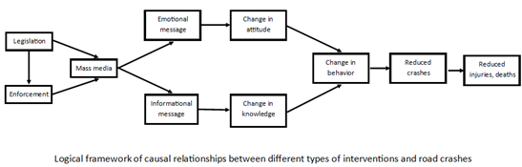

When determining which projects to fund for implementing the countermeasure strategy, GOHS will consider several key factors. These considerations will include 1) Public Engagement to gather community input and understand their concerns regarding traffic safety. This will help GOHS identify specific needs and priorities of the community being served and ensure funded projects align with their expectations; 2) - Traffic Safety data to analyze crash data, traffic volume, and historical trends, identify high-risk areas, prevalent traffic violations, and patterns of unsafe behaviors. This data-driven approach will help prioritize projects based on the severity and frequency of incidents; 3) Directly affected communities impacted by traffic safety issues. Understanding the unique challenges different communities face will guide the countermeasure strategy; 4) Areas such as intersections, highways, or neighborhoods that experience a higher volume of accidents or unsafe behaviors. By focusing on these locations, GOHS can strategically allocate resources to address the most critical areas; and 5) Solicitation of Proposals from relevant stakeholders, including government agencies, nonprofit organizations, and community groups will encourage diverse project ideas, innovation, and collaboration in addressing traffic safety concerns.

These factors will guide GOHS to make informed decisions about funding projects that effectively address the identified traffic safety issues and positively impact the affected communities. This data-driven approach shows a dedication to making Arizona's roads safer.

### Funding sources

|  |  |
| --- | --- |
| **Funding Source** | **Estimated 3-year Funding Allocation** |
| BIL 405b OP Low | $600,000.00 |
| BIL 405d Impaired Driving Mid | $1,000.000.00 |
| BIL NHTSA 402 | $300,000.00 |
| BIL 405f Motorcycle Safety Programs | $300,000.00 |
| BIL 405g Nonmotorized Safety | $300,000.00 |

# ***Program Area: Planning & Administration***

## Description of Highway Safety Problems

The Planning and Administration program will coordinate and facilitate public engagement events, such as awareness campaigns and educational programs, to maximize community involvement in promoting highway safety. The program will also manage the budget and financial aspects of the GOHS, ensuring that resources are effectively allocated to achieve program goals and objectives. Finally, the PA program will be responsible for developing and implementing policies and procedures to ensure efficiency and compliance with all applicable laws and regulations. Through effective management and administration, the PA program will enable the GOHS to achieve its mission of reducing fatalities and injuries on Arizona's roadways.

The PA program will also be responsible for evaluating the success of the projects and programs executed by the GOHS. This includes assessing the impact of grants and activities aimed at increasing highway safety, as well as analyzing the efficiency of resource utilization and identifying areas for improvement. By conducting evaluations and assessments, GOHS can continuously improve its programs and initiatives, ensuring better outcomes for the community. The PA program will also collaborate with external organizations and agencies to promote highway safety across Arizona. This includes working with law enforcement agencies, community groups, and transportation organizations to promote highway safety. The PA program will also help communicate the GOHS' mission and activities to these external partners, ensuring they know about grant funding opportunities.

Overall, the Program Planning and Administration program is critical to the success of the GOHS. Through effective management, planning, and coordination, GOHS can meet its goals and objectives to reduce fatalities and injuries on Arizona's roadways and make the state's highways safer.

**Countermeasure Strategies in Program Area**

|  |
| --- |
| **Countermeasure Strategy** |
| Highway Safety Office Program Management |

## Countermeasure Strategy: Highway Safety Office Program Management

Program Area: **Planning and Administration**

### Countermeasure and justification

The "Grants for Performance" approach followed by GOHS demonstrates a commitment to ensuring effective and accountable use of grant funds. By conducting risk assessments for subgrantees before awarding grants, GOHS aims to evaluate the capacity and capability of the organizations to effectively implement the funded programs and achieve desired outcomes. The risk assessment process helps identify potential risks associated with the subgrantees, such as financial management, program implementation, or compliance issues. By assessing these risks, GOHS can make informed decisions about grant awards, ensuring that funds are allocated to organizations that have the necessary capabilities to carry out the proposed initiatives successfully.

Additionally, the monitoring process plays a crucial role in ensuring compliance with State and Federal regulations. GOHS monitors the activities of subgrantees to ensure that they adhere to the requirements and guidelines outlined in the grant agreements. This includes monitoring financial management practices, program implementation progress, and reporting compliance. By conducting risk assessments and implementing a comprehensive monitoring process, GOHS can uphold its commitment to the public by promoting transparency, accountability, and effective utilization of grant funds. These measures help safeguard the integrity of the grant programs, ensuring that they align with State and Federal regulations and contribute to the overall goal of improving highway safety in Arizona.

### Funding sources

|  |  |
| --- | --- |
| **Funding Source** | **Estimated 3-year Funding Allocation** |
| BIL NHTSA 402 | $3,300,000.00 |
| BIL 405d Impaired Driving Mid | $390,000.00 |

# **Performance Report Chart**

**FY 2024-FY 2026 Triennial Highway Safety Plan**

|  |  |  |  |  |  |
| --- | --- | --- | --- | --- | --- |
| FFY 2023 HSP | | | | | |
| Performance Measure: | **Target Period** | **Target Year(s)** | **Target Value FY23 HSP** | **Data Source*/ FY23 Progress Results** | **On Track to Meet FY23 Target**  **YES/NO/In-Progress  (Must be Accompanied by Narrative**)** |
| C-1) Total Traffic Fatalities | 5 year | 2019-2023 | 1,200.0 | 2018-2022  FARS 1,104.2 | In Progress |
| C-2) Serious Injuries in Traffic Crashes | 5 year | 2019-2023 | 3,659.4 | 2018-2022  STATE 3,625.0 | In Progress |
| C-3) Fatalities/VMT | 5 year | 2019-2023 | 1.655 | 2018-2022  FARS 1.577 | In Progress |
| C-4) Unrestrained Passenger Vehicle Occupant Fatalities, All Seat Positions | Annual | 2023 | 270 | 2022  STATE 272 | In Progress |
| C-5) Alcohol-Impaired Driving Fatalities | Annual | 2023 | 287 | 2021  FARS 421 | In Progress |
| C-6) Speeding-Related Fatalities | Annual | 2023 | 333 | 2022  STATE 425 | In Progress |
| C-7) Motorcyclist Fatalities | Annual | 2023 | 140 | 2022  STATE 227 | In Progress |
| C-8) Unhelmeted Motorcyclist Fatalities | Annual | 2023 | 64 | 2022  STATE 80 | In Progress |
| C-9) Drivers Age 20 or Younger Involved in Fatal Crashes | Annual | 2023 | 123 | 2022  STATE 151 | In Progress |
| C-10) Pedestrian Fatalities | Annual | 2023 | 253 | 2022  STATE 302 | In Progress |
| C-11) Bicyclist Fatalities | Annual | 2023 | 46 | 2022  STATE 48 | In Progress |
| B-1) Observed Seat Belt Use for Passenger Vehicles, Front Seat Outboard Occupants (State Survey) | Annual | 2023 | 89.5 | NHTSA Certified State Survey 87.0% | In Progress |

## Performance Measure: C-1) Number of traffic fatalities* (FARS)

Progress: **In Progress**

### Program-Area-Level Report

GOHS, in collaboration with the ADOT and FHWA, set a 5-year rolling average target for Number of Traffic Fatalities at 1,200.0 for the fiscal year 2023 HSP. Based on the State 5-year rolling average actuals for 2018-2022, Number of Traffic Fatalities was 1,104.2. Based on this data, the projected target of 1,200.0 for 2023 is expected to be met.

As a result, the performance report progress for the FY 2024-2026 HSP includes a "Meet" status for the C-1) Number of Traffic fatalities measure. Although the projected target for 2023 is expected to be met, the status of the performance report measure is still listed as "In Progress" because the 2023 calendar year has not yet been completed.

Despite the challenges in meeting the target, GOHS continues to allocate funds to various program areas within the HSP, focusing on enforcement, public awareness initiatives, community engagement, and education. The ultimate goal is to reduce the total number of traffic fatalities on Arizona roadways.

*2022 Actuals and 2023 Targets are both on 5-year rolling averages.

## Performance Measure: C-2) Number of serious injuries in traffic crashes* (State crash data files)

Progress: **In Progress**

### Program-Area-Level Report

GOHS, in collaboration with the ADOT and FHWA, set a 5-year rolling average target for Number of serious injuries in traffic crashes at 3,659.4 for the fiscal year 2023 HSP. Based on the State 5-year rolling average actuals for 2018-2022, number of serious injuries in traffic crashes was 3,625. Based on this data, the projected target of 3,659.4 for 2023 is expected to be met.

As a result, the performance report progress for the FY 2024-2026 HSP includes a "Meet" status for the C-2) Number of serious injuries in traffic crashes measure. Although the projected target for 2023 is expected to be met, the status of the performance report measure is still listed as "In Progress" because the 2023 calendar year has not yet been completed.

Despite the challenges in meeting the target, GOHS continues to allocate funds to various program areas within the HSP, focusing on enforcement, public awareness initiatives, community engagement, and education. The ultimate goal is to reduce the total number of serious injuries on Arizona roadways.

*2022 Actuals and 2023 Targets are both on 5-year rolling averages.

## Performance Measure: C-3) Fatalities/VMT* (FARS, FHWA)

Progress: **In Progress**

### Program-Area-Level Report

GOHS, in collaboration with the ADOT and FHWA, set a 5-year rolling average target for number of fatalities/VMT at 1.655 for the fiscal year 2023 HSP. Based on the State 5-year rolling average actuals for 2018-2022, number of serious injuries in traffic crashes was 1.577. Based on this data, the projected target of 1.655 for 2023 is expected to be met.

As a result, the performance report progress for the FY 2024-2026 HSP includes a "Meet" status for the C-2) Number of serious injuries in traffic crashes measure. Although the projected target for 2023 is expected to be met, the status of the performance report measure is still listed as "In Progress" because the 2023 calendar year has not yet been completed.

Despite the challenges in meeting the target, GOHS continues to allocate funds to various program areas within the HSP, focusing on enforcement, public awareness initiatives, community engagement, and education. The ultimate goal is to reduce the total number of unrestrained passenger vehicle occupant fatalities, all seat positions on Arizona roadways.

*2022 Actuals and 2023 Targets are both on 5-year rolling averages.

## Performance Measure: C-4) Number of unrestrained passenger vehicle occupant fatalities, all seat positions (STATE)

Progress: **In Progress**

### Program-Area-Level Report

GOHS has targeted 270 number of unrestrained passenger vehicle occupant fatalities, all seat positions for the fiscal year 2023 HSP. However, the recently published 2022 State Crash data shows that the number of unrestrained passenger vehicle occupant fatalities, all seat positions was 272. Based on this data, the projected target of 270 for 2023 is not expected to be met.

As a result, the performance report progress for the FY 2024-2026 HSP includes a "Not Meet" status for the C-4) Number of unrestrained passenger vehicle occupant fatalities, all seat positions measure. Although the projected target for 2023 is not expected to be met, the status of the performance report measure is still listed as "In Progress" because the 2023 calendar year has not yet been completed.

Despite the challenges in meeting the target, GOHS continues to allocate funds to various program areas within the HSP, focusing on enforcement, public awareness initiatives, community engagement, and education. The ultimate goal is to reduce the total number of unrestrained passenger vehicle occupant fatalities, all seat positions on Arizona roadways.

## Performance Measure: C-5) Number of fatalities in crashes involving a driver or motorcycle operator with a BAC of .08 and above (FARS)

Progress: **In Progress**

### Program-Area-Level Report

GOHS has targeted 287 number of fatalities in crashes involving a driver or motorcycle operator with a BAC of .08 and above for the fiscal year 2023 HSP. However, the recently published 2021 FARS data shows that the actual number of fatalities in crashes involving a driver or motorcycle operator with a BAC of .08 and above was 421. The difference between the requirements from pulling data from ADOT State Crash files, GOHS chose to default to FARS to compute the performance target until there is sufficient data from ADOT to establish future trends. Based on this data, the projected target of 287 for 2023 is not expected to be met.

As a result, the performance report progress for the FY 2024-2026 HSP includes a "Not Meet" status for the C-5) Number of fatalities in crashes involving a driver or motorcycle operator with a BAC of .08 and above measure. Although the projected target for 2023 is not expected to be met, the status of the performance report measure is still listed as "In Progress" because the 2023 calendar year has not yet been completed.

Despite the challenges in meeting the target, GOHS continues to allocate funds to various program areas within the HSP, focusing on enforcement, public awareness initiatives, community engagement, and education. The ultimate goal is to reduce the total number of fatalities in crashes involving a driver or motorcycle operator with a BAC of .08 and above on Arizona roadways.

## Performance Measure: C-6) Number of speeding-related fatalities (STATE)

Progress: **In Progress**

### Program-Area-Level Report

GOHS has targeted 333 number of speeding-related fatalities for the fiscal year 2023 HSP. However, the recently published 2022 State crash data shows that the actual number of speeding-related fatalities was 425. Based on this data, the projected target of 333 for 2023 is not expected to be met.

As a result, the performance report progress for the FY 2024-2026 HSP includes a "Not Meet" status for the C-6) Number of speeding-related fatalities measure. Although the projected target for 2023 is not expected to be met, the status of the performance report measure is still listed as "In Progress" because the 2023 calendar year has not yet been completed.

Despite the challenges in meeting the target, GOHS continues to allocate funds to various program areas within the HSP, focusing on enforcement, public awareness initiatives, community engagement, and education. The ultimate goal is to reduce the total number of speeding-related fatalities on Arizona roadways.

## Performance Measure: C-7) Number of motorcyclist fatalities (STATE)

Progress: **In Progress**

### Program-Area-Level Report

GOHS has targeted 140 number of motorcyclist fatalities for the fiscal year 2023 HSP. However, the recently published 2022 State crash data shows that the actual number of motorcyclist fatalities was 227. Based on this data, the projected target of 140 for 2023 is not expected to be met.

As a result, the performance report progress for the FY 2024-2026 HSP includes a "Not Meet" status for the C-7) Number of motorcyclist fatalities measure. Although the projected target for 2023 is not expected to be met, the status of the performance report measure is still listed as "In Progress" because the 2023 calendar year has not yet been completed.

Despite the challenges in meeting the target, GOHS continues to allocate funds to various program areas within the HSP, focusing on enforcement, public awareness initiatives, community engagement, and education. The ultimate goal is to reduce the total number of motorcycle fatalities on Arizona roadways.

## Performance Measure: C-8) Number of unhelmeted motorcyclist fatalities (STATE)

Progress: **In Progress**

### Program-Area-Level Report

GOHS has targeted 64 number of unhelmeted motorcyclist fatalities for the fiscal year 2023 HSP. However, the recently published 2022 State crash data shows that the actual number of unhelmeted motorcyclist fatalities was 80. Based on this data, the projected target of 64 for 2023 is not expected to be met.

As a result, the performance report progress for the FY 2024-2026 HSP includes a "Not Meet" status for the C-8) Number of unhelmeted motorcyclist fatalities measure. Although the projected target for 2023 is not expected to be met, the status of the performance report measure is still listed as "In Progress" because the 2023 calendar year has not yet been completed.

Despite the challenges in meeting the target, GOHS continues to allocate funds to various program areas within the HSP, focusing on including enforcement, public awareness initiatives, community engagement, and education. The ultimate goal is to reduce the total number of unhelmeted motorcyclist fatalities on Arizona roadways.

## Performance Measure: C-9) Number of drivers age 20 or younger involved in fatal crashes (STATE)

Progress: **In Progress**

Program-Area-Level Report

GOHS has targeted 123 number of drivers age 20 or younger involved in fatal crashes for the fiscal year 2023 HSP. However, the recently published 2022 State crash data shows that the actual number of drivers age 20 or younger involved in fatal crashes was 151. Based on this data, the projected target of 123 for 2023 is not expected to be met.

As a result, the performance report progress for the FY 2024-2026 HSP includes a "Not Meet" status for the C-9) Number of drivers age 20 or younger involved in fatal crashes measure. Although the projected target for 2023 is not expected to be met, the status of the performance report measure is still listed as "In Progress" because the 2023 calendar year has not yet been completed.

Despite the challenges in meeting the target, GOHS continues to allocate funds to various program areas within the HSP, focusing on enforcement, public awareness initiatives, community engagement, and education. The ultimate goal is to reduce the total number of drivers age 20 or younger involved in fatal crashes on Arizona roadways.

## 

## Performance Measure: C-10) Number of pedestrian fatalities (STATE)

Progress: **In Progress**

### Program-Area-Level Report

GOHS has targeted 253 number of pedestrian fatalities for the fiscal year 2023 HSP. However, the recently published 2022 State crash data shows that the actual number of pedestrian fatalities was 302. Based on this data, the projected target of 123 for 2023 is not expected to be met.

As a result, the performance report progress for the FY 2024-2026 HSP includes a "Not Meet" status for the C-10) Number of pedestrian fatalities measure. Although the projected target for 2023 is not expected to be met, the status of the performance report measure is still listed as "In Progress" because the 2023 calendar year has not yet been completed.

Despite the challenges in meeting the target, GOHS continues to allocate funds to various program areas within the HSP, focusing on including enforcement, public awareness initiatives, community engagement, and education. The ultimate goal is to reduce the total number of pedestrian fatalities on Arizona roadways.

## Performance Measure: C-11) Number of bicyclists fatalities (STATE)

Progress: **In Progress**

### Program-Area-Level Report

GOHS has targeted 46 number of bicyclists fatalities for the fiscal year 2023 HSP. However, the recently published 2022 State crash data shows that the actual number of bicyclists fatalities was 48. Based on this data, the projected target of 46 for 2023 is not expected to be met.

As a result, the performance report progress for the FY 2024-2026 HSP includes a "Not Meet" status for the C-11) Number of bicyclists fatalities measure. Although the projected target for 2023 is not expected to be met, the status of the performance report measure is still listed as "In Progress" because the 2023 calendar year has not yet been completed.

Despite the challenges in meeting the target, GOHS continues to allocate funds to various program areas within the HSP, focusing on enforcement, public awareness initiatives, community engagement, and education. The ultimate goal is to reduce the total number of bicyclists fatalities on Arizona roadways.

## 

## Performance Measure: B-1) Observed seat belt use for passenger vehicles, front seat outboard occupants (STATE SURVEY)

Progress: **In Progress**

### Program-Area-Level Report

GOHS has targeted 89.5% Observed Seat Belt Use for the fiscal year 2023 HSP. However, the recently published 2022 State Survey data the Observed Seat Belt Use was 87.0%. Based on this data, the projected target of 89.5% for 2023 is not expected to be met.

As a result, the performance report progress for the FY 2024-2026 HSP includes a "Not Meet" status for the B-1) Observed Seat Belt Use measure. Although the projected target for 2023 is not expected to be met, the status of the performance report measure is still listed as "In Progress" because the 2023 calendar year has not yet been completed.

Despite the challenges in meeting the target, GOHS continues to allocate funds to various program areas within the HSP, focusing on enforcement, public awareness initiatives, community engagement, and education. The ultimate goal is to increase the Observed Seat Belt Use rate on Arizona roadways.